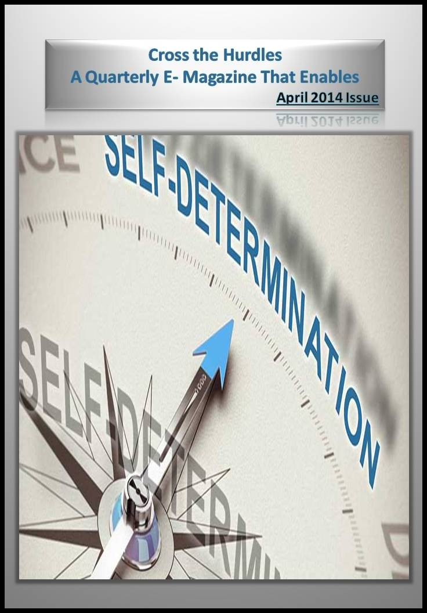

Contents

[Editorial 3](#_Toc383946801)

[Expert Speak 4](#_Toc383946802)

[The Eternal Optimist – A Story of My Life 6](#_Toc383946803)

[Personality of the Quarter 9](#_Toc383946804)

[Photography Workshop for the Intellectually Challenged 12](#_Toc383946805)

[First Ever Mobile App 15](#_Toc383946806)

[Assistance is better than Embarrassment 16](#_Toc383946807)

[Bhavana A Vispute 20](#_Toc383946808)

[“I don’t need to be HEARD and LOUD, little UNCOVERS me and you will get to know all about”. 23](#_Toc383946809)

[Walk Of Life In Mumbai Marathon 2014 27](#_Toc383946810)

[Build your inner resources 30](#_Toc383946811)

[व्यक्तित्व = शरीर ,मन, बुद्धि और आत्मा 32](#_Toc383946812)

[मैंने जीना सीख लिया है (कविता) 34](#_Toc383946813)

[ना खुश हूँ मैं ना उदास हूँ….(कविता) 36](#_Toc383946814)

[लघु उपचार 38](#_Toc383946815)

# snapshot-024.jpgEditorial

Writing an editorial for a magazine which relates directly or indirectly to disability issues sometimes becomes an overwhelming task because one does not know which issue to pick up and which to leave. Issues concerning this section of society cannot be discussed in isolation as each and every topic seems to be an inherent part of the other or correlated to each other. If we talk of independent living we cannot focus on it without considering the employability of the persons with disabilities and when we talk of having some gainful employment we cannot concentrate on it without taking into account the access of education. And then we need to think about linking education to skill development as in our country education and skills development are sometimes taken as two different things. But for persons with intellectual disabilities development of skills is more important than earning the college degrees. As far as skill development is concerned disability management must be taken seriously not only by the state authorities but it should become one of the most important agendas of the private sector and non profit non governmental organizations both at macro and micro levels.

This issue of E-magazine brings you many lived experiences of many people with disabilities who have strived hard to make their place in the society believing that if the society does not include you, you become a part of society by developing your inherent skills and personality. It in a way focuses on what self determination really is.

We wish our readers a very happy and insightful reading!!

Editors: Abha Khetarpal , Rajendra Maurya

Cover page: Abha Khetarpal

# 562697_424378217589924_578933700_n.jpgExpert Speak

Dr Anchal Sandilya [BPT, MPT (NEURO)]

P

arkinson’s Disease

Parkinson’s disease is a movement disorder resulting in slowness in movements. Most individuals with Parkinson's disease are diagnosed when they are 60 years old or older, but early-onset Parkinson's disease also occurs. Researchers have investigated the effect of cueing in disorders like stroke, spinal cord injury for improving motor skills and gait and lower limb functions in Parkinson’s patients.

Parkinson’s disease is a neurodegenerative disease caused by a loss of dopamine producing neurons in brain. Primary motor deficits include resting tremor, slow movements, muscular rigidity, and postural instability. Most importantly, patients have difficulty both initiating movements and performing well-timed movements. Due to the progressive nature, its symptoms worsen over time.

Therefore, these patients exhibit delay in the initiation of movement, slowness in execution, and inability to engage into sequential motor actions. To facilitate initiation and speed of movement, most activities employed visual and auditory cues as triggers. Visual cues were looking at and following the therapist’s or another group member’s movements. A mirror can also be used. Auditory cues like music with regular rhythm, a metronome, verbal suggestions, and reinforcement from the therapist are also useful for the patients.

Fine motor skills with auditory cue training leads to significantly and potentially durable functional gains for activities such as writing, simulated feeding and lifting light weighted cans in dominant and non-dominant hand. Cues can help patients to compensate for their movement generation deficits in Parkinson’s disease.

Picking up rice grains and keeping them in egg cup can really prove useful.

Buttoning of buttons of different sizes should be done as a regular practice.

Patient should also be asked to perform closing and opening of jar with contents inside.



# The Eternal Optimist – A Story of My Life

*Angshu Jajodia*

Many years ago, while browsing through the Classics section of the library at my school, I came across this quote by Plutarch, the ancient Greek philosopher: “What we achieve inwardly will change outer reality.” This quote epitomizes everything I have based my life’s ideals and values on.

I was born deaf. But I am lucky to be born of two very special parents who had a dream that their child would be able to talk and play as any other child despite having a hearing problem. As I gather, when they first came to know the implications of my disability, they were numb with shock – which I guess is only natural – as they were told that the deaf could never learn to speak and would be resigned to communicating in sign language. 

Every time I tell people that I am deaf and was not supposed to speak, I experience an epiphany of sorts, because talking has seemed to be the most natural thing in the world for me. I realize that what seems natural now is the result of immense self-belief that my parents had in those dark times when no one was there to tell them that it was possible for a deaf child to speak.

Those days of uncertainty were definitely not easy. Everywhere my parents went in India, they asked only one question: “Will my child talk?” And everywhere they were met with a response in the negative. Some doctors even had the insensitivity to suggest to my mother to go for a second child to fulfil parental ambitions. But as they say, seekers will be finders and finders will be keepers! In the same way, my parents found guidance, encouragement and knowledge, albeit in a far-off land, in their search for a meaningful rehabilitation programme for me. As a result, I started talking.

Two decades have gone by since then. I have had a truly fulfilling childhood. I was always made to be comfortable with my deafness and have perceived it to be a great blessing instead of a curse. For me, being deaf is the way I am - much as the short or tall person feels about himself. Truly, it is the journey that makes life worth it. No worries if your child does not come first, second or third. No big shakes if your child does come first, second, third or even last. Life is not a race.

My parents did exactly that. They did not have any plan for me to come first in life. They just took things as they came, revelling in the beautiful journey of teaching their child to talk and talk more. They did not compete with anyone nor did they push me to compete. I ambled along at my own pace, going from strength to strength as I moved up the classes. I was never a good student in school. In fact my class reports had begun to worry my teachers who were sensitive of their school’s reputation. So, when I got through my boards in the 1st Division, they were elated. I have never looked back since then! I went through and creditably completed my higher education through one of the best institutes in the country. After a brief stint in the corporate sector, I have now chosen to join the social sector and am also preparing for my Ph.D. Without the solid base in language that was prepared for me early in life, I am sure I would not have been able to make my own choices in life so naturally. So, though my parents didn’t plan for me to come first in life, things fell into place and worked out in the end.

My parents tell me that they have had a very blessed life in mentoring me and watching me grow. Life with deafness has been challenging no doubt, but it has given me unforgettable moments and helped me to appreciate the little joys of human existence. Certainly a child with a disability is not a blessing one would pray for, but nevertheless ours has been a very interesting life.

I’d like to use this platform as an opportunity to share a few thoughts of mine on disability. To persons with disabilities I want to say this: disability cannot be an excuse for mediocrity. We are aiming to reach for the stars and we can certainly reach them in the pursuit of excellence. People who pursue excellence will pursue excellence anyway, whether they are disabled or not. Disability only adds a renewed perspective to the differences that are existent in all of us.

The bumblebee is aerodynamically not supposed to fly, but it doesn’t know that and therefore it keeps on flying. Similarly we should not allow our limitations to hold us back. The focus should be on what we can do rather than what we cannot. Temple Grandin, Stephen Hawking, Sachin Tendulkar and Nobel Laureate Vernon Smith have shown us the way. Who can stop us?

I cannot change the way I look, but I can definitely change the way the world looks at me.

*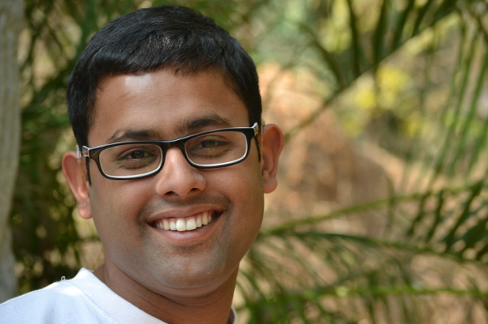{The author is a post-graduate in Social Work from the Tata Institute of Social Sciences, Mumbai and is currently working with an organization that focuses on empowering parents to teach their pre-lingual deaf children to talk. He also holds a Bachelors degree in Social Work from Visva-Bharati University. He is now pursuing his Ph.D at Visva-Bharati University in the field of social sciences.]*

# Personality of the Quarter

***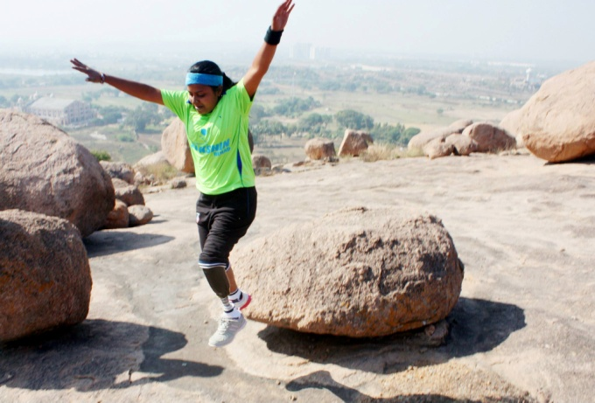‘’To succeed is to be in pain and to be in pain is to succeed’’…Kiran Kanojia has proved this to the world. It was her will to win, the desire to succeed, the urge to reach her full potential which has made her the first woman blade runner in our country... She has unlocked the door to her personal excellence and achieved her goals. Let us know more about her!***

What do you do by profession?

I am working with Infosys as a test engineer.

What was your mental state after your amputation? How did you manage to overcome it?

After amputation, I had lots of thoughts like what would happen to me. Would I able to see the world again as my dream was to go and visit foreign countries at least once in my life. I used to think if people love or hate me.

I have now overcome such fears and have managed myself with help of my family and friends around me and after that I have taken the life as a challenge and have worked hard to come out of it. My parents have played an important role they are the ones who always keep on encouraging me and make me smile each and every moment saying that I am the best in this world and I would be reaching heights more than what I had lost today.

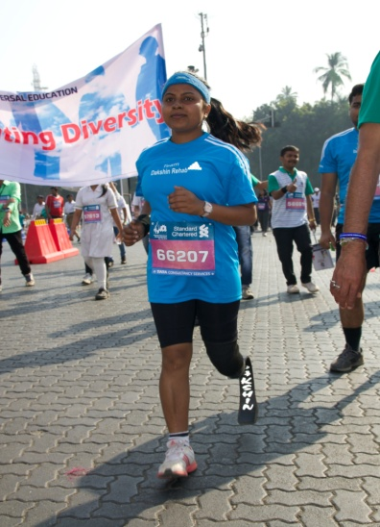Who has been your greatest support?

My parents.

You have earned the title ''First woman blade runner of India''. How did this become possible?

Dakshin Rehabilitation supported me in getting this title. They have guided, supported and provided training to make me run and through this I have found myself as a passionate person in sports. They also help other women to know the importance of sports which makes them feel relaxed and peaceful.

What all other activities interest you? 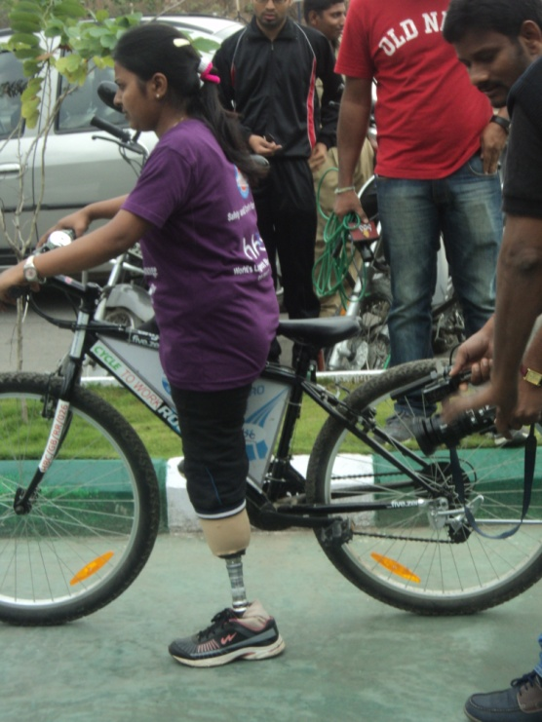

I love to do cycling, swimming and meditation. I also like to meet others amputees to make them smile and share my experiences through which I have undergone.

Do you plan to take part in any international athletic event now?

Yes, I always wish to be a part of international games and make my country proud but right now I don't have any support to move on.

What all drives you to be a sports person?

For a sports person like me, I like to get up early in the morning, start a day with prayers then followed the sports activities running and swimming. For me punctuality and discipline are very important.

Where do you see yourself after 5 years down the line?

I want to see myself as the Indian first woman blade runner Kiran Kanojia who is known to each and every amputee throughout the world.

What message would you like to give to people who have some kind of disability?

My message is that losing a part of body is not the end of life. Just put a step forward and you will see a thousand hands will come forward for your support.



# Photography Workshop for the Intellectually Challenged

An Eye-Opening Experience

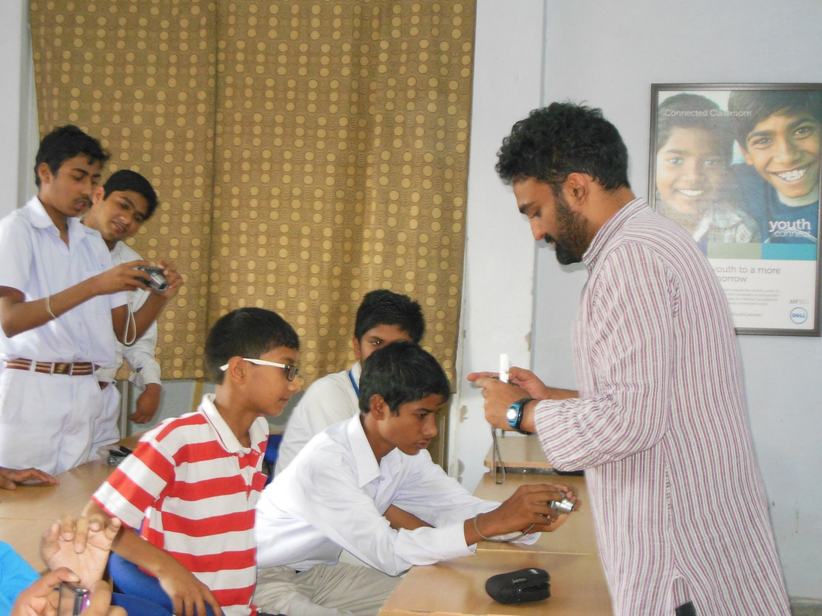Photography is an interesting hobby - an easy one to have in these days of click and shoot cameras. Children learn early how to use these. Could children with intellectual challenges also learn how to use this gadget to express themselves? This is the thought that came to the Team Amrit. *Amrit Foundation of India* is an NGO devoted for the inclusion of the marginalized and providing equal opportunities to all, and its flagship program *The Little Peepul Tree* is designed to promote the inclusion of children with intellectual challenges into mainstream society. The team at Amrit moved purposefully. It contacted the *Happy Camera Club* which is a not-for-profit run by a group of committed young photographers whose passion is to teach photography to the less privileged while pursuing their own professional careers. It also invited *Akshay Pratishthan*, an NGO working for those with all kinds of disabilities including by providing integrated education for all children regardless of the challenges that they face, to join it in holding a workshop for young children with intellectual challenges.

The workshop was designed with our young wards in mind. It was designed to build their confidence and self-esteem, as well as to explore their view of the world. Sessions of demonstration, classroom style teaching and outdoor shoots were held at the Akshay Pratishthan premises and at Lodhi Gardens over a 2 month period. The group was of ten students in total, some mainstream and others with challenges -Down syndrome, mental retardation, hearing disorder. The children viewed this workshop as an exciting opportunity to express their own interests and thoughts. Our job was to ensure that they had the basic concepts of photography and we had their attention.

Each child had his or her own reasons for doing the workshop. One student said, “I was longing to try photography, I always wanted to learn it”. Another child exclaimed, “I always wanted to click photographs on festivals, now I can click as many pictures possible on Diwali and other festivals, and my parents won’t stop me because now I have been trained.” It was marvelous how well these young children with challenges had learnt the techniques from the mentors Siddharth and Vivek from the Happy Camera Club. A child explained, “We understand how to click photos, we need to check all the lines are straight, all angles need to be correct, the background has to be beautiful”. He explained with an example, “If I am clicking a person’s photo, everything has to fit in the photo from an angle, like the flowers in the front of that person or the monument behind”. This is much more than most persons know when they take photographs. By the end of the workshop, they knew about zoom, flash and many other little tricks of the trade. “Now whenever I go back home after attending the photography class my parents start asking me to click photos, random and theirs too. It is really a fun, I enjoy it.”

Our team was awed by their intent to learn. Their sessions had given them an amazing self-confidence. In the second last class of the workshop, the photos clicked by the students were being screened. The photos on the laptop were very clear but were faded on the screen. A child jumped up and asked, “Why are the colours of the photo different on the laptop and the screen? I think this need to be corrected”. The mentor explained this is because the projector is not calibrated with the laptop. The students got the projector calibrated and the class resumed.

But it was not only the children who were changed by the experience. The mentors said, “It was a great experience to teach them. I had forgotten the thrill of my first photograph - being with them has brought it back.” For Akshay Pratishthan too, it was the first. The camera gave even the most self-effacing child a tool with which to show others what s/he was seeing. Teachers were surprised at how enthusiastically each child attended the classes and paid attention to what was being taught. Lesson there - make the classes interactive. And for Team Amrit, well, for us it was a joy to have been there and see the world through the eyes of a little child with dreams.

***Team Amrit***



# First Ever Mobile App

Cross the Hurdles is glad to announce that it has launched first ever android mobile application for the persons with disabilities in India. This is a free application and is now available for download at Google Play Store. It is an information resource containing every information right from accessible places in our country to schools for the children with autism, from blood banks in the country to accessible libraries for people with visual impairment.

For IOS users following steps would install this mobile app on your phone:

* Open up the Safari app on your iOS device.
* Open the website <http://m.crossthehurdles.org/>
* Tap on the "Share" icon at the bottom. This looks like a square with an arrow pointing \*on top or towards top-right.
* Select the "Add to Home Screen" icon.
* Give your Link Button a name.
* Tap on the word "Add" in the upper right hand corner.
* Look for this link button on your Home screen.

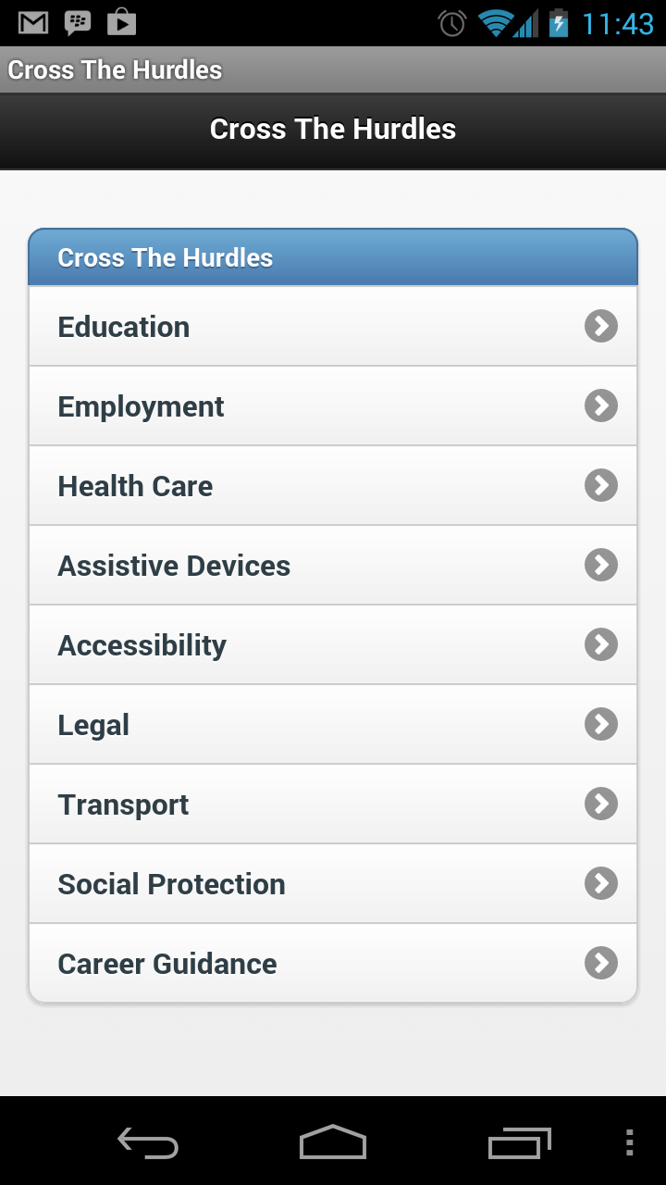

# Assistance is better than Embarrassment

Here in this article, I want to draw your focus towards a thing which I lately experienced and executed. This is something which is helpful in everybody’s life though in different perspectives. The thing I am talking about is to ‘seek for help’. In our lives, we all, most of the times, hesitate to ask for help and fall in a situation of embarrassment. Earlier I used to do the same thing and resultantly, fell in a situation of embarrassment. In my case, I am a visually challenged girl with 75% impairment. I go to New Delhi after every 3 or 4 months for regular check up. The journey to New Delhi is of around 8 to 9 hours from my current city.

Here I would like to share two experiences of my life. In the first experience, I am going to share how my hesitation led me to a situation of embarrassment. In second one, I will share how I didn’t hesitate to ask for help and everything went pretty smooth.

In the first instance, I was in New Delhi for my eye check up with my father. We were standing in a queue to get the ticket of metro. After taking the tickets, we moved towards the machine in which we were to touch our ticket-token to proceed further. There was a huge crowd in the metro station and long queues to get in. While we were standing in the queue, my turn of getting through the machine counter came. Here I want to mention that I always manage to handle these machines through my commonsense and this time also I thought to do the same. But this time, the layout of the machine was quite different than the earlier ones. So, the moment I touched my token against the machine, I found that it was different. I tried to drag it towards the surface of the machine in the hope that it might touch the desired point. I had already taken half a minute to explore that machine. Just then, an officer standing at a distance shouted at me. He in a rude tone said, “Madam, kya kar rahi ho. Karna nahi aatta kya. Pata nahi kaha kaha se aa jaatte hain” *(What are you doing madam? Don’t you know how to operate it? Don’t know from where these people come)*. Suddenly, the token touched the particular point and I passed through the counter. Afterwards, I in my mind, felt so embarrassed about what the officer said amidst a heavy crowd. This thing bothered me for long, even for a few consecutive days.

After returning from New Delhi, I pondered over what had happened. I introspected and reached a conclusion. What I realized was that if I would have told the officer earlier about my vision impairment and need for his/her assistance, this would not have happened. Actually, as I am a confident girl and also wear smart specs, it becomes quite difficult for a person to find out my vision problem. However, on the same day, due to my hesitation, a few other things made me uncomfortable as well.

Now, let us move on to my second experience. This is a similar one but without any hesitation. Lately, I again went to New Delhi for eye check up. I was in a metro station with my father. We took the tickets and then discovered that there were some changes in arrangements of queues and checking counter. This time the difference was that men and women were in the separate lines. There was huge rush on ticket counter and in long queues as well. After realizing the hustle and bustle going on there, I just stopped before standing with my father in a queue. My father asked me to go further with him as it didn’t make much difference. But I was firmly determined to avoid any embarrassment which could have occurred due to that. So, I just called the officer standing nearby. I told him that I was a visually challenged girl and it was quite difficult for me to make my way alone in the areas where only women were allowed to enter. The officer waved his hand to a lady officer standing at a distance. Then she took me with her, checked me and my luggage and told me to stand aside at a point till my father reaches there. In this way, my father joined me there and we smoothly proceeded further.

Here I want to mention that soon there after, another thing bothering me in my mind was how to tackle with the rush in metro. We all know that there is a separate compartment for women in Delhi Metro. But here the issue was that I have had always travelled in metro with my father. Thus, I had to travel in the common compartment in which 99% of crowd was of men because obviously women travelling alone would prefer the separate compartment to avoid the pushes of male crowd in the common compartment. Earlier, I had always felt really uncomfortable travelling in a compartment where most of the passengers were male. The crowd was tightly packed to doors in common compartments. Believe me, being a visually challenged person, it always becomes difficult to judge a person moving in gaps or standing next to you and so on.

This time, I asked some of the women standing in front of the marked point, exclusively meant for women to board the metro, that at which station they had to get down. Unfortunately none of the ladies standing there was going on the station at which I had to get down. So, I had to accompany my father in a common compartment. But for sure, from now onwards I would make it a point to ask the fellow women passengers to assist me in the women compartment so that I can avoid awkward situations in common compartment of the train.

Here, my purpose of sharing my experiences is to spread the message among people, especially women, to make sure that those who hesitate in seeking help the way I used to earlier, should understand that it is always better to ask for help than to suffer embarrassments.

Such embarrassments may occur due to unawareness on the part of people. Because in a similar situation, if we won’t tell a person that we have a particular issue, others can take us as a goon behaving in an unusual manner.

*(Divya Sharma (Bhvya), a promising student and a great lover of music. Music is her passion and her visual impairment has never let her held her back from achieving all the she wants to achieve in her life).*

# Biography

# Bhavana A Vispute

Bhavana met with an accident way back in the October1992 and became paraplegic waist down. Since then she is a wheel chair user but her Wheel Chair is not a Wheel-Chair it’s a ‘’Willed Chair’’ and her ‘’Willed Chair’’ has took her to great heights.

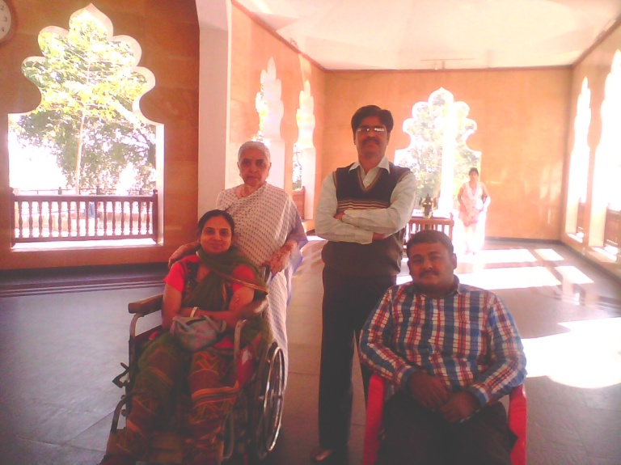She has a Diploma in Civil Engineering. She works as a volunteer for Anandvan (Forest of Joy), is located near Warora, in Chandrapur District of Maharashtra. It is an ashram and a community Rehabilitation Centre for leprosy patients and the disabled persons from downtrodden society. She also sells products manufactured at Swyamsiddha Group (girls with disabilities) of Solapur at no profit no loss basis. Bhavana takes tuition's of school children’s & teaches them all subjects.

Her favourite subject is to motivate common people to come forward donate their eyes & bodies. She has also made her voice available for educational C. D’s and cassettes and also makes such C.D’s and cassettes of short stories with some fun filled puzzles, anecdotes for blinds kids as part of Diwali celebrations for them. Bolka Aank (**Talkative Edition)**  helps to get writers for the students who are appearing for 10th (SSC) and 12th (HSC) exams. She loves to read a lot and has won the first prize in last year’s Kusumagraj’s Littérateur and today’s youth. Her husband Avinash Vispute and her mother in law Mrs Usha L Vispute, have stood behind her as a rock and this helped Bhavana to scale new heights and new horizons. Bhavana used to get up early in the morning along with her daughter and used to read any available book. Her main intention in doing so was to inspire her daughter to study more and more. She instilled faith in her daughter that one day she could became a qualified doctor and today she is proud to be known as the mother of an MBBS doctor. Her daughter Yashsahri has made all their family proud as being the first qualified medical doctor of their family. What physically active persons cannot do, Bhavana can do. Bhavana has shown that she could and she would make it. Recently Bhavana was one of the organizing members of Blind and Handicap Literature Meet held at Nasik on 14th & 15th December 2013, where her role was to take interviews of three persons, two of whom were blind and 3rd was a physically challenged person. After the sad demise of Bhavana’s mother she asked doctors to take her mother’s eyes for donation and implant those eyes to the needy patients so that two persons can see this beautiful world once again. Bhavana loves to guide paraplegics 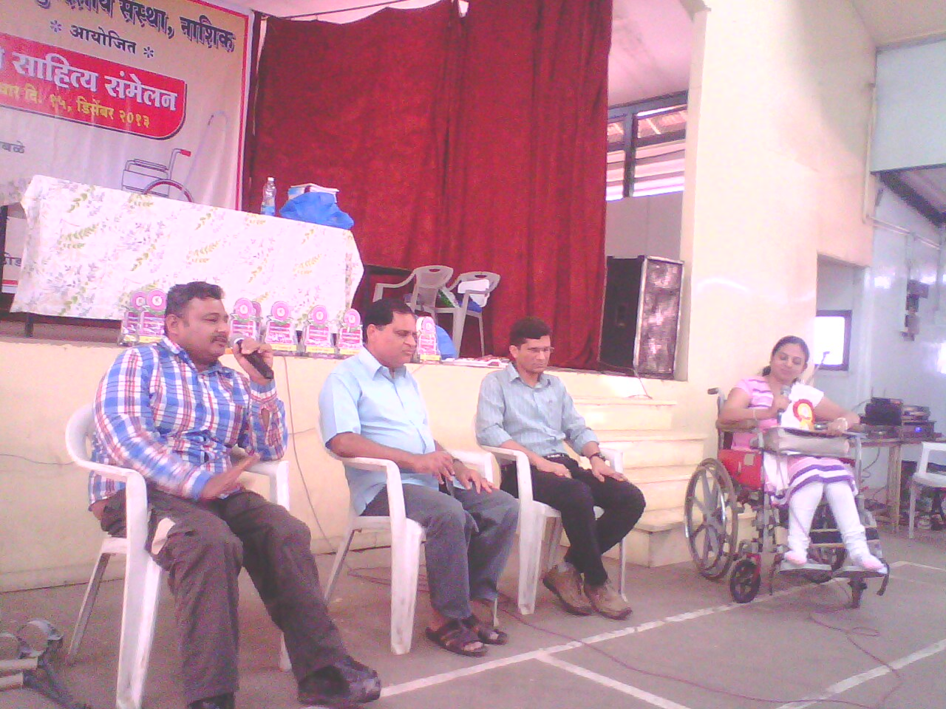how to control bladder and bowel movement as this is a part and parcel of rehabilitation of a paraplegics. If anybody wants any type of consultation from her (regarding bladder and bowel movement), then please feel free to call her on her (Mobile) **09423973361** and /or mail her on [**bhavanaavispute@gmail.com**](mailto:bhavanaavispute@gmail.com)**.** She is an advocate of strong laws for crime against women. In past she wrote many articles in various newspapers to take active role for the cause of eye donation. Bhavana, though herself a paraplegic, motivates other paraplegics about how Life is still enjoyable even after meeting with a tragic accident and becoming a paraplegic waist down. Very recently she has won Nasik Prestigious Award called “**Nishta”** (Faith).

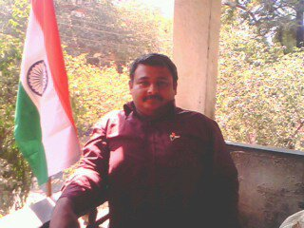Last but not the least Bhavana’s sporting motto of life is “Entire water of sea cant sink a ship unless it gets inside the ship, same way negativity of world can’t put us down unless we allow it to get inside us” .

*(Mr. Mani Laxman Panse does data entry work. He takes active part in Sports meet and has won Medals in the field of athletics. He is a familiar face at every year's Pune International Marathon's Wheel Chair Race which takes places in Pune on 1st Sunday of December each year.  He loves to read a lot. Mani contracted polio at the tender age of 9 Months old).*



# I, Me And Myself

# C:\Users\sarika\Desktop\payal.jpg“I don’t need to be HEARD and LOUD, little UNCOVERS me and you will get to know all about”

Our day to day experiences leave deep edged imprints on our minds. Every now and then they keep popping up thereby shaping our personality.

I, Payal Kukreja, a post graduate in the field of Applied Psychology, have cleared UGC NET and presently an employee of an esteemed American bank in Gurgaon. But the road was not so easy especially with an orthopaedic challenge. Here I take the liberty of taking you along for a walk down my memory lane.

I was the first child born to a middle class and not too much academic oriented family. My mother had a forceps delivery at the time of my birth, and suffered from bleeding and premature labor pains during her conception period. I was born with Congenital Talipes Equinovarus (CTEV) in which the affected foot appears to have been rotated internally at the ankle, followed with meningitis (brain fever), septicemia (a serious life threatening infection in the lungs, abdomen, and urinary tract) and pneumonia at the age of two months. The developmental milestones like crawling, head control, grasping etc. got delayed and I was not able to walk independently. After a lot of running around and undergoing several medical investigations, I was diagnosed with Hip Dislocation (when the ball of thighbone moves out of place within the socket of the pelvic bone) at the age of three years. Few surgeries for the same also took place then and in later years but none of them worked up to the mark level. I was also operated for umbilical hernia (part of the small intestine passes through the abdominal wall near the navel) at three. I was dependent on my parents for the daily chores activities whether it is buttoning of my clothes or feeding me.

My schooling was also not free from challenges. I started my education from a Hindi medium school where I studied till second standard. No other school was willing to enrol me as no one wanted to take the responsibility of a special child. Even after clearing the written tests and interviews, I was not given admission. But my parents’ hope and struggle resulted into my admission in Fr. Agnel School. Getting here was actually a turning point of my life not because it is a good school but because it also provided me with a discrimination free environment in all the aspects and a platform to showcase my calibre and strength. Though my parents are not highly educated, they were aware of the importance of the role played by education in grooming of the person. They always wanted me to attain best of the possible education and stand on my feet. My school Principal Fr. J.A.Carvahlo’s faith in me motivated me to give a justice to his faith and my parents’ struggle.  My classroom used to be on the third floor and to reach there, I had to climb a flight of stairs, which was a bit cumbersome task. Though they offered shifting classes on the ground floor but I preferred to manage on my own. The will to do something and faith of my parents and teachers in me boosted my morale that I was counted among the toppers of my class and was given special admiration. My successful schooling was a stepping stone towards my graduation and post graduation from the esteemed colleges (Gargi College and South Campus respectively) of University of Delhi. My major of Psychology demanded a lot of field work and conducting experiments which often required me to be on my toes, but the passion to study the subject always dominated the issue of mobility. My passion and dedication for my subject, the will power and optimistic attitude towards life won me a lot of good friends and support of my teachers. They never made me feel that I am disadvantaged and always encouraged me. My friends always encouraged and supported me; they made me outgoing and part of all their mutual activities. With the immense encouragement from my family and dear ones, I successfully cleared UGC NET 2012 in the first attempt, which again generated a proud feeling in my parents, teachers and friends.

Getting into the professional world was a bit more challenging. After completing my post graduation, I struggled for one year to earn a job for myself but was unable to. People have a general mindset that a physically disabled person can’t put hundred percent efforts and can only be given charity. But the attitude of “slow and steady wins the race” didn’t allow me to lose my hope. During this year, I took tuitions for junior students and joined internships. Finally after a year I was hired by ‘Bank of America’. Though my work profile is not related to my educational profile, I still took up because one should not restrict its calibre and growth to a specific field. At present, I walk with the help of a walking rollator and a walking stick, and manage my daily activities independently. My journey till date would not have been a success without the support of the Almighty, my parents, my brother, my dear and near ones and, of course, my subject ‘Psychology’. It was not only a curriculum for me but the greatest marker of change in my personality and attitude, and helped me to uncover my real self. It made me more optimistic and taught me to view life from a dual perspective. The almighty has blessed me with commendable parents and a brother who have made me the person I am today. They have always been the pillar of strength for me and sacrificed their happiness for mine. They have taught me how to convert my weakness into strength. My friends and teachers are the real gems who were not only with me in my thick and thin but also changed my entire notion about the term ‘disability’.

According to me the disability of a person becomes more disabling if one thinks it to be a disability. It’s all a game of mind which makes a person disabled or non-disabled. A person is disabled if he doesn’t see the word ‘able’ in ‘disable’. Moreover, the society and the value system play an important role in the improvement as well in the retardation of special people. Society should bear a positive attitude towards disability unlike in my case where it has played a negative role. In spite of making my life at an ease, it created hurdles for me. I welcomed such hurdles as challenges which in turn in a way helped me in becoming what I am today.

It has been rightly said by Charles Chaplin that *“you will never find a rainbow if you are looking down”*

*(Payal Kukreja, Age 24 years)*



# Walk Of Life In Mumbai Marathon 2014

*This Walk Is Dedicated To All Types OF Differently Abled People…. ‘’Just Believe In Yourself’*

To achieve a desired goal, it takes a lot of teamwork, dedication, determination and willingness among the group to achieve it. I saw that same qualities in my family camp this year. From the helper to get me ready and dressed up on time, my parents willingly to drive so early in the morning, and my sisters summing up my family support to be there for me made this Mumbai Marathon 2014 memorable event.

10 years ago was the first time that I heard about Standard Chartered Mumbai Marathon. It's an annual event that was held in mid-January as a part of Mumbai festival that unfolds later in the month. I used to read it in newspapers about various athletes from different parts of the world coming to Mumbai for participation. Strong, sturdy African runners have always been giving tough competition for the other contenders. As a sports-crazy person, there was a big desire in me to see myself involved in this competition. I came to know about the “Champions with Disability” category in which wheelchair users can participate. I was just thrilled to know about it. But then I didn’t believe that much myself to see it happening. 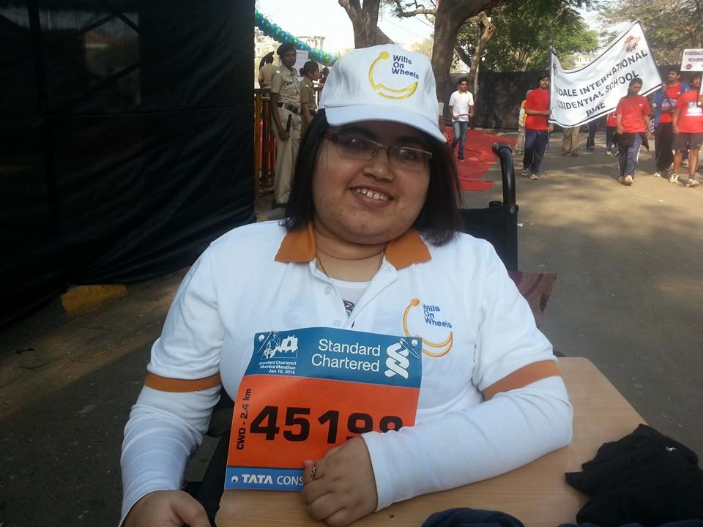

One of my close friends, Kiran, always kept saying it to me those days – “even you will be there one day.” I never took it seriously until last year when, very much to my surprise was a part of Mumbai Marathon 2013. Every year I tried since 2006, I always missed the application dates to find myself cursing and watching marathon from home. Last year, when ‘Wills On Wheels’ was formed, we decided to participate in Mumbai Marathon, to give our NGO a small significance about our existence. My happiness knew no bounds so much that I crazily drove my wheelchair through the roads at 11 in the night to inform some of my friends about participation. I had to say it to someone..!!

Wills On Wheels also participated in this year’s Mumbai Marathon 2014. This time though we had only 3 members of wheelchair users, rest could not make it due to health conditions. Also cold weather played its part in taking a skeptical decision for the participation of the event. I was determined myself and maintained the fitness throughout the week mainly for the race-day. It was good to see our cofounder Priti Shetty and one of the new members of W.O.W named Manisha make it to Mumbai Marathon. I was happier to see them participating willingly and finish the race despite being little out of schedule. That’s what mattered to me.

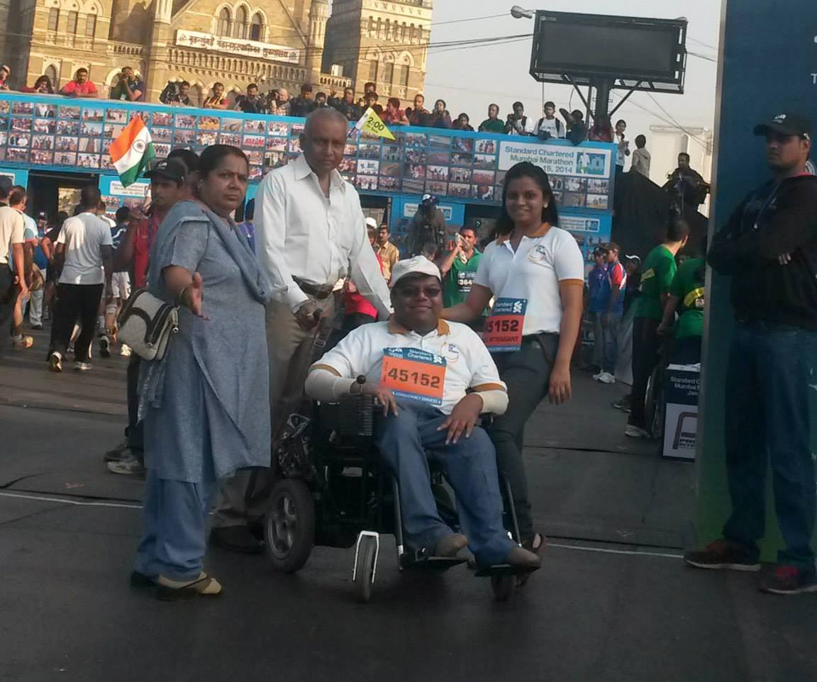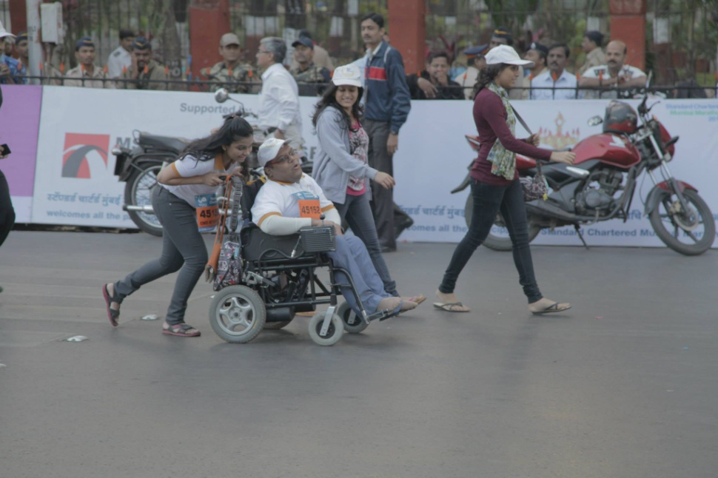‘’Champions with Disability Category’’ in Mumbai Marathon is about participation. A collective group of wheelchair users, crutch-users, visually impaired, paraplegic coming out in public and making ourselves heard in the ignorant society. It's about representing yourself on a race track as contestants or about NGOs with their missions of a social cause. 2.5 km of the road lined with all the people cheering on. It's great to see thousands of Mumbaikars standing and cheering differently able people. Bollywood celebrities cheering us on, I had an opportunity to have a quick chat with John Abraham and meeting the actress Dia Mirza at the end of the race.

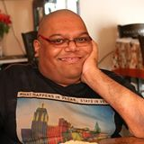Hats off to Standard Chartered Mumbai Marathon team who handled Champions of Disability category in a world-class manner. The special parking lots, accessible toilets, volunteers co-ordination, after race refreshments were one of the finest to offer for any contestant of this category.

*(Santosh R. Shriyan.*

*Wills On Wheels*

*Know me more at sanstormspress.wordpress.com)*

# Build your inner resources

In building up internal resources, you will find that you have become calmer, happier, and much less needy. In spending a little time on yourself, you will find that you would be able to give back much more.

Some tips, for building up your own inner resources:

* Take care of yourself physically. Not feeling your best will make it much easier for life to bow you down. Eat healthy foods, exercise, and make sure you are getting enough sleep.
* Give yourself some quiet, solitary time each morning. Spend this time doing whatever it takes to renew you spiritually. If you don’t pray, then watch the sun rise, do some yoga, or just take a quiet walk.
* Forgive yourself. Being angry towards yourself or others uses up your resources and exhausts you. If we dwell on past mistakes we are more likely to repeat them. Examine why you did what you did at the time, and understand that you did the best you could with the resources and understanding that you had.
* Question negative thoughts. Any thought or assumption that doesn’t feel right should be questioned. Ask yourself why you believe that – is it helping you or hurting you?
* De-personalize every interaction. People’s words and actions are manifestations of misunderstandings and fears that the other people have. Just understanding this can help you to be less afraid, less defensive, and more understanding.
* 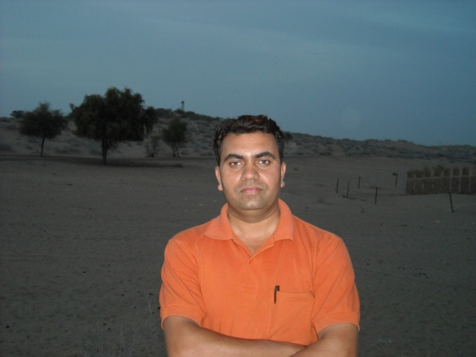Practice asking questions. Be curious about others. Practice gently asking for clarification. In clarifying, the other person will be more likely to see their misunderstandings, and you will be able to de-personalize the situation.

*(Contributed by Rajendra Maurya*

*Team, Cross the Hurdles)*

# व्यक्तित्व = शरीर ,मन, बुद्धि और आत्मा

हमारे ऋषियों का मत है कि मानव एक ही समय में शारीरिक रूप में जीने के साथ-साथ सुन्दर -विचारों एवं पवित्र- आदर्शों का जीवन भी जीता है|मानव के विचार ही उसके व्यक्तित्व का दर्पण होते हैं.

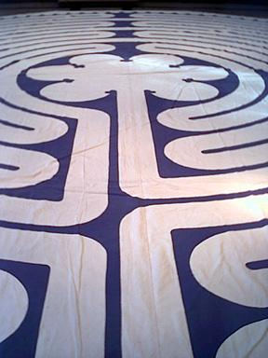हमारा जीवन अनुभवों की एक अनवरत धारा है. जब व्यक्ति संसार के संपर्क में आता है, तो उसकी प्रतिक्रियाएँ ही उसके अनुभव बन जाती हैं –कुछ खट्टे और कुछ मीठे |इन्हीं खट्टे- मीठे अनुभवों के परिप्रेक्ष्य  में जब हम किसी बाह्य वस्तु के संपर्क में आते हैं तो हमारा वह अनुभव हमारे व्यक्तित्व की चार इकाइयों के रूप में होकर पूर्ण होता है- शरीर ,मन, बुद्धि और आत्मा |व्यक्तित्व की इन चारों इकाइयों में  जितना अधिक सामंजस्य एवं एकता होगी ,हमारा व्यक्तित्व भी उतना ही सुदृढ़ होगा.

 जीवन में कभी-कभी इच्छाएँ पूरी हो जातीं हैं ,सपने भी पूरे हो जाते हैं लेकिन बौद्धिक-स्तर पर  हम संतुष्ट नहीं हो पाते और कभी शारीरिक, मानसिक तथा बौद्धिक इन तीनों स्तर पर संतुष्ट होने के बावजूद भी एक अधूरेपन का अहसास हमारा पीछा नहीं छोड़ता. हम किसी भी परिस्थिति में प्रसन्न नहीं रह पाते क्योंकि हमारे व्यक्तित्व की चारों इकाइयां शरीर ,मन ,बुद्धि और आत्मा एक –दूसरे के साथ सामंजस्य स्थापित न कर सकने के कारण, एक दूसरे की विरोधी होकर हमें अपनी–अपनी ओर खींचती हैं |परिणामस्वरूप ,हमारी शांति ,हमारा सुख ,हमारी प्रसन्नता और हमारा आनंद – सब कुछ धीरे –धीरे बिखरने लगता है. पर हम तो ईश्वर की सर्वश्रेष्ठ रचना और बुद्धिजीवी हैं ,ऐसे कैसे हार मान सकते हैं? हमारे लिए तो हमारे ऋषियों ने परिस्थितियों के ‘स्वामी’ बनने का स्वप्न देखा है ,हम उसे निष्फल कैसे जाने दे सकते हैं? हमारे शारीरिक ,मानसिक तथा बौद्धिक रूप से शांत क्षणों में भी एक दबी हुई निःशब्द पुकार हमारे अंतरतम की गहराई से उठती है. यह पुकार इतनी गहरी तथा तीव्र होती है कि उसे नकारा भी नहीं जा सकता. इसी का नाम आध्यात्मिक पुकार है.

प्रसन्नता, सुख , समृद्धि, शांति एवं आनंद की इच्छा किये बिना हम रह  नहीं सकते। इसलिए तब हमें चाहिए कि हम अपने अनुभवों को परख कर अपनी आध्यात्मिक पुकार को सुनकर ,बुद्धि से यह निश्चित कर लें कि इस लक्ष्य मन का संकल्प की प्राप्ति के लिए जीवन में कैसे प्रयत्नशील रहें | हम सब सुन्दर विचारों और पवित्र आदर्शों की आधारशिला पर गर्व से खड़ा ‘जीवन’ जी सकें और अपने जीवन में आनेवाली प्रतिकूल परिस्थितियों में भी हमारा व्यक्तित्व सुदृढ़ बना रहे ऐसा हमारा प्रयास होना चाहिए.

# 

# मैंने जीना सीख लिया है (कविता)

  
हे ईश्वर !  
माँ के आँचल से निकलकर  
कुल चार कदम चली थी मैं  
तुने मुझे क्यूँ नजरों से गिरा दिया?  
दरिया में गिरा, भवरों में फंसा दिया  
उबरना चाहा उबरने न दिया  
डूबना चाहा तो डूबने न दिया  
सबकुछ तुझको हीं तो सौंपा था  
तुझपर हीं सबकुछ छोड़ दिया  
पर तुने  
तुने क्या किया?  
पुर्णतः घायल हो चुकी थी मैं  
न ताकत न हिम्मत थी की  
उठकर मैं चल भी सकूँ  
चलने का नाम हीं जिन्दगी है  
और मैं जिन्दगी घिसट रही थी  
अनायास आँखें फलक पर  
टिक जाती थी  
दुआ में दोनों हीं कर  
उठ जाते थे  
बेबसी से मैं दामन  
फैला देती थी  
हे ईश्वर, या खुदा  
अपने पास बुला ले  
ऐ गगन लील ले मुझको  
धरती खुद में समां ले  
पर था कौन सुनने वाला यँहा?  
नक्कारखाने में तूती कि  
आवाज़ थी मैं  
अश्कों के अपने दरिया में  
बस बह रही थी मैं  
कब तक? आखिर कब तक?  
बेरुखी सहती मैं  
फ़रियाद हीं करना छोड़ दिया  
तुने मुख मोड़ा था  
अब मैंने मुख मोड़ लिया  
अरमानो को जलाकर  
रौशनी लाना सीख लिया  
अश्कों कि दरिया में  
कागज़ कि कश्ती बहा  
दिल बहलाना सीख लिया  
तेरे अभिशाप में भी  
मैंने जीना सीख लिया  
मैंने जीना सीख लिया है

*(अलोकिता, एक विद्यार्थी) 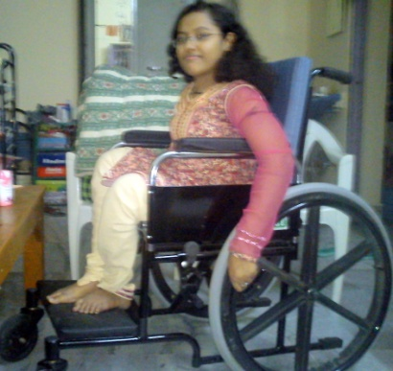*

# ना खुश हूँ मैं ना उदास हूँ….(कविता)

ना खुश हूँ मैं ना उदास हूँ   
ना रहनुमा कोई ना रकीब है   
अजब इतेफाक़ सुकून में हूँ   
ये उल्फ़ते राह भी अजब सी है   
ना बिछड़े वो ना मैं साथ हूँ   
  
ना   
जो तलाशते रहे उम्र भर   
उन्ही रास्तों में सदा से हूँ   
ना मंज़िलें ना कोई कारवां   
बस बहते हुए दरिया में हूँ   
  
ना   
अहले दिल का गिला भी क्या   
इसी के हाथों लुटा भी हूँ   
कुछ तुम भी कह दो हाल-ऐ-दिल   
तो सुकून से थोड़ा जी भी लूँ   
  
कभी कशिश है कभी उलझने   
बदहवास सा सदा से हूँ   
तुम बदल गए तो बदल गए   
मैं तुम्हारी चाहतों में लुटा सा हूँ   
  
ना   
ज़हन में ख्याल फिर भी है   
जुड़ा हूँ तुझसे तो कुछ खास हूँ   
ज़ख़्म-ऐ-दिल से गिला नहीं   
उसी के सोज़ से जीता हूँ   
पलक में आह अश्क़ बनी   
अश्क़ों से लबों को सीता हूँ   
गर मिले हबीब तो अच्छा है   
वरना मैं कातिलों में खुश सा हूँ     
  
ना   
कट जायेगी फ़क्त ये उम्र भी   
इश्क़ की इस रवायत में ज़िंदा हूँ   
वो मिलेंगे मगर ना कभी मुझे   
अब तलक उन्ही की तलाश में हूँ   
बेकार हैं ख्यालात मगर   
इन्ही सवालात मैं खुश सा हूँ

*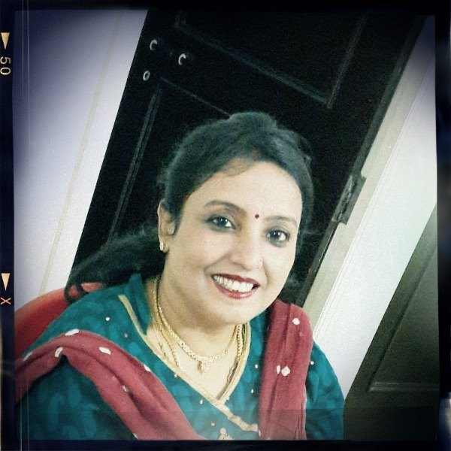*

*(श्यामली रस्तोगी, स्त्री रोग विशेषज्ञ… इन्होने पोलिओ होने के बावजूद भी घंटों खड़े रह कर अपने मरीज़ों का इलाज किया है)*

# लघु उपचार

दाद, खाज, खुजली, फोड़ा, फुंसी या अन्य किसी भी प्रकार की चरम रोग के लिए तुलसी के पत्ते और नीम के पत्तो पीस कर लगाने से सभी प्रकार के चरम रोग समाप्त हो जाते है.

फेफड़ो से सम्बंधित जितने भी रोग है उनके लिए अजवायन सूँगने से लाभ हो सकता है. अजवायन को गर्म करके सुंगने से श्सन, जुकाम, खासी की व्यवस्था प्रथक हो जाती है.

यदि पेट में कोई घाव हो जाये या आमाशय में कोई घाव हो जाये तो सीधा सा उपचार है थोडा सा दही ले उसमे इलायची, मिश्री मिलाये और बेल के पत्ते को पीस कर मिलाये और मरीज को पिलादे ऐसा सात दिनों तक करे.  सात दिनों में ही कटाव की जो व्यवस्था है वो खत्म हो जाएगी।

यदि किसी के बवसीर हो जाये तो नारियल की जटा को जलाये और जलाये पश्चात उसकी राख को छान ले, थोड़े से दही में मिलाये साथ ही उसमे बेल का पत्ता, तुलसी का पत्ता, इलाइची और मिश्री इन सभी को मिलकर सुबह -२ पिलादे सात दिनों में ही बवसीर खत्म हो जायेगा.

मधुमेय का सीधा सा उपचार है कि करेले का रस निकाल ले और नियमित सुबह और शाम एक गिलास ले.

गांठ, बालतोड़ हो जाने पर थोड़ी सी मसूर की दाल ले उसे जल में भिगो दे बाद में उसमे से एक मुठी निकले बांटे, उसके बाद पश्चात उसमे सरसों के तेल की एक बूँद डाल कर गर्म करे और गांठ पर लगा दे. वह गांठ ही खत्म हो जाएगी.





