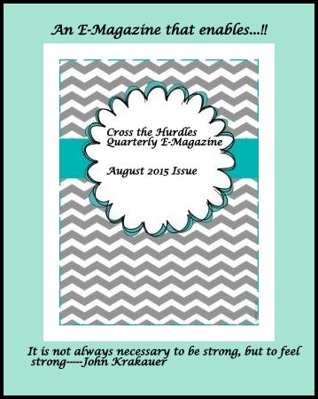

Contents
Editorial 4
Interview of the quarter 6
Thank God… I Failed… 10
Poem of the quarter 12
Why so serious? 14
News of the quarter 16
Women Who Made Us Proud 17
Ira Singhal 17
Beno Zephine 18
Expert Speak 19
Career Guidance 19
Career Opportunities 21
Positions vacant 21
Students’ Corner 23
National Scholarships for persons with Disabilities (2015-16) 23
Quote of the quarter 27
Disability and Driving 28
Nutrition in Multiple Sclerosis 31
Survey report 33

August 2015 Issue

All Copy Rights Reserved

Editorial
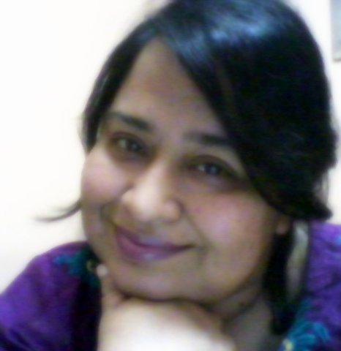
We are very happy to be back with our Cross the Hurdles Quarterly E-Magazine. A lot has happened in this one year, not only in the disability sector but also throughout the world.
One thing remains the same is my happiness when I sit down to write Editorial for this magazine. I always feel my inner voice talking to you while writing.
We really feel glad to inform our readers that from this issue we are going have a new section about Career Guidance and Career Opportunities for persons with disabilities. Students with disability have a higher dropout rate when it comes to succeeding in schools, colleges and universities. They not only face difficult but also complex situations when entering into labour market. This is because they do not come across the normal pitfalls. They confront number of barriers while establishing a career. So it is at the onset of establishing a career path that the career guidance teacher emerges as an important aide for the students. Due to many complexities, students with disabilities need the support of both their families and the employers. The employers are required to develop a receptive employer culture, and parents must instil more confidence in their sons and daughters
We would be publishing few vacancies every quarter with by collaborating with a jobs portal Jobs For Disabled.
I hope and pray that this proves beneficial for all.
Keep us updated with your valuable comments and feedback in the form of Letter to Editor. We would be more than happy to publish your letters.
Happy reading!!
Abha Khetarpal
(Chief Editor)
President Cross the Hurdles

Interview of the quarter
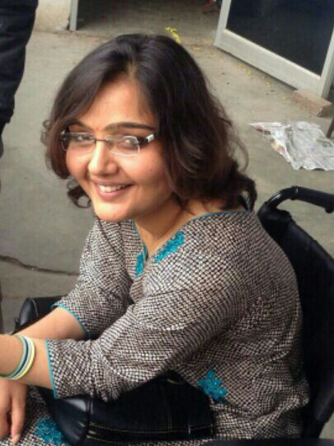
In this quarter we bring you a heart to heart talk with Ekta Bhyan. Ekta had spinal cord injury when she was 18. Let us see how she managed to come out that trauma and have accepted a life with disability. Ekta got selected in Haryana Civil Services as an Assistant Employment Officer. Ekta has worked really hard to cross every hurdle coming her way. Let us see what she has to tell in her own words…..
Tell us about your life after spinal cord injury?
Life took a dramatic turn upside down. I was 18 years old and had dream of becoming doctor, so moved to Delhi for PMT coaching. But destiny had some other plans and I met with a fatal accident on the very first day of coaching as an overloaded truck hit my stationary car. The accident resulted in spinal cord injury at c5-c6 level, means neck down paralysis. I could move neither my hands nor my legs and had to learn every single and simple activity like sitting, eating, holding things etc from all over again. The trauma was not only in physical terms but also at mental front, as initially acceptance was the toughest task and dependence for every single need was painful. I had to give up my dream career. A feeling of helplessness and worthlessness was there but I am blessed to have such supportive parents who always keep me motivated at every stage. With them I moved ahead in life and gradually resumed the life again. Their care and concern made my life possible to look forward.
How did you manage your higher studies after injury?
I had passed class 12th with medical stream at the time of accident. After injury, for a year I couldn't study as 9 months were spent in hospital. After discharge from the hospital, I enrolled myself in Government College, Hisar, in B.A. (English Honours) course. But it was not possible to go to college daily. I talked to the teachers and I was allowed to have classes as per my convenience (Till today I feel so grateful to them for the way they co operated). With the support of teachers, friends and self study I completed my graduation with 76%. Then I took admission in M.A. (English) in the same college and also completed B.Ed. After that I started preparing for competitive exams and qualified Teachers Eligibility Test and Haryana Civil Services( PRE) but couldn't make it to the mains. I tried again and this time my efforts paid. I got selected in Haryana Civil Services as an Assistant Employment Officer.
How have your family members supported you?
What ever I am today is all because of my parents. The credit of all my achievements goes to them. They have always kept my spirits high and motivated me to do best in every situation. Having a disabled child is not an easy job. Helping in every single task at home, visiting doctors and accompanying to the examination hall, every time they have been with me. Their unconditional love and support makes the things easier. I am blessed to have them.
Tell us about your professional life?
I am working as an Assistant Employment Officer at Hisar. I am happy with my job as I am contributing towards society in whatever way I can. Implementing the government policies in the society and working for the welfare of lower strata give immense satisfaction. The office staff is also co operative.
Do you encounter any accessibility issues in your workplace?
The office is on ground floor. So, no major accessibility issues except few inches height at every entry.
Have your office people provided you with any special accommodations?
No, not as such no special accommodation has been provided.
What do you aspire for?
I want to work for the upliftment of persons with disabilities especially who belong to poor financial background as they are the most neglected and underprivileged section of the society.
Where do you see yourself after 5 years from now?
Career wise, I would be probably at a better place and contributing more towards the society. And now a days, a new interest of playing table tennis has developed in me, so may be something in that field too I want to attain, though it is just a beginning and will have to work a lot in this direction.
What message would you like to give to the people with disabilities?
We should take the reigns of our lives in our own hands, accepting our strengths and weaknesses and strive for better under any circumstances, instead of waiting for others' help. Life is not our hands but living is and we can always make it better. And to achieve this, I think education is the best and easiest way as it not only gives financial security but also an awareness of our rights. So, every one must educate themselves.
What is your opinion about the notion of double discrimination of women with disabilities? Have you ever faced any? (Discrimination on the basis of gender and on the basis of disability)
Though personally I have never faced any such discrimination but I have observed this in the society. In our society where a girl is considered a burden and if she is disabled, she is considered a huge liability and stigma. She is not allowed to pursue education outside home or the things of her interest; and family feels shy of taking her to public places. A change of perception is required towards disability and especially towards girls. First, society needs to accept that there is an existence of disabled people and they should be treated at par, as it is their right to avail equal opportunities and to be a part of nation's growth like any other citizen.

Thank God… I Failed…
In retrospect, I feel much grateful for the invaluable learning that some of my biggest failures, losses and struggles provided me. They had greater and far reaching impacts in my life than my successes.
I would actually like to call my successes boosters or stepping stones that can help me catch up with my breath, become stronger and more courageous to get prepared to face even bigger failures as my life moves along.
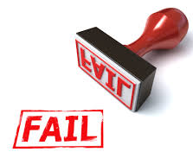
I always feel human life is like a river and I wish to live it that way, to enjoy the surprises the next moment may bring; reflecting its true spirit of flowing continuously and exuding divinity. Sometime it brings me blooming flowers to light up my day and on some occasions it pounded big boulders on me.
When a river originates from the pristine wilderness, it is in its purest form just like how pure we were when we were born. As the river flows, it takes all it possibly can along its paths similar to our pursuit of learning and getting educated. Sometimes it changes its course when it meets a boulder it cannot move. Likewise, our lives too change when we meet with things that are not in our full control and cannot be changed. All along its journey towards the ocean, it passes through lots of places and people of different culture, color, character and creed. Some respect it; some even worship it; while some tread it and consider it a drain to just wash their sins off. Similarly, we too come across many people in our lives. Some care for us and respect us; some support us during our struggles while some just fly off after benefiting from us. Nevertheless, like a river, our lives continue to move on and they must do so.
I just love the sound when a rock or boulder impedes the flow of a river and the same way, I learn (and am still learning) to love the overall experience when going through difficult times considering the value of the learning.
I learnt so much from my failures and losses and while enduring my struggles than enjoying in my so-called successes. Those moments when I felt completely lost and worthless; when I was the most embarrassed; and when I was in utter despair are vivid in my memory and will remain so till my lifetime. I value these difficult moments much more than the intermittent joyous occasions of successes that I enjoyed in the past and expect to have in future.
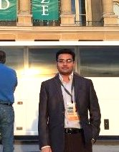
It doesn't matter what I get tomorrow - blossoms or boulders - but I like to live my life flowing like a river and be thankful to God for giving me failures and losses only to emerge a better human being from my hardships.
So, God!!! Thank you.... I "FAILED"

(Raghavan Sampathkumar was born and raised in a rural town in Tamil Nadu. He chose to study agriculture. Currently he is in Singapore. His hobbies and interests are diverse which include singing, performing on stage and writing.)

Poem of the quarter

And so she decided to step out of the house with a valiant heart
She gasped her wheelchair
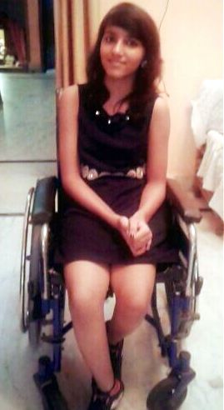
Sat on it with a thought of a new start
It was raining outside,
Beautiful pearl like drops touched her alluring face
Despite sitting on her chair
She danced with grace
She stopped at once
She realised the drops were no more falling away
She wheeled further
Exploring everything once again in a new affirmative way
A jovial smile she had on her face
That could force anyone to gaze
Woefully that smile vanished
When she entered a bunch of moronic people,
Everyone was staring at her some from windows, roofs nd even from steeple
Confused she was
Was it her charming smile that made everyone gape at her?
Later she perceived it was the wheelchair.......
Those starving eyes made her lose her confidence again
She was about to wheel back but recalled why she had stepped out
She could hear her inner voice shout
She was devastated but knew going back was a wastage
She knew no one could ever understand how she felt
And so she tightened her belt
Brought back that jovial smile
And moved further with a pride
(Srishti Panday, a class IX student, is a promising student and jovial and vibrant girl. She loves to write and wants to be a psychologist).

Why so serious?
Sitting in the garden with newspaper and a cup of coffee is what satisfy us. This is known to be the reality of world that we all want to stay up to date with world but when it comes to us, we forget that there is something inside us. I was sitting in the garden motionless like a statue. Maybe I was smiling, or maybe I was crying, and to be honest I didn’t notice. I was simply staring the sky because it was blank unlike my documents, my newspaper, and my books and so on. Suddenly a beautiful creature in the sky drew my attention. It was simply a bird but I was so busy since last 25 years to observe its beauty. During my youth I was busy in understanding the way of surviving and after that I was busy to win the battle of life though life never asked me for this. I wondered how lucky these birds are, they have no boundaries to cross, no luck to blame, no battle to fight, no task to complete, nothing. In a moment, human race has become the most difficult thing on the earth. May be it is true because we are equipped with brain. Next day I was travelling to office and it was raining heavily, I reached office and I was parking my car. Just few steps away, there were few young birds roaming. Just out of my curiosity, I went there to watch them and found a dead bird with shattered nest. It was of no use to see them, so I just ignored and returned to my office. If you can’t face it then just ignore, best solution invented by human beings ever. Few days back, I was praising the life of birds and now I was afraid to see that struggling bird. I can’t even imagine the time when I will be dead on the road and my belongings scattered around me. Even I am not ready to encounter my own death. On that day, I understood that God has made everything with its own advantages and disadvantages. What I see and I think, what most of us use to see, is disadvantages. Ok, yes I accept that I am a negative person, but why am I negative? Is it my parent’s fault? Is it the fault of my surrounding? Ohh! Little asshole, your surrounding and your parents are happy so how they can pump negative thoughts in you. In the whole story, from beginning to end, you are just blaming to protect yourself. The reason of dissatisfaction is you yourself. Most of us are spending 80% of our lives in doing work what we dislike and we expect that this should give us satisfaction. Am I fooling myself by expecting this? When I was young I use to pursue my happiness by doing what I want to do. Nowadays I play football daily after my office hours and I feel happy because this had been pending since many years. Go and do what you want do. How can you serve best out of your dissatisfied body? I think my boss is calling me and I have to stop it here otherwise he will ask me to stay back extra in the evening. Go and do what you want do otherwise you won’t be able to do what you have to do.
(Sidharth Taneja is A Cavincare awardee and is working for Makemytrip.com and a Cavinkare awardee. He also delivers motivational lectures. He has cerebral Palsy. He is a valuable member of Cross the Hurdles)

News of the quarter
The Directory of Aids and Assistive Devices for Persons with Disabilities (PwDs) is an online repository of information built as a result of an initiative of the Department of Disability Affairs under the Ministry of Social Justice and Empowerment, Government of India to collate exhaustive resources around assistive technology on a single platform.
The portal aims to –
1. Facilitate the users & their families with the explicit knowledge of all the available assistive technologies and their makers under the one roof for their easy pick and choose.
2. Compile and disseminate information about the latest research in this field and identifying the challenges and gaps in the research leading to a paradigm for the Development.
3. Provide information on the upcoming products, both nationally and internationally.
4. Facilitate support and interaction for a multi-stakeholder engagement between PwDs and the families, the manufacturers, researchers and developers of assistive technologies, organisations working with PwDs to access assistive devices and the government systems.
For more information visit: http://swavlamban.info/index.php/en/

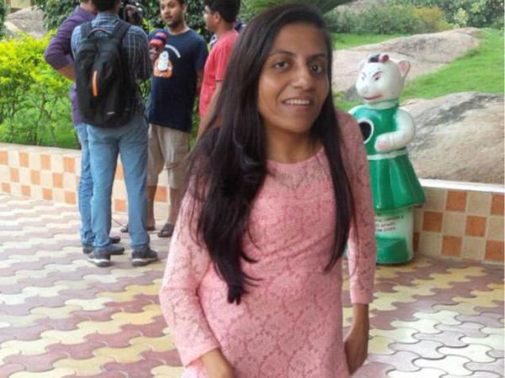
Women Who Made Us Proud
Ira Singhal, 31-year-old, recently topped India's prestigious and tough civil services examination. Ira Sighal is a woman with disability. She has scoliosis i.e. an abnormal curvature of the spine.
Ira in her own words, ‘’I have never felt "different" or been treated differently because of my physical appearance’’.
After not being able to get posting in the year 2010, she gave the test twice afterwards because she wanted to improve her rank. This is her fourth attempt in which she has topped the examination.
The Delhi girl is currently posted as Assistant Commissioner in the Customs & Excise department of the Indian Revenue Services, but will likely move to an IAS posting soon. Ms. Singhal has earlier worked as a Spanish teacher for a year, as well as a manager in Cadbury India and a marketing intern in beverage giant The Coca Cola Company.
She holds an MBA in Marketing from Delhi University's Faculty of Management Studies (FMS), and a BE in Computer Engineering from Netaji Subhas Institute of Technology (NSIT).

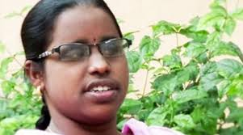
Beno Zephine is 25 and she made history when she became India's first 100 per cent visually challenged person to be inducted into the country's elite Indian Foreign Service (IFS).
After school, she joined Stella Maris College to do my degree in English literature. She did her post graduation in English literature from Loyola College.
She secured 343rd rank in the 2013-14 Civil Service examination
As soon as she completed her MA, in 2013, she got a job as a probationary officer with SBI.

Expert Speak

Career Guidance
Welcome to this new section of our E-Magazine. From this issue onwards we would be providing Career Guidance. So let us start by looking at the need for career guidance.
Career guidance is objective as well as strategic. One could get a clear picture what ones goal should be or must be. Little career guidance offered at schools. Career guidance gives learners a platform to make meaning of their existence by constructing careers that will help them carve out worthwhile livelihoods It is also a valuable tool to teach disabled learners about their rights as a prospective employee.
Disability normally translates into less advantageous career options because of the barriers prevailing everywhere in the society as well as the environment. Students with disabilities mostly learn in ‘special settings’ and have segregated learning experiences. This results in limiting their social development, problem solving and decision making skills. Many times they are not even allowed to express their choices, likes and dislikes. They have negligible exposure to world of work and there is complete absence of role models. They have less career exploration opportunities.
Persons with disabilities are seen to possess inadequate, unrealistic and irrational occupational beliefs. They have poor work culture in the presence of lack of responsibility and commitment. They are made to believe that work for them is only means to pass time. Thus work for them is not a means of self satisfaction, self realization and strengthening knowledge.
But present day occupational settings require decision making and management skills. Career guidance can play an important role in matching what is required and what actually a person possesses.
Career guidance can help a person with disability in deciding the direction of actions and achievement or desired goals. In short career guidance can assist an individual with the attribute of self determination.
Abha Khetarpal
Counsellor for Students with Disabilities
President
Cross the Hurdles

Career Opportunities

Positions vacant in organization across different locations in India for individuals with different disabilities are:
Job Title | Disability | Location | Organisation | Link
Customer Care Executive/Practitioner Non-Voice Process | Locomoter Disability | Haryana | Concentrix | http://jobsfordisabled.org/job/concentrix-haryana-33-customer-care-executivepractitioner-non-voice-process-gurgaon-2/
Tele-caller | Visually Impaired | Tamil Nadu | Can Do | http://jobsfordisabled.org/job/can-do-tamil-nadu-30-telecaller/
Customer Care Executive Voice International Process Pune | Locomoter Disability | Maharasthra | Concentrix | http://jobsfordisabled.org/job/concentrix-maharashtra-33-customer-care-executive-voice-international-process-pune/
Customer Care Executive/  Practitioner | Locomoter Disability | Haryana | Concentrix | http://jobsfordisabled.org/job/concentrix-haryana-33-customer-care-executivepractitioner-gurgaon/
Web Search Assistant | Hearing Impaired | Tamil Nadu | Can Do | http://jobsfordisabled.org/job/can-do-tamil-nadu-31-web-search-assistant/

Vacancies posted by Jobsfordisabled.org
Jobsfordisabled.org is a not for profit organisation operating from Delhi-NCR. Their team brings together employment opportunities for professionals with disabilities. They can upload their resumes and apply for jobs at the site. The employers too can post jobs and find suitable candidates there. For more info write to then at info@jobsfordisabled.org
Those interested in above mentioned jobs must send their resumes to Jobsfordisabled.org

Students’ Corner
National Scholarships for persons with Disabilities (2015-16) is introduced under the supervision of Ministry of Social Justice & Empowerment, Govt. of India), intended to promote higher education across the particular class.
This scholarship is for candidates with disability who are presently in Class 11/diploma or higher (upto Ph.D) and pursuing Technical or Professional Courses in recognized institutions.
On availing this scholarship, students with disabilities will be imparted with financial assistance for selected courses.
National Handicapped Finance and Development Corporation( NHFDC) is responsible for the allocation of this scholarship.
Applicants must be with at least 40% disabilities certified as per the definition under Persons with Disabilities Act 1995.
Under the scheme 500 scholarships are offered every year to students with disabilities. Scholarship will be awarded to one student for pursuing only one course. Awardees can also apply for the renewal of the scholarship after the successful completion of first year of the course.
The applications for the fresh application or renewal of the same should be received by the concerned department on or before August 31, 2015.
Different category of disabled students can apply for the scholarship considering the applied criteria.
Academic Qualification:
Students currently enrolled in post-Matric/Post-Secondary technical and professional courses including Ph.D & M.Phil in recognized institutions are eligible to apply for the scholarship.
Students with specific disability: The minimum education qualification for students having Cerebral Palsy, Multiple Disabilities, Mental retardation and Severe Hearing disabilities is class 8 and scholarship will be offered to pursue general, technical, vocational or professional courses.
Monthly income of the beneficiary inclusive of parent/guardian income should not be more than Rs. 15000.
Eligibility for Renewal of Scholarship
Students successfully completing the professional courses in the preceding year with 45% marks and students attaining 40 % marks in other courses can apply for the renewal of the scholarship.
Other Eligibility criteria
Student can avail the scholarship for commencing only one course at a time.
Awardees cannot experience benefits of other scholarships while using the National Scholarships for persons with Disabilities (2015-16)
In case of being already awarded with any of the scholarship or stipend, student has to inform the awarding authority about the same
Minimum Duration of the course: Courses undertaken by the students must be of 1 year
Documents to be sent with the Application form:
- The Application form should be counter signed and recommended by the head of the institution and it should be sent along with the following documents (attested copies only)
- Academic records (attested copy of certificates and Mark sheets - matric & above)
- Family Income Certificate/ Proof of annual income, e.g. Salary Slip, last Income tax Assessment order.
- Attested copy of Disability Certificate.
- Course fee receipt (if any): Receipt of the course fee paid during the session with complete breakup.
- Hostel Certificate or certificate from the house owner in case of accommodation hired by at least by a group of 3 students living together with common mess arrangements
The application form in the prescribed format along with other documents has to be sent to any of the following address:
National Handicapped Finance and Development Corporation
Ministry of Social Justice & Empowerment, Govt. of India
Red Cross Bhawan,
Sector-12,
Faridabad-121007(Haryana).
OR
National Handicapped Finance and Development Corporation,
PHD Chamber of Commerce & Industry, PHD House,
4/2, Siri Institutional Area, August Kranti Marg,
New Delhi – 110016.

Quote of the quarter

“In order to succeed, your desire for success should be greater than your fear of failure…………..”
Bill Cosby

Disability and Driving

The availability of public transport that is accessible to anyone with a disability varies greatly from town to town and sometimes from county to county. Only the ability to drive a vehicle can make unlimited freedom of travel possible for a disabled person.
Over the past few years, there have been many advances made in the area of adaptive driving equipment for people with disabilities. It is now possible for severely disabled individuals to operate a motor vehicle without leaving their wheelchair. Such advances as reduced effort steering systems for people with limited strength in their arms and head operated switches to activate headlight, horn, and other accessory controls for people with limited hand function are now readily available.
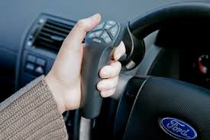
Driving involves more than the physical ability to operate controls. It requires adequate vision and the mental skills to process what we see in a manner quick enough to ensure safe efficient decisions are made by the driver.
An individual with a physical disability, seek the assistance of a driver assessment specialist. This is an individual who specialises in the field of driver evaluation and education for anyone with disabilities. The evaluation process usually includes tests of physical function, visual skills, reaction time, and mental skills as well as driving performance tests.
Based on the results of these evaluations, the driver assessment and rehabilitation specialist will decide what if any adaptive driving equipment you may need, whether you have the potential to drive independently and whether you need further driver training.
The range of adaptations that can be made to a car is extremely wide and there are very few people who are unable to drive as a result of physical disability. However, you should approach buying adaptive equipment in the same way you would approach buying a new car. By making competitive comparisons, reviewing the functional options, and seeing demonstrations.
In order to be issued a driver's license, you must show the licensing authority you not only know the rules of the road, but that you can safely drive a car without any hindrances or obstructions. This means special steering wheel hand controls, including throttle, braking, signalling and steering, must be installed.
Choosing the best car for your needs includes your decision whether a car is suitable you should look at:
- How wide the doors open
- The height of the seat from floor level
- How much leg room there is
- How adjustable the seats are
- If you need more adaptations, these can be made to most of the cars.
When choosing the make of car you must check:
- You can get into and out of the car
- You can store your wheelchair easily in the car
- If a car with automatic transmission would be better for your needs
The kinds of adaptations you might be able to have made to your car include:
- Converting foot controls so they can be controlled by hands
- Converting hand controls so they can be operated by foot
- Adapting the indicators, switches or fittings for opening doors and windows so you can use them more easily
- Adaptations that allow you to remain in your wheelchair while driving, although this may require you to have a special wheelchair.
If you need adaptations, get advice from someone who's experienced in fitting and using these adaptations
Rajendra Maurya
Team Cross the Hurdles

Nutrition in Multiple Sclerosis

If you have MS, you are at greater risk for being low in some vitamins and minerals, including the following:
Calcium and vitamin D
Some people with MS have low bone mineral density and are more likely to break bones or get osteoporosis. Getting enough calcium and vitamin D can help prevent osteoporosis. Good sources of calcium include:
- Milk products (milk, yogurt and cheese)
- Fortified soy beverages
- Tofu with added calcium
- Canned fish with bones.
- Good sources of vitamin D include milk, fortified soy beverages and fatty fish such as salmon, sardines and tuna.

Vitamin B12
Low levels of vitamin B12 can cause anaemia and make you feel tired. Foods that contain vitamin B12 include milk products, fortified soy beverages, eggs, meat, fish and poultry.

Selenium
This trace mineral is often low in people with MS. Good sources are Brazil nuts, seafood and fish.

Zinc
Zinc deficiency is common in people with MS. Good sources are meat, seafood, whole grains, dried beans and lentils.
In addition to eating the right foods, you may need to take vitamin and mineral supplements to get enough of these nutrients. Work with your doctor to learn how much (what dose) is right for you. There is no proof that taking very high doses of these nutrients is helpful, so make sure to follow your doctor’s advice.

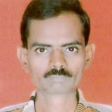
Survey report
A research study was conducted by Surendra Patil and he has sent us the survey report of his research work.
Survey of special recruitment drive at Kamayani Training & Research Centre, Gokhale-Nagar, Pune.
About Kamayani institute;-
KAMAYANI PRASHIKSHAN AND SANSHODHAN SOCIETY
Kamayani was set up in 1964. The word ‘KAMAYANI’ derived from Sanskrit, means faith, a great belief; A belief that comes from within and touches our souls. It gives us courage to face the world, confidence to achieve and helps in acceptance of the truth.
Kamayani was started by Mrs. Sindhutai Joshi and it is here that children’s are taught to have faith in self and in their abilities. Despite personal hardships and tribulations the founder Mrs. Joshi’s overwhelming loves for children of a lesser God-the ‘mentally challenged’ children, led her to make a humble beginning.
Her dedication for well over three decades has transformed the modest one room school into an institution recognized all over the country for the human services rendered to a much neglected segment of our society.

Children go to school till they are 18 years of age. But what after that? Where would they go?
They are not independent to go and work in the society on their own. Also, they might not get an understanding and supportive environment to work in. This lead to the concept of sheltered workshop.
Here mentally challenged persons are trained in various activities and skills which can help them rehabilitate.
Kamayani started sheltered workshop in 1977. It was recognized by government of Maharashtra, social welfare. In 1983, sheltered workshop got funds for a building from International Lions club.
Introduction ;- the rate of employment of disabled in private sector was a dismal 0.28% and in multinational Even though disabled people constitute a significant 5 to 6 percentage of the population of India, their needs for meaningful employment largely remain unmet, in spite of the implementation of the ‘The Persons with Disability’ Act 1995
The bleak scenario is of the approximately 70 million persons with disability in India, only about 0.1 million have succeeded in getting employment in the industries till now. In a survey conducted by National Centre for Promotion of Employment for Disabled People (NCPEDP) on top 100 companies companies
The Ministry of Labour and employment (2007-8) indicates there are 6,87,632 disabled people on the live register of the 81 Employment exchanges and special cells of the country
Importance of the survey regarding to following facts:
Education, vocational training and employment. They experience inequality in living, access to credit, and rarely participate in economic and vocational training, promote opportunities for self-employment, and calls for reasonable accommodation in the workplace. However, despite the fact that India is developing, young people still struggle to access decent work. Access to quality education, vocational training and employment are denied to millions of young persons with disability,
The pool of disabled people focuses on inclusive education, the number of educated persons with disability is gradually rising. Moreover, with technological advances and assistive devices, it is possible to skill this human resource pool to industry needs. This opens up an opportunity, therefore, for this target segment to contribute to India’s economy
There are several barriers for people with disabilities to enter the labour market. The challenges can range from their lack of education and training or a lack of financial resources which limit access to labour markets. Other reasons include the nature of the workplace or occupation and employer-perceptions of disabled people. Anecdotal evidence suggests that social protection systems can create incentives for persons with disability to leave their jobs and move on to the disability benefits.

OBJECTIVES OF STUDY;
- TO STUDY ABOUT HOW TO An employment portal should be set up:
- TO KNOW ABOUT There Is an opportunity to Skill the disabled for industry needs
- TO STUDY ABOUT SET UP Giving technical aid to training centres for persons with disability
- TO STUDY ABOUT THE COMPANIES WHO Some companies which hire disabled highlight the Business Case

ANALYSIS OF DATA

Reasonable adjustments in employment
Determining what is reasonable
People who meet the legal definition of disability may be entitled to reasonable adjustments.
‘A person has a disability if they have a physical or mental impairment, and the impairment has a substantial and long-term adverse effect on his or her ability to carry out normal day-to-day activities.’
Data outlines that, when considering what is reasonable, an employer should consider:
== How effective the change will be in avoiding the disadvantage the disabled worker would otherwise experience
== Its practicality
==The cost
== The organisation’s resources and size
== The availability of financial support

Further clarity of this definition is provided at Reasonable adjustments are required when disabled people experience substantial disadvantage in comparison with nondisabled people. The duty for employers to make reasonable adjustments applies for potential and current employees in relation to:
== A provision, criteria or practice, for example work patterns
== Physical features, for example the built environment or furniture
== Auxiliary aids, for example the provision of specialist equipment

The duty applies in recruitment and during all stages of employment.
An employer only has a duty to make reasonable adjustments if they know, or could reasonably be expected to know, that a person is disabled.
Findings;

Persons with disability
Some of the constraints persons with disability face in accessing labour markets are the following:

Low literacy levels:
Literacy levels are low among children of all categories of disability. Illiteracy is 52% among disabled versus 35% in the general population. 25 As with the overall population, there are strong gender differences in educational attainment among persons with disability, with female illiteracy being 64% against disabled male illiteracy of 43%. In rural areas, the schools are located at large distance; colleges are in the district headquarters. Added to this is the fact that in many schools are not equipped to cater to the special needs of the disabled because of infrastructure, accessibility and availability of special instructors. Many persons with disability youth invest in their education, battling family and societal barriers which do not encourage putting their limited financial resources into educating children with disability. Even in states with good educational indicators and high overall enrolments a significant share of out of school children are those with disabilities: Data also indicates that across all levels of severity, children with disability very rarely progress beyond primary school.

Government
- Job quotas ineffective so far
- Ineffective access to Persons with disability employment related data/information
- Awareness about benefits limited
- Training may not be market linked
- Limited success of programs

NGOs
- Scalability challenges for skilling and training model
- Lack of sustainable funding
- Lack of proper infrastructure
- Training quality
- Many in number but fragmented
- Sharing of best practices
- Instructor effectiveness

Companies
- Availability of skilled general category candidates
- Lack of necessary education and/or qualifications among persons with disability
- No efficient centre for sourcing Persons with disability
- Infrastructure
- Unwillingness / Unawareness

Persons with disability
- Lack of accessible education
- Impact of disability / logistical barriers
- Lack of encouragement from family and society (Social stigma)
- Limited interaction
- Fast pace of environmental changes

References
- 22Maureen Gilbert, Solution Exchange for work and employment community, Query: Access to decent work for Persons with disability, Compilation 19 August 2010.
- 23 http://www.vabir.org/tilting-at-windmills/, Vermont Association of Business, Industry& Rehabilitation, accessed March 2012
- 24Prof. Mukta Kulkarni, IIM, Bangalore and Prof. Reimara Valk,Utrecht University, Netherlands, July 2011, Employing the disabled-Is HR part of the problemwww.iimb.ernet.in/newsletter/issues/
- 18 http://infochangeindia.org/disabilities/analysis/india-needs-new-legislation-on-disability-rights.html, March 2012
- 19 Singh, N, Forgotten Youth: Disability & Development in India, RECOUP working paper No.14, 2008.

(Surendra Patil is 40 years old and has orthopedic disability. He is pursuing masters in philosophy commerce, from B.M.C.C College, Pune University)

