

Contents

[Editorial 3](#_Toc373605065)

[Quote Of The Quarter 4](#_Toc373605066)

[Personality Of The Quarter 5](#_Toc373605067)

[No Market For Sorrows 10](#_Toc373605068)

[Discrimination At Many Levels 12](#_Toc373605069)

[मेरी वो चीज ढूंढ के ला दो 14](#_Toc373605070)

[We shall overcome 16](#_Toc373605071)

[DEVELOPMENTAL MILESTONES AND DELAY 18](#_Toc373605072)

[Nightmare Of A Parent 26](#_Toc373605073)

[अपस्मार या मिर्गी 27](#_Toc373605074)

[Diet Of People With Muscular Dystrophy 29](#_Toc373605075)

[Quashing hopes 31](#_Toc373605076)

[अक्षमों की अक्षय क्षमता 32](#_Toc373605077)

# Editorial

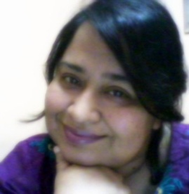When ever we talk about disability and its issues, the word ‘inclusion’ is always brought forward. An inclusive culture involves the full and successful integration of diverse people into a workplace or industry. It is not limited simply to basic representation; it indicates a climate in which respect, equity and positive recognition of differences are all cultivated and the social and institutional response to disability poses no barrier to a positive employment experience.

To bring the real kind of inclusion into practice following things need to be kept in mind:

* Keep an open mind.
* Take advantage of an individual's strengths
* Be open with the persons having disability and ask what their limitations are before trying to make accommodations for them
* Take advantage of the problem-solving insight that the persons with the disability have
* Avoid attitudinal barriers by creating opportunities for them
* Address concerns about everybody’s productivity, safety, insurance costs, and transportation
* Develop cooperative relationships with local resources, disability organizations, rehabilitation hospitals, independent living centers, and state agencies for vocational rehabilitation, the department of health, and the department of human services

Inclusive cultures extend beyond basic or token presence of workers who have disabilities. They encompass both formal and informal policies and practices, and involve several core values:

***Editor in Chief***

***Abha Khetarpal***

***Acknowledgement***

***Alokita Gutpa***

******

**Representation Receptivity and Fairness**

Abha Khetarpal

President

Cross the Hurdles

# Quote Of The Quarter

 ***is elegant in its simplicity and like love, awesome in its complexity. ….Marsha Forrest***

# C:\Documents and Settings\Alokita\Desktop\CTH Dec 2013\75082_585730488121069_626016025_n.jpgPersonality Of The Quarter

*Let us meet Ms Ummul Khair in this issue. She is an amazing personality who is not only strong but bold enough to raise her voice whenever she sees discrimination or violence of any kind. In spite of having Osteogenesis Imperfecta or Brittle Bone Syndrome, she has managed to stay independently and irrespective of the risks of having frequent fractures she is never scared to face the challenges of life. She is the voice of today’s youth and refuses to be bogged down by adversity of any kind.*

**Tell us about your childhood and student life. What types of hurdles you faced and how you overcame them?**

My childhood was full of struggles and hardship. My father abandoned us when I was just 10months old and came to Delhi, leaving us behind in Pali Marwar Rajsathan. My mother started teaching in a local school to make both ends meet but very soon she had to give up because of the unsupportive and conservative social set up towards a single mother, financial hardships and frequent fractures of me and my elder sister, (my sister also has the same disorder and she uses wheelchair).

My mother became schizophrenic and because of this she had to leave her job. It was catastrophic for us. This forced my elder brother, who was just nine year old at that time, to start working as a child labourer with the daily wage of Rs 10 for the entire day’s back breaking toil. Thus I spent my childhood in very impoverished condition. We could not eat chapattis for months, instead, we used to eat boiled wheat daily because after buying candle for our gloomy house without electricity, ten rupees could fetch that only. The situation became worse because of me and my elder sister’s frequent fractures. When my grandmother saw our problem, she asked my Delhi-based father to take care of at least one of us.

In 1996, I came to Delhi, at the age of 6. My father had re-married here. From the beginning, I was very fond of studies and always used to stand first in the class. My new mother was not very comfortable with it. By the time I reached 7th standard, I started giving tuition to the neighbouring kids to arrange the expenses of my studies. When I was in 9th standard, my mother refused to keep me at home with her so I had to take a rented accommodation in the nearby slum. I continued giving tuitions but teaching for 6-7 hours daily used to give me little time for my own studies. But somehow I managed to stand first in every class with 91% in 10th standard and 90% in 12th standard and I was elected Head Girl of my school.  
In my college, I became President of Debating Club. I started participating in debates and other elocutionary competitions organized by the leading colleges of Delhi University. I won more than 40 debates during my graduation. The fame and prestige that used to come along the trophy used to be just the byproduct for me. My major concern was the prize money with which to pay my room rent, my college fee and other bills.

In 2011, I was selected for a fully funded international leadership program meant for the youth with disability in Seoul and in 2012, I got the chance to represent Indian Youth with Disability in Rehabilitation International’s World Congress and Asia Pacific Disability Forum’s General Assembly in Incheon city, South Korea where Ban Ki Moon, the Secretary General Of United Nations Organization was also present.

My hard work and long struggle got acknowledgement when National Commission for Women GOI conferred National Extraordinary Woman award upon me for being the role model for young women, especially the women with disability on March 2013. Among all the eminent recipients from myriad of professions and fields, all over the India, I was the youngest.

Till now financing my studies is the biggest challenge after my disability but now I have cleared UGC-NET so I am eligible for being assistant professor in Indian Universities. The financial worries have been taken care of as I have got the prestigious Junior Research Fellowship in my subject of specialization International Relations.

**What courses are you pursuing at present and from where?**

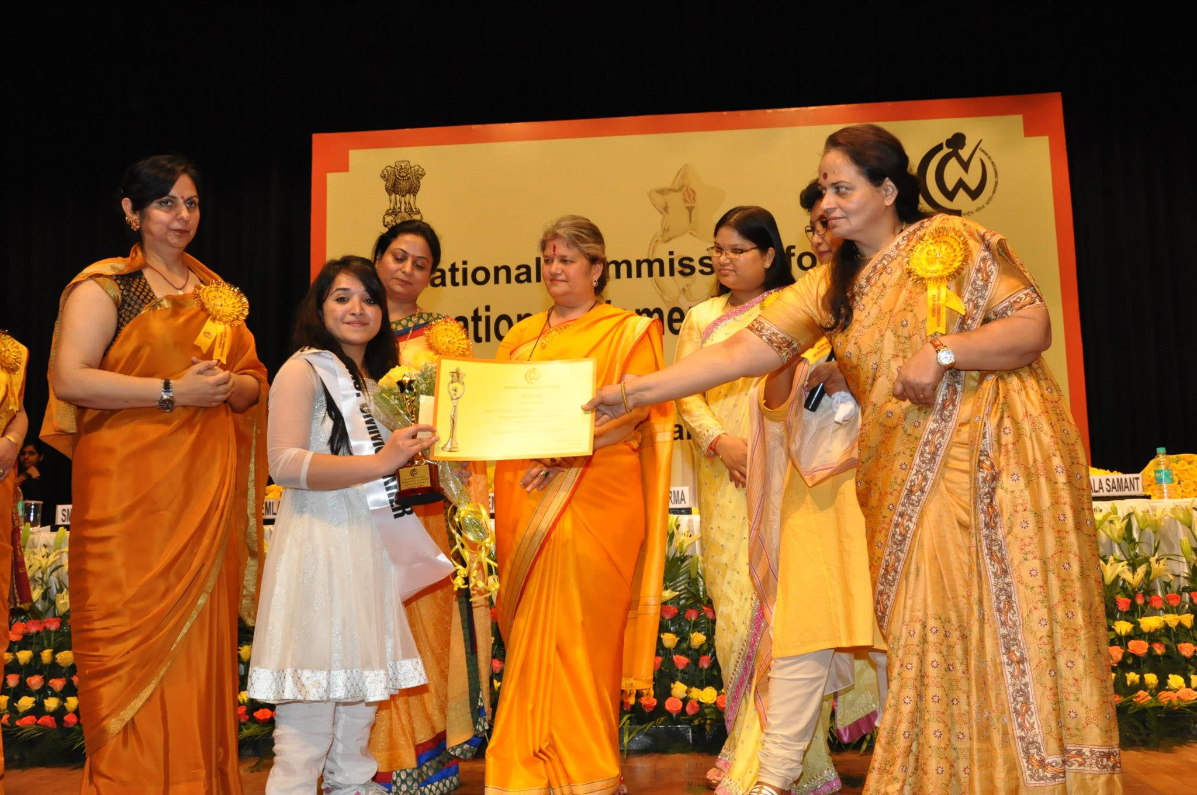Right now I am doing my M.Phil Research in International Relations (Area Study) from Jawaharlal Nehru University.

**Why did you choose this subject of study?**

I chose this subject because of circumstances. I was very interested in Applied Psychology and wanted to pursue my education in that subject only. But the problem was that the subject used to have a lot of practicals, fieldwork and the internships at the psychiatry department of the hospitals and it was so much time consuming and tiring that it became difficult for me to give time to my coaching classes. So I gave up the plan of doing Masters in Applied Psychology and took admission in International Relations at JNU. I had a good rank in the entrance exam so I got hostel accommodation easily. Leaving Psychology was a great pain for me but I was contented that I had got a place to live where I would not have to be afraid of indecent landladies and frequent shifting from one shanty to another.

**You say you are living away from family. Do you find any difficulty in living in a hostel or are you enjoying your hostel life?**

I was forced to live alone when I was just in 9th standard. The initial days were really torturous because I was not able to balance between my own schooling, my tuition classes and the household chores. The people around me were also not kind towards an abandoned disabled child.

Remembering my earlier struggles, the hostel life is a boon for me. It is very cheap so now I don’t need to give tuitions for hours to arrange for my food and room rent etc.

**Is your educational institution completely accessible or do you have to take help for doing various activities?**

Jawaharlal Nehru University in situated on the residuals of the Arawali Mountain ranges. One can assume the inhospitable contours and slopes on the roads which make the use of wheelchair almost impossible. During my fracture in 2012, I was not able to attend classes for the entire semester because of the over vastness of the campus and great distance between my hostel (Koyna) and the School of International Studies. I had to take help of my friends to push my wheelchair. Now when I have recovered and have started walking, I still have to take an auto rickshaw to reach the classroom premises. As far as the matter of accessibility is concerned, JNU infrastructure is not completely disabled friendly. After a series of hunger strikes and talks with the Vice Chancellor, finally a multimillion accessibility project is given to some experts, including Mr Gaurav Raheja from Indian Institute of Technology. But the work is yet to start. Fingers crossed.

**What is your opinion about the condition of females with disabilities in our country? What all can be done to improve their plight?**

In our Indian society where poverty and illiteracy is rampant, taking birth as a woman is itself sometimes very crippling and disabling and being a woman with disability multiplies these challenges many folds. They face triple disabilities, being a woman, being disabled and being poor as India is still a developing country. In our social set up, getting married and giving birth to children is considered the ultimate trophy for a woman, cutting across the various social strata, their social worth is majorly decided by this. I accept that if I would have been a boy, then living alone without any guardianship in sub-standard locality would not have been as difficult as it turned up in my case.

In India, women with disabilities are powerless, isolated, anonymous and vulnerable to abuse and violence. Their plight is worse than both, men with disabilities and women without disabilities. Violence faced by women with disabilities, lack of access to police and judiciary, exclusion from Violence Against Women (V.A.W.) related laws in India are some of the things which need immediate attention. I think along with the lack of infrastructures and facilities there is a dearth of rationality and objectivity in our ways of thinking and perceiving disability. It cannot be changed overnight but efforts can be made to improve the situation. For this we have to make the issue of disability as mainstream and as visible as possible. Introduction of Disability studies in education institutes will really help people to know about disability and to learn the manners of empathy instead of sympathy, patronage and “welfare”.

**Where do you see yourself 5 years from now?**

I have a dream to become an IAS officer. This dream got germinated in me after reading Subhash Chandra Bose’s stint in Indian Civil Services. That time I was just in 6th standard and did not know what an IAS officer does but I figured out from the story that it might be quite significant job as Subhash Chandra Bose was challenged by his father for cracking this tough exam which used to take place in England. Over the years, with increasing knowledge about it, the desire of becoming the one has also increased. So in next five year, I will be an IAS officer. InShaAllah.

**Recently you with your friends organized a discussion titled ''Disability is an art''...what is your own opinion on this topic?**

Disability is considered as a big abnormality, a stigmatizing taboo which is thought to be concealed and denied. Our purpose of our seminar was to make it realized that disability is an integral part of human diversity. It should be mainstreamed and accepted because everyone is disabled in one or the other way. The point which we highlighted through that event was that we are so enthusiastic in praising and protecting the diversity of flora, diversity of fauna but we shy to accept the diversity in human beings. We are yet to develop the maturity that disability is nothing but an integral part of human diversity. Disability is something we must be comfortable about. It is an art, to live with imperfection, it is a skill which everybody is not master of.

**What message would you like to give to the people with disabilities who remain depressed because of their condition?**

We become sad when we start considering ourselves as ‘abnormal’ because of our disability. Our social upbringing teaches us to create certain norms and standards for being happy. According to our self imposed criteria only the people who can walk, talk listen, speak are worthy of happiness and contentment. We unconsciously teach ourselves that persons with disability must be depress and mourn because they are not ‘normal’. But we forget that it is the human beings only who have generated these parameters for normalcy.

Apartheid is a good example. Not very much long ago, black people used to bear similar brunt of discrimination. Dark colour was synonymous with servitude slavery and racial inferiority but now almost all the civilized people in the world have accepted that black people are nothing but a beautiful and respected part of human diversity. Let’s hope that one day the same sanity will prevail for disability also.

**How would you like to contribute to the disability sector?**

Myself being a girl with disability, I have experienced disability in every moment of my life. I want to dedicate my life for the upliftment of my extended family, i.e. the persons with disability. I want to become an IAS officer and in that capacity I will try to utilize the power and authority which constitution gives to a civil servant to the maximum possible extent.

# No Market For Sorrows

Bhagwat Subramanya Chandrasekhar was born 17 May, 1945 in Mysore. At a very young age, polio (Poliomyelitis) left his right arm withered. Chandrasekhar played 58 Test matches, capturing 242 wickets at an average of 29.74 in a career that spanned for over sixteen years. At Mysore, he took his primary education. He developed an early interest in cricket watching the playing styles of Australian leg spinner Richie Benaud. An attack of polio at the age of six left his right arm withered. At the age of 10, his hand had recovered and Chandrasekhar started playing cricket.

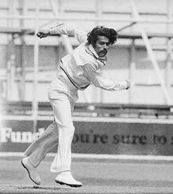By that time his family relocated to Bangalore and he got an opportunity to play for "City Cricketers". In an interview, Chandrasekhar stated that he joined up mainly to get a chance to play with the leather ball.  While playing on the streets of Bangalore, he had mainly used a rubber ball. While playing for the club, Chandrasekhar tried different bowling styles that also included fast bowling. It was in 1963 that he decided to play as a leg spin bowler. His idea proved to be right as he was soon selected for the national side.

Making his Test debut for India against England at Bombay in 1964, he collected four wickets in the match. He was named Cricketer of the Year in the same year. Chandrasekhar was instrumental in setting up India's first victory in England when he picked up six wickets for 38 runs at the Oval in 1971; the bowling was named the "Indian Bowling performance of the century" by Wisden in 2002. Wisden noted that, "[Chandrasekhar] was wonderfully accurate for a bowler of his type, and his extra pace made him a formidable proposition even on the sluggish Oval pitch."  His consistent bowling performance in 1971 earned him being named as one of the five [Wisden](http://en.wikipedia.org/wiki/Wisden_Cricketers%27_Almanack) Cricketers of the Year in 1972.

In a Test against New Zealand in 1976, Chandrasekhar and Prasanna took 19 wickets and were crucial in setting up India's win. Attributed to him is a famous umpire-directed quote, made during a day of bad decisions in New Zealand after several of his LBW appeals were given not out: "I know he is bowled, but is he out?" Chandrasekhar also played a major role in India's victory in Australia in 1977–78.

Chandrasekhar had minimal batting skills, finishing with a Test average of 4.07. He was given a special Gray-Nicholls bat during the 1977–78 Australian tour with a hole in it to commemorate the four ducks he scored,  and he has 23 Test ducks to his credit. He also holds the dubious distinction of scoring fewer runs (167) off his bat than wickets (242) taken in Test cricket; the only other cricketer with this distinction over a significant Test career is New Zealand fast bowler Chris Martin.

B S Chandrasekhar’s life sketch tells us:

There is no Market for your

Sorrows so never advertise them

**

***(Mr. Mani Laxman Panse*** *does Data Entry work. He takes active part in Sports meet and has won Medals in the Field of Athletics. He is a familiar face at every year's Pune International Marathon's Wheel Chair Race which takes places in Pune on 1st Sunday of December each year. He loves to read a lot. Mani contracted Polio at the tender age of 9 Months old).*

# Discrimination At Many Levels

Employment should be based on talent and not on the looks.

Discrimination occurs at many levels, and just like a person’s creed, caste and gender is not under his control, so do his disabilities. As per a recent study, people with disabilities constitute 10% to 15% of population and however small the number it may sound, in a population this is big, it’s definitely of a significant value. India regards 'equality' as a vital element in governance, and each time we recite our National pledge, or sing our National anthem we are reminded of the same but why do we forget this while employing these people?

To start with employment, it is a vast term but in simple language it is the occupation for which you are paid or you can earn your living.

In India, as per the observation and my communication on internet with my friends with disabilities, most of the individuals are self-employed because the numbers of employers willing to hire a candidate with disability is very less which is almost 0.0001% (estimate) of our population. I have observed from their communication and the current status, for a person with disability, he needs to have rich parents because then only he can be self-employed by opening some small business or else he will have to keep struggling revolve around depression. People say, government jobs are easy for differently-abled people and my friend thought of the same. He was going for some government job, when he read the details; he was advised that it was not suitable for anybody. One has to go through 100 formalities like getting registered, making a demand draft, showing some certificates and then going through actual examination. Then he said, “Can’t we have something simple for us or isn’t there some company which can guide us and give us confidence that it’s genuine?’’

We need to make such an individual INDEPENDENT and for that they need to be employed. Let’s talk about the benefits of employment and I believe the first and the foremost benefit is living. The person doesn’t have to get dependent financially on any one and the family doesn’t regard them as dependents. There are monetary benefits attached to the salary, like medical, insurance of self and parents. It gives the person confidence to survive, and then this gradually leads to the personality development. The same creates equality in the society.

Instead of holding on to their disabilities against them, we should utilize their strong abilities in favor of them, ourselves and the economy. We need to understand the fact that these people have already their physical challenges to survive, hence we need to provide them financial support, for them to live independently and have their families and personal lives the way every other person.

The benefit of hiring differently-abled people is that they have more confidence, they have positive attitude to work and take their work much more seriously, they will always put their 100 percent to prove their worth and work very hard to outdo themselves each time.

Often this question is being asked, what kinds of jobs are suitable to them and the answer is other than marketing jobs (field jobs), all jobs are suitable. As per the government rules there are 1100 recognized work arenas that are suitable for them. Jobs like research, operations, stock market trading, call centers, information security these are best suitable jobs.

We have numerous politicians, actors, business tycoons who are the best people to influence the policies of our country. We need their support, their voice so as to bring employment opportunities for our friends.

I have personally talked to my friends who are ready to provide jobs which are work from home; with Abha mam's effort soon we will be reaching MNCs to create such awareness to employ them. Whosoever reading this, please encourage your teams to hire people with brains and not physical status.

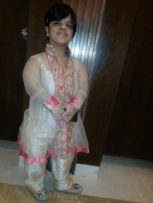

*(****Sheetal Malhotra*** *is a manager at JP Morgan and Chase Bank in Mumbai)*



# मेरी वो चीज ढूंढ के ला दो

कौन सा खर्च निकल जाएगा? मैं ये बिलकुल नहीं कह रही कि इस राशि को बढ़ाया जाए मैं क्या कोई भी नहीं कहता. कहना तो ये है कि बंद हो जाए ये पैसे लकिन बदले में हमें हमारे मौलिक अधिकार मिले. स्कूल, कॉलेज, दफ्तर सभी सार्वजनिक स्थल ऐसे हों कि हम अपनी मर्ज़ी से स्वाभिमान के साथ कहीं भी जाएँ, अपनी प्रतिभा, अपने हुनर से अपनी जीविका के लिए खुद कमा सकें. ***किसी एक अंग के कमज़ोर या न होने के कारण हम ‘निशक्त’ हैं यह एक ग़लतफ़हमी है.***

कहने के लिए तो ट्रेन में सफर करने के लिए किराए में छूट दी जाती है पर इस छूट का क्या फायेदा जब ट्रेन के डब्बे ऐसे हों जिनमें हम खुद जा हीं न सके, जिसका शौचालय हमारे उपयोग के लायक हो हीं नहीं?

सुनिए ज़रा .....

अरे हाँ भई आप ही से बात कर रही हूँ, एक छोटी सी मदद चाहिए थी. कुछ खो गया है मेरा ढूंढने में मेरी मदद कर देंगे? हाँ हाँ बहुत ज़रुरी चीज़ है, कोई अहम चीज़ न होती तो नाहक हीं क्यूँ परेशान करती आपको? उसकी अहमियत? *मेरे दिल से पूछिए तो मेरी आज़ादी, मेरा स्वावलंबन, मेरा स्वाभिमान सब कुछ तो है वो और आपके समझने वाली किताबी भाषा में बोलूँ तो मेरा “मौलिक अधिकार”.* क्या कहा आपने, मुझे पहले खुद प्रयास करनी चाहिए थी? मैंने बहुत प्रयास किया, कसम से हर जगह ढूंढा पर कहीं नहीं मिला.

हाँ सच कहती हूँ मैं स्कूल गयी मैं कॉलेज भी गयी अपने बराबरी का अधिकार, अपनी शिक्षा का अधिकार ढूंढने पर . . . क्या बताऊँ मुख्य द्वार पर हीं रोक दिया गया. नहीं नहीं किसी ने खुद आकर नहीं रोका पर वहाँ केवल सीढियाँ हीं सीढियाँ थीं कोई रैम्प नहीं जिससे मैं या मेरे जैसे और भी व्हील्चेयर इस्तेमाल करने वाले लोग, कैलिपर, बैसाखियों वाले या फिर दृष्टि बाधित लोग जा सकें. हाँ एक कॉलेज में रैम्प जैसा कुछ देख के आशा जगी कि शायद यहाँ मिल जाए मेरे अधिकार लेकिन वह भी ऐसा रैम्प था कि चढ़ने का प्रयास करते हीं व्हीलचेयर के साथ लुढक कर सड़क पर गीर गयी. फिर भी मैं वापस नहीं लौटी, एक राहगीर से मदद ले कर अंदर गयी . . . क्या आप विश्वाश करेंगे अंदर एक भी कमरा जी हाँ एक भी कमरा ऐसा नहीं था जिसमें मेरे जैसे विकलांग छात्र-छात्राएं जा सकें और जब हमारे पढ़ने के लिए कक्षाएं हीं नहीं तो शौचालय ढूँढना तो बेवकूफी हीं है. मन में एक बात आई ***‘क्या ये शिक्षण संस्थान ये मान कर बनाये जाते हैं कि हमारे देश में विकलांग छात्र-छात्राएं है हीं नहीं? क्या ऐसा सोच कर वो हमारे मौलिक अधिकारों का हनन नहीं कर रहे?’***

क्या? पत्राचार से घर बैठे डिग्री ले लेने के बाद मेरी लाइफ सेट है? सरकारी नौकरी की बात कर रहे हैं? हा हा हा हा ... माफ कीजियेगा, आप पर नहीं हँस रही, बस हँसी आ गयी वो कहते हैं न ‘ज़न्नत की हकीकत हमें भी मालुम है ग़ालिब, दिल बहलाने को ये ख़याल अच्छा है’. पहले सबकी बातें सुन सुन कर मैं भी कुछ ऐसा हीं सोचती थी और मैंने तो एक नौकरी के लिए फॉर्म भरा भी था. सचमुच विकलांगो के लिए एक अलग सेंटर दिया था उन लोगों ने, और पता है उस सेंटर की खासियत क्या थी? खासियत ये थी कि एक भी कमरा निचली मंजिल पर नहीं था, सभी को सीढियाँ से उपरी मंजिलों तक जाना था. कोई गोद से जा रहा था तो कोई ज़मीन पर घिसटते हुए. जब आगाज़ ये था तो अंजाम की कल्पना तो की हीं जा सकती है. विश्वाश नहीं हो रहा? अरे कोई बात नहीं मेरा विश्वाश ना कीजिये सरकारी दफ्तरों के एक चक्कर लगा के देख लीजिए खुद नज़र आ जायेगा कि उन दफ्तरों की संरचना कितनी सुगम है. कोई भी बैंक, ए०टी०एम, पोस्ट ऑफिस कहीं भी जा कर देख लीजिए कि विकलांगो चाहे वो कर्मचारी हो या कोई और किसी के लिए भी आने जाने का रास्ता बना है कहीं? अगर बराबरी का अधिकार है तो कहाँ है? नज़र क्यूँ नहीं आता?

जी क्या बोला आपने? मेरा दिमाग गरम हो गया है? थोड़ी ठंढी हवा खा लूँ? हाँ ठीक है पँखा चला लेती हूँ पर ठंढी हवा से याद आया सभी कहते हैं प्राकृतिक हवा स्वास्थ के लिए बहुत लाभकारी होती है और यही सोच कर मैं भी और लोगों की तरह पार्क गयी थी लेकिन देखिये ना इतने सारे पार्क सब के लिए 3-3, 4-4 गेट बने हुए हैं पर उसमें से एक भी गेट विकलांगो की सुगमता के लिए नहीं.

विकलांगो को और लोगों से बढ़ कर सुविधा दी जाती है? करोड़ों रूपए खर्च होतें है? आप भी न, नेताओं वाली भाषा बोलने लगे. हाँ बाबा जानती हूँ निशक्तता पेंशन अलग अलग राज्यों में अलग अलग योजनाओं के तहत बांटे जाते हैं. पिछले साल मुझे भी मिले थे (इस बार वाले का कुछ पता नहीं) पर तीन सौ रूपए महीने में कौन

ट्रेन में सफर करने के लिए भी बाकी लोगों के टिकट तो घर बैठे ऑनलाइन बनाये जा सकते हैं पर विकलांगो का टिकट तो काउंटर पर जा कर ही बनेगा. मेधा छात्रवृति की बात हो तो भी बाकी छात्र तो अपने अपने कॉलेज में हीं फॉर्म भर लेते हैं लेकिन विकलांग छात्रों को एक दूसरी जगह से फॉर्म मिलता है वो भी जमा करने खुद जाना होता है. क्या इसी को बराबरी का अधिकार कहते हैं? कहने को तो अभी बहुत कुछ है पर कहूँगी सिर्फ इतना कि मेरे सारे मौलिक अधिकार ढूंढ के ला दीजिए. हर जगह देख लिया नहीं मिला लेकिन अब रहा नहीं जाता कहीं से भी मुझे मेरे अधिकार चाहिए.

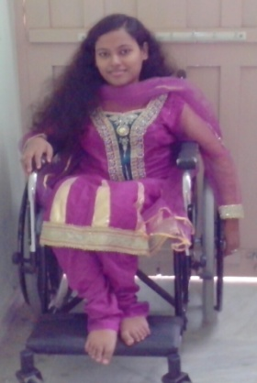

**(आलोकिता गुप्ता** एक विद्यार्थी जो अपने लिए दुनिया में अपनी राह खुद बनाना चाहती है)



# We shall overcome

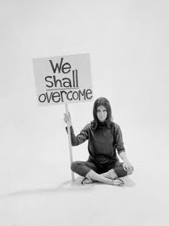A story on CNN today was about Tim Bowers, a 32-year-old Indiana man who chose to end his life this week after a hunting accident left him paralyzed. Mr. Bowers’ widow, whom he married this past summer, is expecting their first child.

This story tugs at the heart strings, a life just ended as a new one is on the threshold of starting … the little one probably looking forward to meeting the new family he is going to be part of. Will the family ever be complete now!!

Hearing about this incident brought to my mind what I have been hearing all my growing years about my dad’s teenage years and how he overcame his disability. I shudder to think what if he had given up on himself!! I wouldn’t possibly be sitting and writing this today.

As a teenager my Dad got typhoid which relapsed and left him blind…yes BLIND !! Remember I am talking about way back in the 40s when medicines were not that effective and all that probably worked were prayers. As if that was not enough both of his legs became bent which left him totally crippled and stranded to bed. He got bed sores on both sides from lying continuously which left him gaping depressions, the size of tennis balls, on both sides as the skin got plastered to the bone. Years later he would show these to us and tell us how he got hit by a bullet which entered from one side and left from the other, and of course we would believe it, considering he was in the police services. He could laugh about it later but I am sure what he suffered back then must have been monumental.

He relates what he went through. The depression of not being able to go out and play sports was killing him. He would get frustrated and was so many times on the verge of giving up. With his mom by his side encouraging him and helping him deal with this new life, he just about managed.

One day as my grandmother went into his room, he called out in fear because he felt a shadow. This was the first sign that he was beginning to see more than the black layer of darkness that had now become a part of his existence. Call it a miracle or the effect of the prayers and best wishes of the friends and family, as time passed he could see blurred images and soon he could see a bit more clearly with the help of spectacles. As he got better he started limping to school. His passion for sports was so great that despite his condition he started playing football, hockey and cricket at school. One of his teachers arranged wild boar oil for massage on his legs which gave him some relief. A servant at home massaged some sheep milk on his legs which helped. With his willpower and a never say die attitude, my dad went on to play Ranji Trophy Cricket, Santosh Trophy Football and Abdulla Trophy Hockey, all at the national level. He got into the police services and was honored with the President’s medal for Meritorious Services. With the very same leg that had once become crippled, he booted a child away from harm’s way as he had got entangled with a live wire, thus saving his life, for which he was awarded the Prime Minister’s Life saving medal, not to mention the hoards of blessings from the parents of the little boy.

Today at the age of 80+ and after four operations of hernia and two stents placed in his heart muscle all I see him do is spread more love and blessings on us and our kids, without expecting anything from us in return. My Daddy Strongest!! Totally proud of him!!

Having narrated this, I feel as a society, our perception of what it means to live with disability is so infused by prejudice that what we see as a “poor quality of life” could actually be a life filled with joy and purpose and fulfillment – all just as profound and meaningful as its challenges. The people who endure it every day are no less in any way. They are at par and all they need is our support, our empathy and not sympathy and a helping hand when they so desire.

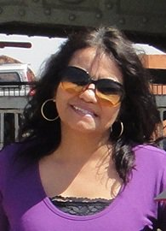

***Reva Sudeep*** *was born and brought up in Jaipur. In her own words, “I am Reva- a daughter, a wife, and a mother to two wonderful young boys. I love to blog (http://revasudeep.wordpress.com/) whenever I want to express whatever I am feeling at the moment. A die hard romantic and optimistic to the core- love my family and friends-sums me up I guess :)”.*

**Expert Speak**

# DEVELOPMENTAL MILESTONES AND DELAY

**‘Mankind owes to the child the best it has to give’** – **Unknown**

As a child grows and develops, he learns different skills, such as taking a first step, smiling for the first time, or waving goodbye. These skills are known as [developmental milestones](http://mychildwithoutlimits.org/understand/developmental-milestones/). There is normal variation around what age children will achieve a specific developmental milestone.

***The first three years of a child's life are an amazing time of development*...**

***...and what happens during those years stays with a child for a lifetime. That's why it's so important to watch for signs of delays in development, and to get help if you suspect problems. The sooner a delayed child gets****early intervention****, the better their progress will be.***[So, if you have concerns, act early](http://www.cdc.gov/ncbddd/actearly/concerned.html).

At 2 months:

* Turns heads toward bright colors and lights
* Recognizes bottle or breast
* Responds to their parent’s voice
* Makes cooing sounds
* Brings hands together
* Wiggles and kicks with arms and legs
* Lifts head when on stomach
* Becomes quiet in response to sound, especially to speech



At 4 months:

* Makes sounds with expression as if trying to talk
* Attempts to imitate sounds when engaged in vocal play with parent
* Follows moving objects with their eyes from side to side
* Holds head steady
* Pushes down on legs when feet are on a hard surface
* Recognize familiar people and things at a distance
* Lets you know if they are happy or sad

At 6 months:

* Shows some response when name is called
* Turns toward the source of sounds
* Reaches for objects and picks them up
* Plays with their feet when laying on back
* Helps hold the bottle during feeding
* Knows familiar faces and begins to know if someone is a stranger
* Attempts to imitate speech sounds
* Rolls over

At 9 months:

* Has favorite toys
* Shows some ability to understand the word “no”
* Uses fingers to point at things
* May be afraid of strangers
* Can sit without support
* Crawls
* Copy sounds and gestures of others

At 1 year:

* Gets to a sitting position
* Stands briefly without support
* Imitates adults using a cup or telephone
* Plays peek-a-boo and patty cake
* Waves bye-bye
* Puts objects in a container
* Makes “ma-ma” or “da-da” sounds

At 18 months:

* Likes to push and pull objects
* Says at least six words
* Follows simple directions
* Pulls off shoes, socks and mittens
* Can point to a picture that you name in a book
* Feeds themselves
* Makes marks on paper with crayons
* Walks without help
* Walks backwards
* Points to things he wants and tries to use words to ask for things



At 2 years:

* Creates and uses two word phrases
* Says more words that you can easily count
* Recognizes familiar pictures
* Kicks a ball forward
* Feed themselves with a spoon to feed themselves (not necessarily neatly)
* Demands a lot of your attention
* When playing with a book, turns pages, although may turn two or three pages together
* Identifies central body parts such as belly, eyes, ears and nose by pointing
* Shows affection

At 3 years:

* Throws a ball overhand
* Rides a tricycle
* Can put on shoes
* Opens doors in the home
* When playing with a book, can turn one page at a time
* Plays with other children for a few minutes
* Repeats common rhymes
* Is able to use small sentences when speaking
* Name at least one color correctly

At 4 years:

* Sometimes uses five to six word sentences when talking
* Throws a ball overhand
* Understand the concept of counting and may know a few numbers (e.g understands ‘you can only have one’)
* Attempts to draw a person resulting in a drawing with at least two body parts
* Recalls and is able to tell parts of stories
* Begin to have a clearer sense of time
* Understand the concepts of “same” and “different”
* Has imagination and shows fantasy elements in play (e.g may be afraid of “monsters”, may like to dress up)

At 5 years:

* Sometimes uses five to six word sentences when talking
* Fantasy play
* Understands gender (e.g. knows they are a boy or girl, knows mommy is a girl and daddy is a boy)
* Can count 10 or more objects
* Tells longer stories
* Says name and address (if taught address)
* Hops, somersaults, swings, climbs
* Attempts to draw a person has a two dimensional body (e.g. a circle instead of a stick for a body)
* Can print some letters (if taught)
* Can dress and undress without help
* Use fork, spoon and (sometimes) a table knife

**Developmental Delay**

Developmental delay refers to a child who is not achieving milestones within the age range of that normal variability. Most often, at least initially, it is difficult or impossible to determine whether the delay is a marker of a long-term issue with development or learning (i.e. known as a disability) or whether the child will ‘catch-up’ and be ‘typical’ in their development and learning.

There are five main groups of skills that make up the developmental milestones. A child may have a developmental delay in one or more of these areas:

**Gross motor**: using large groups of muscles to sit, stand, walk, run, etc., keeping balance and changing positions.

**Fine motor**: using hands and fingers to be able to eat, draw, dress, play, write and do many other things.

**Language**: speaking, using body language and gestures, communicating and understanding what others say.

**Cognitive**: Thinking skills including learning, understanding, problem-solving, reasoning and remembering.

**Social**: Interacting with others, having relationships with family, friends, and teachers, cooperating and responding to the feelings of others.

Usually, there is an age range of several months where a child is expected to learn these new skills. If the normal age range for walking is 9 to 15 months, and a child still isn’t walking by 20 months, this would be considered a developmental delay (2 standard deviations below the mean). A delay in one area of development may be accompanied by a delay in another area. For example, if there is a difficulty in speech and language, a delay in other areas such as social or cognitive development may coexist.

It is important to identify developmental delays early so that treatment can minimize the effects of the problem. Parents who have concerns about their child’s development should consult the child’s physician, who, in turn, might make a referral to a developmental pediatrician, developmental psychologist or pediatric neurologist. The consultant can evaluate the child and recommend treatments and therapies that might benefit the child.

**Developmental Delay Affects**

In the United States, 17% of children under the age of 18 years – or one in six – have a developmental or behavioral disability such as autism, intellectual disability, or attention-deficit/hyperactivity disorder (ADHD). These conditions may initially present as developmental delays. Less than 50% of these children are identified as having a problem before starting school, by which time significant problems may have already occurred and opportunities for treatment have been missed.

There is definitely a gender bias when it comes to developmental delays, with more males affected than females. The higher proportion of males with developmental delay and disabilities is well documented. This is in part due to X-linked conditions (such as fragile X syndrome, the most common cause of inherited intellectual disability).

X-linked conditions are genetic diseases carried on the X chromosome. Girls have two X chromosomes and boys have 1 X chromosome (and one Y chromosome).  Since boys only have one X chromosome, any abnormality on that chromosome will be expressed clinically (conversely because girls have two X chromosomes, an abnormality can be carried on one X chromosome but not be clinically evident because of the other normal X chromosome that the girl has).

However, the increased prevalence of developmental challenges in boys is not all explained by X-linked conditions. For example 4 times as many boys have autism compared to girls. There is also a racial predisposition, with black males affected more than white males, black females, or white females. The underlying reason for this has been attributed to socioeconomic disparities.

**Causes**

Developmental delay can have many different causes, such as genetic causes (like Down syndrome), or complications of pregnancy and birth (like prematurity or infections). Often, however, the specific cause is unknown. Some causes can be easily reversed if caught early enough, such as hearing loss from chronic ear infections.

**Prevention**

Since there are so many different conditions that can lead to developmental delays, there isn’t one “right way” to prevent developmental delay. What’s important is to be aware of when your baby should be reaching developmental milestones and to consult your paediatrician if you think there may be a problem. Early intervention is the key in helping your child overcome any developmental delays.

**Treatment**

There is no one treatment that works for every child with a developmental delay. Children are unique; they learn and grow and develop in their own way, at their own pace, based on their strengths and weaknesses. Any treatment plan will take this uniqueness into account and be designed to focus on individual needs. [Early intervention](http://mychildwithoutlimits.org/plan/early-intervention/) services are the main theme of treatment, but any underlying conditions that have led to developmental delay will need to be treated as well. Early intervention services may include:

* [Speech and Language Therapy](http://mychildwithoutlimits.org/plan/common-treatments-and-therapies/speech-therapy/)
* [Occupational Therapy](http://mychildwithoutlimits.org/plan/common-treatments-and-therapies/occupational-therapy/)
* [Physical Therapy](http://mychildwithoutlimits.org/plan/common-treatments-and-therapies/physical-therapy/)
* [Behavior Therapies](http://www.mychildwithoutlimits.org/plan/common-treatments-and-therapies/behavior-therapy/), such as those used to treat autism and behavioral issues

In addition, if there are other disabilities present medical or surgical treatments may be required to manage those conditions.

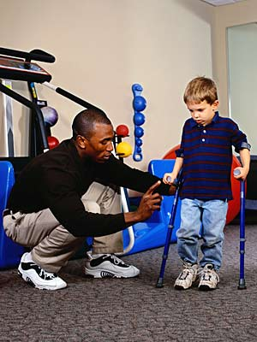It is important for all children with developmental delay to have their hearing and vision evaluated so that untreated visual or hearing impairments do not complicate the situation.

**What Happens Over Time to Children with Developmental Delay**

The child’s progress depends in large part on the underlying diagnosis for the delay and the individual child’s constellation of strengths and challenges. Early identification and treatment will optimize a child’s progress.  With a proper treatment plan, most children should progress in their development although the rate of that progress and the extent that the delays resolve is highly variable depending upon the underlying condition.  Some children may “catch up” to peers over time while others may have disabilities that persist into adult life.  Many of these adults may be independent in their function, some individuals may have mild disability requiring limited societal supports, and others may require extensive supports due to the extent of their disability.

A minority of children might be diagnosed with a “progressive” condition (one that causes further injury to the nervous system over time) in which case, the child may plateau or regress in their development due to that condition. Still, with supports, the child’s function can be optimized.

**There's one basic rule you should remember about development charts that will save you countless hours of worry.... The fact that a child passes through a particular developmental stage is always more important than the age of that child when he or she does it. In the long run, it really doesn't matter whether you learn to walk at ten months or fifteen months--as long as you learn how to walk – Lawrence Kutner**

**"The more I read and the more I talked to other parents of children with disabilities and normal children, the more I found that feelings and emotions about children are very much the same in all families. The accident of illness or disability serves only to intensify feelings and emotions, not to change them." - Judith Weatherly**

**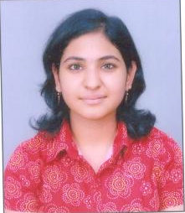**

*(Dr Preetika Kalra (PT)*

*BPT, MPT (NEURO), MDCPT, MIAP)*

# Nightmare Of A Parent

I am a single mother. My son has had very high fever since last night and I can’t take a leave from my job as it is the day of inspection. Being very sure that my sister will support me in this hour of need, I contact her. But she has her own set of problems. And she is also not sure if she will be able to “manage” my son for seven long hours. I understand her dilemma. But now what?

This may be story of me, you or anyone of us. My biggest nightmare is that what I will do if I face this situation. In India or especially in cities which are not metros, lack of emergency care, day care or respite care is a big issue and a major concern for the care givers. As a parent so many times after being slightly ill or at slight discomfort I have prayed to god to keep me fine because if I fall ill, who will look after my child? We need to form a strong parent support group system which also provides some respite care in moments of emergencies. I know in many cities very strong parent support groups are working but are they available for each other during such moments, I doubt.

I am trying to form a parent support group in my city. But now that I have resumed job I wonder will I do it justice! But that will not stop me from working towards my aim am waiting for similar kind of parents to join me in my Endeavour. What any of parents who want to do the same can do?

They can begin with spreading the word and they should start creating the data base. I did the same and my parents reached out to me with the suggestion seconding my plan of starting parent support group. They even expected and suggested that I should start a centre on this side of city. A welcome suggestion indeed. Now I am progressing towards organizing meetings of parents to plan further. A small step towards my dream but a step indeed.

(***Nalini Srivastava*** *is the mother of a six year old boy, Kabir, with Asperger's Syndrome. Kabir, 6yrs old, is doing well in his studies in a mainstream school)*

# अपस्मार या मिर्गी

मिर्गी एक तंत्रिकातंत्रीय विकार (*न्यूरोलॉजिकल डिसॉर्डर*) है जिसमें रोगी को मष्तिष्क में किसी गड़बड़ी के कारण बार-बार दौरे पड़ते है.दौरे के समय व्यक्ति का दिमागी संतुलन पूरी तरह से गड़बड़ा जाता है और उसका शरीर लड़खड़ाने लगता है. इसका प्रभाव शरीर के किसी एक हिस्से जैसे चेहरे, हाथ या पैर पर देखने को मिल सकता है. इन दौरों में तरह-तरह के लक्षण हो सकते हैं, जैसे कि बेहोशी आना, गिर पड़ना, हाथ-पांव में झटके आना। मिर्गी किसी एक बीमारी का नाम नहीं है। अनेक बीमारियों में मिर्गी जैसे दौरे आ सकते हैं। मिर्गी के सभी मरीज एक जैसे भी नहीं होते। किसी की बीमारी मध्यम होती है, किसी की तेज। यह एक आम बीमारी है जो लगभग सौ लोगों में से एक को होती है.

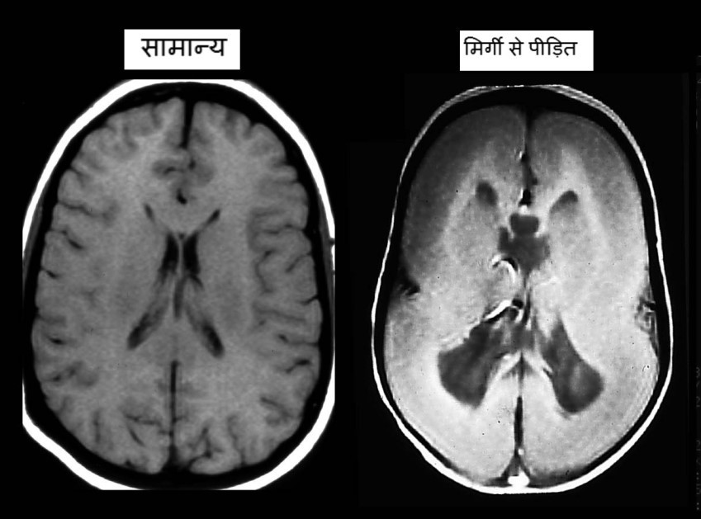

मिर्गी रोगी की चिकित्सा ऐसे करें

* अंगूर का रस मिर्गी रोगी के लिये अत्यंत उपादेय उपचार माना गया है. आधा किलो अंगूर का रस निकालकर प्रात:काल खाली पेट लेना चाहिये। यह उपचार करीब ६ माह करने से आश्चर्यकारी सुखद परिणाम मिलते हैं.
* एप्सम साल्ट (मेग्नेशियम सल्फ़ेट) मिश्रित पानी से मिर्गी रोगी स्नान करे। इस उपाय से दौरों में कमी आ जाती है और दौरे भी ज्यादा भयंकर किस्म के नहीं आते है.
* मिट्टी को पानी में गीली करके रोगी के पूरे शरीर पर लेप लगाना अत्यंत लाभकारी उपचार है। एक घंटे बाद नहालें। इससे दौरों में कमी होकर रोगी स्वस्थ अनुभव करेगा.
* विटामिन बी६ का प्रयोग भी मिर्गी रोग में परम हितकारी माना गया है। यह विटामिन गाजर,मूंगफली ,चावल,हरी पत्तेदार सब्जियां और दालों में अच्छी मात्रा में पाया जाता है। १५०-२०० मिलिग्राम विटामिन बी६ लेते रहना अत्यंत हितकारी है.
* मानसिक तनाव और  शारिरिक अति श्रम रोगी के लिये नुकसानदेह है। इनसे बचना जरूरी है.
* मिर्गी रोगी को २५० ग्राम बकरी के दूध में ५० ग्राम मेंहदी के पत्तों का रस मिलाकर नित्य प्रात: दो सप्ताह तक पीने से दौरे बंद हो जाते हैं। जरूर आजमाएं.
* रोजाना तुलसी के २० पत्ते चबाकर खाने से रोग की गंभीरता में गिरावट देखी जाती है।
* पेठा मिर्गी की सर्वश्रेष्ठ घरेलू चिकित्सा में से  एक है। इसमें पाये जाने वाले  पौषक तत्वों से मस्तिष्क के नाडी-रसायन संतुलित हो जाते हैं जिससे मिर्गी रोग की गंभीरता में गिरावट आ जाती है। पेठे की सब्जी बनाई जाती है लेकिन इसका जूस नियमित पीने से ज्यादा लाभ मिलता है। स्वाद सुधारने के लिये रस में शकर और मुलहटी का पावडर भी मिलाया जा सकता है.
* १०० मिलि दूध में इतना ही पानी मिलाकर उबालें  दूध में लहसुन की ४ कुली चाकू से बारीक काटक्रर डालें ।यह मिश्रण रात को सोते वक्त पीयें। कुछ ही  रोज में फ़ायदा नजर आने लगेगा.
* गाय के दूध से बनाया हुआ मक्खन मिर्गी में फ़ायदा पहुंचाने वाला उपाय है। दस ग्राम नित्य खाएं.

# Diet Of People With Muscular Dystrophy

**Foods to Avoid with Muscular Dystrophy**

Those who have Muscular Dystrophy must try to eliminate any food allergies by removing all common food allergens including corn, dairy, soy, wheat (gluten), preservatives, and food additives.

They should avoid refined foods, including white bread, pasta, and sugar.

They must decrease or eliminate red meat and trans fatty acids found in commercially prepared foods including cakes, cookies, crackers, donuts, French fries, onion rings, margarine, and other processed foods, and avoid stimulants, including coffee, alcohol, and tobacco.

**What to Eat for Muscular Dystrophy**

People who have Muscular Dystrophy should include good sources of protein like fish and beans. If one is not allergic to soy, tofu is another option.

They must eat plenty of antioxidant-rich foods including fruits like blueberries, cherries, tomatoes and dark green vegetables like spinach, and green peppers.

Their food should be cooked with unsaturated oils (canola and olive oil) and they must drink plenty of filtered water—six to eight glasses daily. Other vegetables and whole grains can also be included.

**Vitamins and Nutritional Supplements for Muscular Dystrophy**

The following vitamins and nutritional supplements may improve the quality of life by slowing down degeneration, promoting muscle regeneration, and reducing inflammation associated with muscular dystrophy symptoms:

* Omega-3 fatty acids such as fish oil, 1 to 2 capsules or one tablespoon, to decrease inflammation and enhance the immune system.
* A multivitamin containing vitamins A, C, E, B, and trace minerals including magnesium, calcium and zinc.
* People with muscular dystrophy tend to have low levels of selenium, vitamin E, and lecithin. Selenium is also found in nutritional yeast, seafood, legumes, whole grains, animal products, and vegetables.
* Calcium, 1000 to 2000 mg, with vitamin D, 400 to 1000 international units (IU), to support muscles and bones.

**Poem**

# Quashing hopes

In the era of talent and gusto,

Amidst the high spirits and surpassing minds,

There exist turncoats who possess power and authority in their hands.

We the common people make them the rulers,

And then we shrill, “This and that is happening without our say.”

These turncoats are our leaders, who have feet of clay,

Because they never do what they really say.

We live in a system where the most important thing is not your degree or capability,

But simply your acquaintance with a minister or perhaps his friends.

No doubt there remains good leaders too,

But unfortunately they generally have to give way.

Everyone is hoping for a corruption free day,

But in the presence of our hypocrite and turncoat leaders, this seems a far dingy day,

Scams, scandals, rapes and murders are becoming order of the day,

and even if the culprit is in the hand, the courts declare nothing but next date and dates.

The hope of help and justice from our leaders the real turncoats, is fading away day by day.

After hearing such things, all I can say is

, “Be Safe and don’t expect anything from the leaders and our system’s hopeless ray.”

***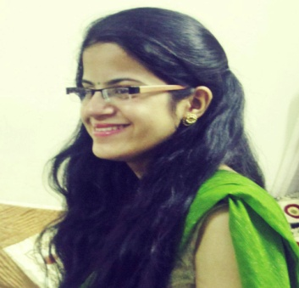***

***(Divya Sharma(Bhvya****), girl with visual impairment, is a budding rock star. Music is her passion but she equally is a wonderful and a dedicated student who really wants to achieve something in her life).*

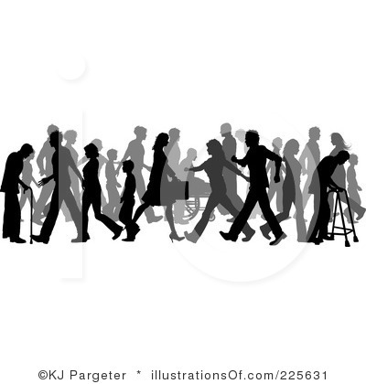अक्षमों की अक्षय क्षमता  
अक्षम है हम तन से   
ना कि मन से  
सक्षम से ज़्यादा हम है  
हर काम में हर ओर से  
जब ठान लें, सब सुन लें  
कदम पीछे ना हटें  
हो या ना हो अंग हमारे  
अक्षम है हम तन से  
ना कि मन से  
कोई गर कहे हमें "बेचारे"  
गाँठ बांधें एक बात वे सारे  
नहीं चाहिए सांत्वना किसी की  
जो जैसा दिखता है वैसा नही होता प्यारे  
अक्षम है हम तन से  
ना कि मन से

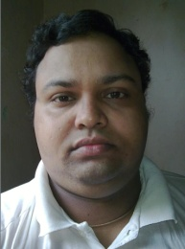

*(रूपेश  गोआ में रहते हैं और कविता लिखने में रुचि रखते हैं)*

