Editorial 3
Personality Of The Quarter! 7
The Expert Speaks 9
Something Inspirational 20
LONELY TREE WAS GROWING AMONG HOT SANDS OF DEAD DESERT… 20
Science and Technology----- 21
Parent’s Speak 22
(Gary Shulman) 22
Kids Korner 24
पेशीय दुर्विकास (मस्कुलर डिस्ट्रोफी) / Muscular Dystrophy 25
कविता 27
Name- Tripti Profession- Artist Disability: Muscular Dystrophy Category- Poem and illustration Email add- triptisony@gmail.com 27
Gandhari’s dream (English version) 28
(Written by Raghavan Sampathkumar) 28
Quote of the Quarter 38

Editorial

International Day of Persons with Disabilities, i.e. the 3rd of December is again here.
It is estimated that there are over one billion people, or approximately 15 per cent of the world’s population who live with some form of disability. And unfortunately “this largest minority of world” often faces all kinds of barriers in the journey of life. Architectural, environmental, technological and attitudinal barriers hold them back from participating in any field including education, employment, health care, transportation, political participation or justice.

Editorial Team

Chief Editor
Abha Khetarpal

Cover Page
By
Abha Khetarpal

Each year the UN announces a theme. The theme for 2015 is: Inclusion matters: access and empowerment for people of all abilities.
There are also three sub-themes this year:
- Making cities inclusive and accessible for all
- Improving disability data and statistics
- Including persons with invisible disabilities in society and development.
The annual theme provides a frame for considering how people with disability are excluded from society by promoting the removal of all types of barriers; including those relating to the physical environment, information and communications technology (ICT), or attitudinal barriers. This has been occurring since 1992 when the General Assembly proclaimed 3 December as the International Day of Disabled Persons.
Accessibility and inclusion of persons with disabilities are fundamental rights recognized by the CRPD. They are the pre-requisites for the enjoyment of other rights. Since we too stand for the principal of inclusion and accessibility for all, efforts of Cross the Hurdles are been directed towards the formation of a microcosm in the macrocosm of this society.
I pray to the almighty that we are able to achieve what we intend to do.
Hope you would all love reading this issue. Your comments and feedback would be a source of inspiration and guidelines for us so we would be waiting for them impatiently.
Abha Khetarpal
President
Cross the Hurdles
(www.crossthehurdles.org)
© Cross the Hurdles

e from the dterestingRyley Batt

(Contributed by Mani Panse)

Ryley Batt, Winner of Medal the Order of Australia (born 22 May 1989) is an Australian wheelchair rugby player.
Ryley Douglas Batt was born on 22 May 1989 without legs and had surgery to separate his webbed fingers. Up to the age of 12, he did not use a wheelchair, preferring to move around on a skateboard. He was convinced to use a wheelchair when he saw a demonstration of wheelchair rugby at his school, and took up the sport shortly afterwards in that year. He first participated in the Australian Steelers in 2002. He was part of the national team at the 2004 Athens Games, where he was the youngest Paralympic rugby player in the world at the age of 15, the 2008 Beijing Games, where the team won a silver medal, and the 2012 London Games, when the team won a gold medal from 2006 to 2010, he was the national team's most valuable player.
He competed in the 2010 World Rugby Wheelchair Championships, where his team won a silver medal, and he won the most valuable player award. He was a member of the Australian team that won its first world championship gold medal at the 2014 World Wheelchair Rugby Championships at Odense, Denmark
He lives in the New South Wales city of Port Macquarie, and leads the New South Wales Gladiators and the San DiegoSharp Edge in the United States.
Batt was a finalist for the 2012 Australian Paralympian of the Year. He was awarded an Order of Australia Medal in the 2014 Australia Day Honours "for service to sport as a Gold Medallist at the London 2012 Paralympic Games."In November 2014, he won three awards at the New South Wales Institute of SportAwards” Clubs NSW Male Athlete of the Year, Office of Communities, Sport and Recreation Regional Athlete of the Year and Quest Serviced Apartments Team Athlete of the Year.
"Infuse your life with action. Dont wait it to happen. Make your own future .Make your own hope. Make your own love. And whatever your beliefs, honor your creator , not by passively waiting for grace to come down from upon high, but by doing what you can to make a grace happen... yourself , right now , right down here on Earth."
Bradley Whitford
(Mr. Mani Laxman Panse does Data Entry work. He takes active part in Sports meet and has won Medals in the Field of Athletics. He is a familiar face at every year's Pune International Marathon's Wheel Chair Race which takes places in Pune on 1st Sunday of December each year. He loves to read a lot. Mani contracted Polio at the tender age of 9 Months old).

Personality Of The Quarter!

Sharath Gayakwad
Paralympian and multiple Asian Games medalist Sharath Gayakwad is perhaps one of India’s best Para-swimmers. Bangalore based Sharath holds a record for most number of medals won by an Indian at an International sports event, at the young age of 24, beating a record set by the Payyoli Express, P.T. Usha.
He took up swimming as a mandatory activity in school and developed a passion for this sport. Today he has over 90 medals in his kitty and has become the first Indian to win six medals in a multi-disciplinary sport event.

In his own words, “I enjoyed football and cricket, but then swimming became a compulsory activity in my school. I was a little reluctant to opt for it and even my family was hesitant in letting me take up this activity as they weren’t sure whether I’d be able to pull it off. But gradually, after much practice and support from the coach, I not only learnt to swim but also started enjoying it and thought of taking it more seriously”.
Sharath began his campaign by winning a silver medal in the 200m Individual Medley event. He followed it up by winning bronze medals in 100m butterfly, 100m breaststroke, 100m backstroke, and the 50m freestyle.
Sharath suffers from a dysfunctional left short arm and the recurring shoulder injury is what bothers him when he thinks of the 2016 Rio Olympics.

The Expert Speaks

Nutrition in Autism

Vitamin and mineral deficiencies are common among those with autism, and in many cases, they relate to overly restricted eating habits.
Autism spectrum disorders (ASD) are commonly associated with gastrointestinal problems and sensory issues with food textures and smells. It is also possible that the underlying biology of autism may cause deficiencies in the digestion of certain foods, which could affect vitamin intake. For example some children with autism and gastrointestinal disturbances have impaired carbohydrate digestion. Normal growth and good health depend on the body absorbing and metabolizing the vitamins and minerals that are part of a well-rounded diet.
Studies show that nutrient deficiencies affect thinking and behavior – for example, the ability to focus or stay alert in school. Also, nutrient deficiencies such as those involving omega 3 fatty acids may worsen behavioral symptoms such as irritability and hyperactivity. As such, it’s entirely possible that taking supplements may improve such symptoms in some individuals with ASD - especially if the individual has clinical or laboratory evidence of low levels of crucial vitamins, minerals or other nutrients.
Researchers have come out with conclusions that how particular vitamins, minerals and nutritional supplements lessen the severity or intensity of core autism symptoms – namely communication difficulties, social challenges and repetitive behavior.
The results of these clinical studies have been mixed. One recent large study examined the effect of an over-the-counter supplement called Syndion on 141 children and adults with autism, as compared to the effects of a placebo pill. The researchers reported that the product effectively raised levels of vitamins and minerals in the blood. They also showed that it produced no significant side effects during the 12-week study.
It is important to continue supporting research that will provide parents and individuals with clear answers about the value of vitamins, minerals and other nutritional supplements in ASD.

▬▬▬▬▬▬▬▬▬▬Tips Of The Quarter▬▬▬▬▬▬▬

Travel Tips for People with Disabilities
If you travel with a disability, handicap, physical limitation, mobility limitation, or developmental disability, have special needs, or use an electric wheelchair or handicap scooter, it's a good idea to learn as much as you can to make disabled travel easier.
Or if you're a mature traveler or senior who is a slow walker or just wants a slower pace, becoming more informed about disabled travel services and disability travel resources, will lessen the anxiety that often accompanies disabled travelers.
The following travel tips, resources and information for the disabled will help make trips, tours, holidays and vacations a lot easier for you, or for a child with a disability, whether short-term or long-term.
1. Plan your trip well in advance!
Do you need to order extra supplements, medications or renew prescriptions, fix eyeglasses or change prescriptions, get a physical, have dental work done, have your wheelchair fixed or tuned up, etc.
2. If possible, always book your travel through an agency that specializes in helping people with disabilities.
This is important because specialized travel agents and tour operators for the disabled are experienced and can save you some awful headaches.
They offer a lot of good tips and a wide range of services for the handicapped traveler. Among other things, they can arrange for a: wheelchair at the airport, wheelchair accessible hotel room, wheelchair rental, lift-equipped accessible van, full van, minivan, RV, disability scooter, or any other handicap vehicle.
Travel agents for the disabled can help arrange accessible transportation, help plan the best accessible cruise, give cruise line and cruising tips, arrange travel insurance and take care of special needs.
Agents can check with hotels for: inner and outer door widths to accommodate your wheelchair, ADA-approved handicap bath tubs, grab bars, or for roll-in showers. Just tell them your needs.
3. Take along your travel agent's phone number.
You'll also want to take with you the phone numbers for the travel agencies that specialize in disabled travel at your destination, in the event you can't reach your own agent.
These travel agents may know how to solve problems that come up regarding your hotel, car or van rentals, etc., even if you didn't order your tickets through them.
4. When traveling to another city, check out the local health and medical associations before you go.
They usually know what museums, restaurants, theaters & other local facilities are wheelchair accessible and where you can get oxygen, emergency supplies or medical assistance. They may be able to help you with any problems that arise.
5. If you plan to rent a disability scooter, wheelchair, electric wheelchair, handicap van, full van, mini-van, RV or other vehicle in another city, don't wait until you get there.
Make all the arrangements before you leave on your trip. Also make sure you ask any specifics like, are there tie-downs, ramps, or hoists, etc. Check on what van, RV, car or auto insurance you'll need before you go.
6. Don't leave anything to chance.
If you can, double-check all the arrangements your travel agent makes. Call the airlines, hotels, scooter, wheelchair, car, RV or van rental companies, medical equipment rental companies, etc., and verify the specifics, especially if you're traveling in a wheelchair or have any other special needs like oxygen. This is important if you haven't used the agent before.
7. If you need oxygen or any other special medical equipment, call airlines and suppliers well in advance of your trip.
Don't wait until the last minute. Start calling them as soon as you know you're going to be traveling or taking a trip. Double-check with your travel agent and the airline at least three to four days before your flight.
8. Arrive early at the airport.
It's better to wait around there than miss your plane. This will eliminate some of the pre-trip anxiety you might feel and make for more leisurely travel. This seems like common knowledge but many people still arrive at the gate just in the nick of time.
With all that's going on in the world today there are many reasons why you want to allow for more time at the airport.
9. Stuff to take
In your airplane carry-on bag keep copies of the prescriptions for your medications and eyeglasses, extra eyeglasses, sunglasses, all your medications and supplements, and a list of your doctor, dentist and other health professionals with their addresses, and phone numbers.
Include your doctor's fax number for prescriptions in case you lose your medications. Keep duplicate copies of these in your luggage and at home by the telephone. Know where your medical records are kept.
10. When you travel, and for any other time too, if you take medications, learn their names and exactly what they're for if you don't know.
People come into the emergency room all the time and don't know what medications they're taking. You might be surprised to find out that most people say 'a little yellow pill' or 'a white capsule', etc.
Emergency workers need to know what you're taking so they don't give you medication that would interact adversely with it, overdose you or somehow interfere with their treatment and your recovery.
11. If you're traveling by air, tell the flight attendants when you board, of any medical problem you might encounter on your flight.
Note the location of the closest restroom before getting seated. Tell the flight attendant if you think you'll need assistance getting to it during the flight.
You may need or want an aisle seat for easy access to the restrooms. Discuss seating with your travel agent.
12. If you need someone to travel with you, ask your travel agent for ideas or suggestions.
Call the local chapters of medical associations and ask if they can recommend a travel assistant or travel companion to help or accompany you.
There are national companies who offer traveling nurses, traveling companions or travel assistants to accompany disabled travelers or people with serious medical issues.
13. Make sure to take with you:
Any medical cards, Medicare cards, discount cards, car or auto rental discount cards, auto insurance policy numbers and agent's phone number, passport, airline tickets, etickets, American Express Travelers Checks, debit cards, credit cards, and drivers license. Photocopy everything.
Keep photocopies in your luggage and at home by the telephone or someplace where someone has access to it in case you need it.
14. Read everything you can about traveling with a disability.
Read disabled travel books, access guides, accessible guidebooks, disability travel articles and travel publications for the disabled traveler. Read the personal travel experiences of wheelchair users and others who have traveled with disabilities. Be informed.
These travel tips, information, resources, and services for the disabled should help you, or anyone with a disability, handicap, physical limitation, or who uses a wheelchair, have an easier, more pleasant, anxiety-free, trouble-free trip, tour, holiday or vacation.
(Contributed by Rajendra Maurya, Team Cross the Hurdles)

सुगम्य भारत अभियान

विकलांग जन सशक्तिकरण विभाग, सामाजिक न्याय और अधिकारिता मंत्रालय ने एक राष्ट्रव्यापी फ्लैगशिप अभियान के तौर पर सुगम्य भारत अभियान शुरु किया है. इस अभियान से हम उम्मीदें हैं. अनुमोदित योजना के महत्वपूर्ण बिन्दु निम्न प्रकार से हैं:
वर्ष 2015-16 कार्य योजना के अंतर्गत राज्य सरकारों, सुगम्यता पेशेवरों और विशेषज्ञों के प्रतिनिधियों को मिलाकर एक संचालन समिति और कार्यक्रम मानीटरिंग यूनिट की सहायता ली गई है. ‘‘सुगम्य भारत अभियान’’ प्रारम्भ में पायलट आधार पर सात राज्यों में कार्यान्वित किया जायेगा, जिनमें-दिल्ली, तमिलनाडु, गुजरात, असम, राजस्थान, महाराष्ट्र और हरियाणा शामिल हैं.
सारे देश में जागरूकता कार्यशालाओं का आयोजन जायेगा. सुगम्यता के मुद्दे पर ब्रोशर/शैक्षिक पुस्तिकायें और विडियों सृजित किये जायेंगे. गैर सुगम्य संस्थानों के संबंध में व्यापक सूचना प्राप्त करने हेतु एक सार्वजनिक मंच सृजित करने हेतु मोबाइल के साथ पोर्टल का सृजन भी होगा.
सुगम्य भारत अभियानः विकलांग व्यक्तियों हेतु सुगम्य वातावरण का सृजन के लिए लक्ष्य और विचारः-
एक समावेशी समाज में विकलांग व्यक्तियों की समान अवसरों तक पहुंच सुनिश्चित करने और आत्मनिर्भरपूर्वक रहने और जीवन के सभी क्षेत्रों में पूर्ण रुप से भाग लेने में उन्हें सक्षम बनाने उनकी सार्वभौमिक (यूनिवर्सल) पहुंच सुनिश्चित करना आवश्यक है. विकलांगजन सशक्तिकरण विभाग, ने विकलांग व्यक्तियों हेतु सार्वभौमिक सुगम्यता प्राप्त करने के लिए ये राष्ट्रव्यापी अभियान सुगम्य भारत अभियान की शुरूआत की है, जो समावेषी समाज में, विकलांग व्यक्तियों को समान अवसर तथा स्वतंत्र जीवन यापन और जीवन के सभी क्षेत्रों में भागीदारी करने के लिए सक्षम बनाने में मदद करेगा.

●Poem

Everyday
Everyday…
Everyday when she woke up, she would open that door of his which was now just a room full of his pics and a beatiful canvas.
Bcause somehow that room gave her immense happiness
Bcause everytime when she gazed at those eyes she was left twitterpatted.
She would sit in front of that camera for hours,
For that smile of his imprinted on the canvas helped her heal her inner scars.
And then, when she would close her eyes everytime, and would go to flashback, that day, the qualtagh.
When he knelt to the ground nd pulled out the ring.
And those sunday evenings when he would sing,
Really bad.
But that laughter of her after the song
And then....she remembered that night when their car bumped into that tree,
And his glowing face changed to fruillement.
Right then she would open her eyes,
and those tears full of his memories would fall..
She was living in his sillage
Everyday she would relive those moments again,
Everyday she would fall in love with him again,
Everyday..
(Srishti Panday is fun filled, energetic and positive towards life. She studies in clas 11th in V.V.DAV School, Vikaspuri, New Delhi. She loves to write stories, poems and makes wonderful drawings. She is a sensitive and an ambitious young girl. She has paraplegia with more than 40% disability).
Something Inspirational

LONELY TREE WAS GROWING AMONG HOT SANDS OF DEAD DESERT…
Lonely tree was growing among hot sands of dead desert. Prickly sands covered the Wood. The Sun mercilessly burned its bark. But the Tree kept on living in spite of all.
One day a Hawk flew over the desert. The Hawk saw the Tree and sat on its branch. He looked around the desert and said:
— You are a strange Tree, why do you keep on living among these dead hot sands? Who needs it?
— You, — the Tree answered.
— Me? — the Hawk was surprised. — I don‘t need you.
— But if not me, — the Tree told, — you would have to sit on the hot sand instead of my branches. If not me, someone, seeing you sitting on the tree alone, would say that nobody needs you, too and would ask you what you live for. Sitting on my branches you, Hawk, think that I need you. The Hawk thought about it and had to agree with the Tree. If there was no Tree, the hawk would feel himself alone and useless among this vast desert.

(Anonymous)
Science and Technology-----

Technology to help people with disabilities

Mobile devices have become incredibly popular for their ability to weave modern conveniences such as Internet access and social networking into the fabric of daily life. For people with disabilities, however, these devices have the potential to unlock unprecedented new possibilities for communication, navigation and independence.

Apple’s VoiceOver software is a screen reader built into its Mac and mobile operating systems. VoiceOver for iOS reads aloud information from iPhone or iPad screens as the user passes a finger over icons and text. Google offers similar capabilities on Android mobile devices through its TalkBack feature. Both Apple and Google mobile devices also work with Bluetooth-connected braille keyboard.

In addition, “assistive touch” apps available on Apple, Google Android and other mobile devices help users unable perform certain gestures, such as multifinger swipe required to use their touch screens.

Parent’s Speak

Come Touch His Cheek

(Gary Shulman)
This child of mine you stare at so
Please come closer so you will know
Just who my child is and what I see
when those sweet eyes stare back at me
I see no limits to my child's life
Although I know
It will be filled with strife,
I'm hoping that doors will open each day
I'm praying that kindness
will come his way
You look frightened?
You tremble with fear?
Come, come closer
touch him my dear
Touch his cheek so soft
so sweet
Be one of those people
he needs to meet
Someone who will look
and hopefully see
The skill, the talent
The ability
Please come closer
You don't have to speak
Come a little closer
Just touch his cheek
And when you do
you will see
this sweet, sweet child
is no different
than you or me….

Kids Korner

Art of the Quarter

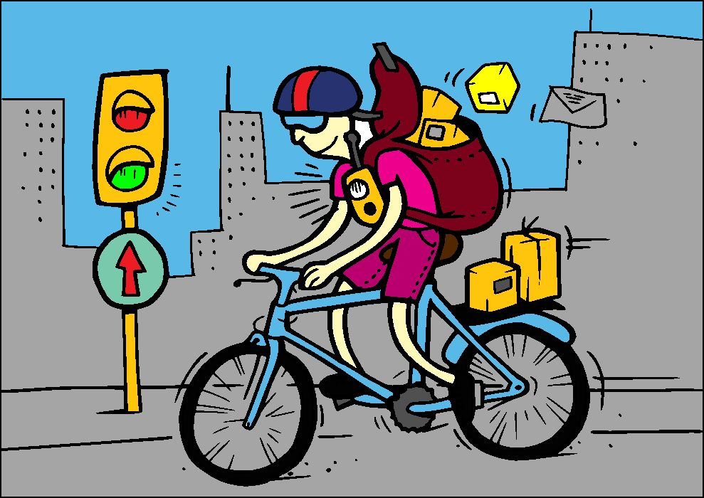
This beautiful painting is made by Krishnanand Jha. He is 13 years old and has muscular dystrophy but his disability has not come in the way of making such a beautiful piece of art.
पेशीय दुर्विकास (मस्कुलर डिस्ट्रोफी) / Muscular Dystrophy
पेशीय दुर्विकास (मस्कुलर डिस्ट्रोफी) का शाब्दिक अर्थ होता है शक्ति क्षीण होना या पेशीय अपक्षय. पेशीय दुर्विकास आनुवांशिक रोगों का समूह है जिसमें क्रमिक अंदाज में कमजोरी आती जाती है; और गति को नियंत्रित करने वाली कंकालीय पेशियां (स्केलेटल मसल्स) छीजती जाती हैं. कई तरह के पेशीय दुर्विकास होते हैं. उनमें से कुछ जन्म के समय दिखाई पड़ जाती हैं और उन्हें जन्मजात पेशीय दुष्पोषण कहा जाता है जबकि कुछ अन्य पेशीय दुष्पोषण या दुर्विकास किशोरावस्था में विकसित होते हैं (बेकर एमडी). पेशीय दुर्विकास की शुरुआत चाहे जब भी हो लेकिन उनमें से कुछ चलने-फिरने की असमर्थता या यहां तक कि लकवा पैदा करती हैं.
डचेन एमडी
डचेन एमडी मुख्य रूप से लड़कों मे होती है और पेशीयतंतुओं की अखंडता को नियंत्रित अक्षुण्ण रखने वाली प्रोटीन डिस्ट्रोफिन को नियंत्रित करने वाली जीन के उत्परिवर्तन का नतीजा होती है. इसकी शुरुआत उसे 5 साल की उम्र में होती है और बहुत तेजी से बढ़ता है. अधिकतर लड़के 12 की उम्र में चलने-फिरने में असमर्थ हो जाते हैं और 20 साल की उम्र तक पहुंचते-पहुंचते सांस लेने के लिए उन्हें श्वास यंत्र की आवश्यकता पड़ जाती है.
फेसिओस्कैपुलोह्यूमेरल एमडी
फेसिओस्कैपुलोह्यूमेरल एमडी किशोरावस्था में प्रकट होता है और चेहरे और हाथ-पैरों की कुछ विशेष पेशियों में सिलसिलेवार कमजोरी पैदा करती है. यह धीमे-धीमे बढ़ता है और इसमें हल्के पेशीय दुष्पोषण से लेकर विकलांग तक के लक्षण पैदा करता है.
मायोटोनिक एमडी
मायोटोनिक एमडी अलग-अलग व्यक्तियों में अलग-अलग उम्र में प्रकट होता है और इसमें उंगलियों और चेहरे की पेशियों में मायोटोनिया (विलंबित पेशी आकुंचन) और अस्थिर पैर, ऊंचे कदम उठा कर चलने की चाल, मोतियाबिंद, हृदय विकार, और अंत:स्रावी विक्षोभ-जैसी तकलीफें होती हैं. मायोटोपिक एमडी से पीड़ित व्यक्तियों के चेहरे लंबे होते हैं और और पलकें भिची रहती हैं. परुषों में आगे की तरफ का गंजापन आ जाता है.
पीड़ादायक पेशीय आकुंचनों को रोकने के लिए प्राय: भौतिकोपचार का सहारा लिया जाता है. और कुछ तरह के एमडी के रोमियों के दर्द पर नियंत्रण रखने और पेशीय क्षय को रोकने के लिए कुछ निर्धारित दवाइयां दी जाती हैं. सहारा देने के लिए विकलांग उपकरणों का इस्तेमाल किया जा सकता है जबकि कुछ मरीजों के जीवन की गुणवत्ता में सुधार लाने के लिए विकृति निवारण विकलांग शल्यचिकित्सा की जाती है. कुछ मरीजों को जैसा कि पहले भी उल्लेख किया गया है. श्वसन चिकित्सा की अनावश्यकता होती है और अंतत: हृदय विकारों के लिए पेसमेकर की जरूरत पड़ सकती है.

कविता

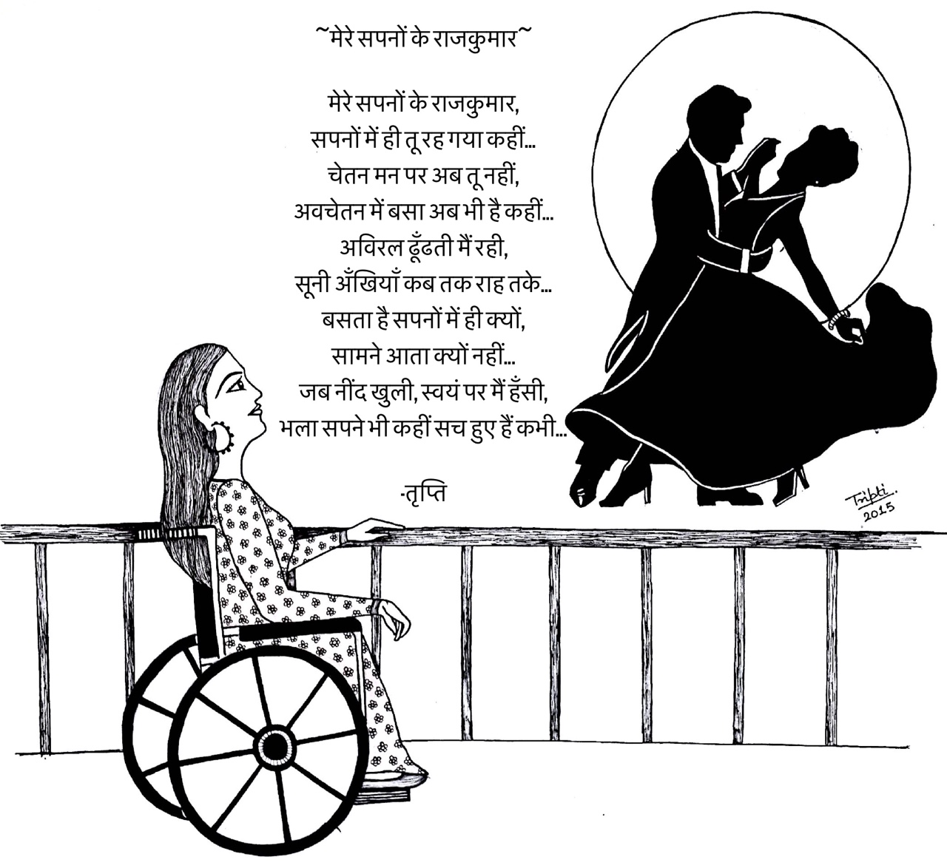
मेरे सपनों का राजकुमार

(A beautiful poem and illustration by Tripti. She is an artist by profession. She has muscular dystrohphy. Email id: Dystrophy triptisony@gmail.com)

Gandhari’s dream (English version)

(Written by Raghavan Sampathkumar)
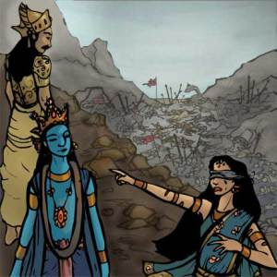
“Oh Krishna! The eternal Lord of the Universe, thou art the Director and the chief performer of this entire gory drama happened in the name of Kurukshetra war. Millions of men were slain, their spouses and children now weep inconsolably. Listen to their saddening screams, oh! Gopala! Once there were cuckoos gleefully singing in this beautiful country but now dogs and wolves happily howl after filling their stomachs by feeding on the rotting carcasses that are indistinguishable whether these are that of the warriors or of the horses and elephants.
You drank Kshatria blood of 21 generations as Parasurama. Are you still thirsty for more? Behold ! Our entire clan is obliterated. I lost all my hundred sons and my many beloved grandsons. Pandavas too lost all of their siblings and children. O Kesava, our entire vamsa vruksha (family tree) was burnt down to ashes. Let me ask you why did you let this gruesome war happen in the first place? Why?
You know everything and you could have prevented this carnage, for you have the inimitable power to do so. You could have brokered peace with your full potential but you failed to do, Oh! the mighty, miraculous, omni-potent son of Nandagopa! can you ever get to understand a mother’s pain of losing her children? Indeed you took birth after killing six of your elder siblings in the guise of Karma (fate). Ask your mother about the pain.
Now you watched the brothers of the same family slay each other with vengeance but you took side unjustifiably to annihilate only my sons. Now if I have acquired my deserving merit and power owing to my pathivratha (being a truthful wife to my husband) dharma, I shall curse thee! Just how I happened to bear the grievous burden of watching my entire family and relatives perish in the war, in 36 years from today, your Vrishni clan will also be destroyed by infighting and you will die in great pain watching it happening right in front of your eyes. Just as the mothers, wives, and sisters of the warriors died in Kurukshetra, women in your country, Dwarka, will have to weep, scream and cry over the huge piles of dead bodies!”
yelled Gandhari at Krishna, the ever-smiling, eternally shining savior of the worlds.
Krishna was just standing watching all these and listening to Gandari’s curse with his usual captivating smile in His face that even beats the glow of a lotus that just bloomed. He seemed to be neither surprised nor disappointed. Rather he seemed as if he was waiting for this occasion. However, listening to Gandari’s curse, the rest of the people in the great Emperor’s court stood dumbfounded like rocks whose face have gone aghast and pale in utter grief and pain owing to the severity of her words. She returned to her palace after venting out her anger but still deep in her mind the pain loomed large. She tried to justify her anger on Krishna. Nice and soothing breeze peacefully caressed her to make her think about the periods of unending happiness prior to the war and slowly nudged her to go to sleep.
Suddenly she woke up to a strange sound and felt the room was filled with divinely aroma and noticed a dark figure holding flute and smiling like a lightning. She immediately realised it was Krishna and her anger erupted again like a volcano.
G: “Oh! the slayer of Madhu, the great artist, have you come to check who else is alive and who can be killed next? What else is left in this country for you to destroy?”
Krishna smiled and replied “Gandhari, why don’t you stay calm? I thought you vented out your anger completely by cursing me?”
G: “No! How can I stay calm when my hundred sons were killed brutally in the war. Why didn’t you attempt to prevent this war from happening? Why?”
K: “Gandhari, I know you. You are my beloved follower and an ardent devotee. So, I am bound to your question. Yes, I could have stopped the war or I could have just obliterated everything in a flash of a second with my power of sankalpa (determination).”
G: “Then why did you remain a mute spectator to it and even directed it as you wished?”
K: “My beloved Gandari! The yuga (era) ends as the war ended as I mentioned in my Gita. Kaliyuga starts from the day the great war ended. Everything is happening as per the rules of the universe so don’t let your mind get clouded by worldly issues and try to understand my words.”
“In this grand palace that is filled with darkness of ignorance, Vithur is the only string of light with his true divine wisdom of knowing who I really am.”
G: “Krishna! Indeed, I came to know about both you and Vithur today and became fully aware of your cruel and ostensible benevolence.”
K: “Dear Gandari! Don’t ever imagine even for a second bad mouthing about my true followers. It is perhaps the greatest of all sins that has not even the slimmest possibility of redemption for thousands of births. Now, I will surely answer your question but let me ask a few to you and try if you can answer them.”
G: “Go ahead, Krishna”
K: “Why didn’t you curse your husband? He is the root cause of all of Duryodhan’s sinful behavior and hatred towards Pandavas. Had he wished, he could have fostered better relationships between the brothers by duly giving the Pandavas what they truly deserve – their share of the rajya (country). Rather he chose to be oblivious to the enmity Duryodhan and his brothers cultivated from their young age towards the sons of Pandu.
“Then, why didn’t you curse Bheeshma, Krupa and Dronacharya? These great men hath let Duryodhan insult the queen of Pandavas by pulling her clothes off in front of thousands of spectators. All these saintly men are respected and the most educated but eventually became puppets at the hands of merciless Duryodhan and even fought against the Pandavas conveniently ignoring their own conscience questioning them. Vithur was the only one who paid heed to his own conscience and dharma and chose not to participate in the war. Just like Vibheeshan in my previous Rama avatar”
“Why didn’t you curse your son for he is the most sinful creature of all? He perhaps did the most heinous crime of ordering the Pandavas’ queen; who must be respected as equal to you (mother); and also as the spouse of his own brothers to sit on his lap as a slave. Thus he became the inimitable testimony for the greatest punishment that one – who insults women of purity and righteousness – can ever get in all the three worlds.”
“Lastly, why didn’t you curse your own brother, Shakuni? He, with his criminal mind and cruel instincts, indeed laid the foundation of your sons’ demise.”
G: “Oh Krishna, stop! He is my brother and all those who you mentioned were my relatives and kinsmen.”
K: “Poor Gandhari! Then who am I for you, your family and the whole world? Pandavas considered me one among them. Actually, they completely surrendered unto me and were protected.”
G: “Krishna! Don’t try to fool me. Kunti is your maternal aunt. So it’s natural for you to be on their side.”
K: “Poor ignorant Gandhari! I am the closest friend of all those who are righteous, benevolent and honest in the world. I always reside in the hearts of all those good people who don’t even think of harming others by words or deeds. Understand this well before even trying to understand me!!”
K: “Fine Gandhari! Let’s assume Pandavas were defeated and killed by your sons. Your son would have become the emperor. And that would have made you happy, correct? Wouldn’t it be called selfishness?”
G: “Madhusudhana! Any mother will be happy about good things happening to her children.”
K: “Yes, Gandhari. Am the mother of this vast universe. I created everything in this world and hence why shouldn’t I be selfish in my thinking of destroying the evil and nurturing the good for my children?”
G: “Then why I only should suffer by losing my children, my Lord?”
G: “Priyeh! (Oh my beloved!) everything in the universe is bound by karma, the actions and consequences that people have to go through during their endless cycles of births and deaths. Even though I am beyond all the karma and its results, I don’t interfere in one’s karma. That’s why I have created humans with the sixth sense to judge by themselves and distinguish the wrong and the right.”
Krishna continues…
“Just ask yourself, if I am the omni potent, then why in my earlier Rama avatar, struggle to that extent to get the help of monkey herd to kill Ravana and rescue Sita?”
“Am the primordial substance, the peerless preceptor and the Supreme Personality of Godhead, who doesn’t have any need whatsoever to put my prowess on display by doing cheap miracles or black magic. Neither I need any advertisement for my endless powers. But it’s my primary responsibility to glorify my truthful followers, my beloved bhagavathas.”
Krishna paused a while and said,
“Without the war, how could the world have come to know about the greatest of the Warriors – Abhimanyu; Bhishma’s integrity and determination, which is stronger than the mountain Sumeru; the unmatchable glories of Karna- who is the personification of magnanimity by donating everything including himself to others.”
“On the other hand, the world needs to learn from the gory endings of the most cruel, malignant, and sadistic humans to walk on the earth such as Ashwatthama, Jayathradha and your beloved brother Shakuni. These are the ultimate goals of me stewarding the war.”
G: “That’s fine Krishna. I can understand but you were on the side of the Pandavas, right?”
K: “Wrong Gandhari! I was, am and will always be on the side, which is of ‘Dharma’. Nevertheless it’s your son who shunned me – as I vowed not to touch any weapon in the war – and instead preferred my army when he got an opportunity to choose. I can only laugh at his ignorant mind, which believed that one’s strength lies in his weapons. Anyway, I was always with you and your spouse in the guise of Vithur and his truthful words. It’s you who didn’t care to understand my presence. I am present wherever there is dharma.”
K: “Even today, I might not have come in your dreams, but I rush to help those who care to think about me even for a second. Moreover, you are my beloved bhakthai (follower) so I wanted to speak to you through your dreams. In fact, I saved you from another greatest sin, had you cursed any of the Pandavas instead of me.”
Now Gandhari speaks with tears welling up in her eyes.
G: “Oh! Dear Govinda! How do you still show such boundless mercy and love on me?”
K: “Priya Gandhari! This is my style and habit to recognize true devotees and be at their service.”
G: “Oh graceful Vanamaali! I realized now the deeper manifestations of our karma. Can you be merciful to show me the ways and means of eternal bliss? The one that transcends the yugas and helps me attain your golden feet in Sri Vaikuntam?”
K: “Dear Gandhari! You asked the right question at the right time. Let me tell you in simple words what I narrated Arjuna in 18 detailed chapters.
Ananya-s-chintayanto Maam Yae Janaah Pary-upaasatae
Taesham Nithya-abhi-yuktaanaam Yoga-kshemem Vahami-aham
“I reside in those who think about me all the time and when one has complete trust upon me, I take the complete and absolute responsibility to assure everything needed in his/her life in this mortal world and the blissful life beyond.”
G: “Oh Parama Dayala! (One with boundless mercy) forgive me for my curse and other sins and help me reach your lotus feet as soon as I can.”
K: “Don’t worry!! Even your curse is a means and a trick in my game that I dictate. When the time comes, my staunch enemy from my previous avatar – Vaali – will take life as a hunter and let me leave this world in the same way I killed him. Hence, keep chanting my sahasra (1000) namas (names) and you will reach me in time.”
Then suddenly she regained her senses and started wondering whether the experience and the conversation was a dream or happened really.
Nevertheless she realized the underlying message that she and her husband need to relinquish their worldly material lives and head to the jungle to do penance in order to attain moksha (eternity). So she slowly started walking towards her husband’s palace.
A dark figure with an enchanting aura billion times brighter and glorified than the Sun, was standing behind her and smiling at His just enlightened devotee.
———————–
Humble prostrations at the golden feet of acharyan

Quote of the Quarter

I don’t look to jump over 7-foot bars: I look around for 1-foot bars that I can step over…
Warren Buffett

मैं ७ फुट के अवरोध को पार करने की नहीं सोचता: मैं १ फुट का अवरोध ढूंढता हूँ जिसे मैं पार कर सकूँ….

