

Contents

Editorial 3

Quote of the Quarter! 5

Crime prevention for the people with disabilities 6

Personality of the Quarter 8

Károly Takács 12

Need New Normal Now 14

Tips for Safe Exercise with Multiple Sclerosis 16

Big News This Quarter 18

Tips of the Quarter 20

Ayurvedic Remedy and Cure for Constipation 20

मुस्कुरा ऐ ज़िन्दगी...! 23

दिखाएं हाथ का हुनर पाएं रोजगार 26

कविता 28

कर्म की महानता 30

# snapshot-024.jpgEditorial

Today when I again sit down to write the Editorial column of this magazine, I am thinking about various disabilities that remain invisible and so the problems associated with these disabilities remain under the layers of ignorance. One of such disabilities is Dyslexia.

Fifty years ago, dyslexia and other learning differences were unclear and very rarely understood concepts. Their study remained limited to a small corner of the medical world. Fortunately today research into dyslexia and other language-based learning disabilities is on the cutting edge of neuroscience.  Researchers are now using the technology of functional magnetic resonance imaging (fMRI). By this they are now able to image the working brain and literally see the difference in circuitry of dyslexic readers. So a lot is being done in this field and their publications are doing a great work of bringing awareness into this area.

Students with reading disabilities, such as dyslexia, have difficulties with the most basic step in the reading process: breaking down the word into the simplest sound units.  To put it into simpler form we can say that they simply are unable to break the reading code.  And yet they commonly have strengths in problem solving, reasoning, and critical and conceptual thinking. Unfortunately our education system still lags behind. Dyslexic readers are disproportionately penalized by standardized, multiple-choice tests that provide scanty context to them. Our educational system that is run on the traditional methods of testing the knowledge of the students hardly realizes that the skills and strengths of the students with dyslexia in areas of thinking, reasoning, problem solving and creating are often more difficult to measure, and yet ultimately far more important.

There is a need for a level playing field in standardized tests and this need remains relevant and urgent. The teachers in inclusive education set up must be well trained to know that dyslexic learners have difficulty with the printed word, they benefit from multisensory approaches to reading, writing, and even arithmetic. The response mode can be changed to underlining, selecting from multiple choices, sorting, or marking. Students with fine motor problems can be given extra space for writing answers on worksheets or can be allowed to respond on individual chalkboards.

We need to help the Dyslexic students discover their personal learning style (auditory, visual or kinesthetic) and teach them how to use their strongest sense to process information and perform new skills with greater understanding.

A lot has to be done in this area in our country if we want to fulfil the dream of inclusive education and Universal Design.

Have a happy reading!

Abha Khetarpal

President

***Editor in chief***

Abha Khetarpal

***Designing and lay out***

Rajendra Maurya

***Cover Page***

Tanya Chawla

Cross the Hurdles

# Quote of the Quarter!

I was always looking outside myself for strength and confidence, but it comes from within. It is there all of the time. **…Anna Freud**

# Crime prevention for the people with disabilities

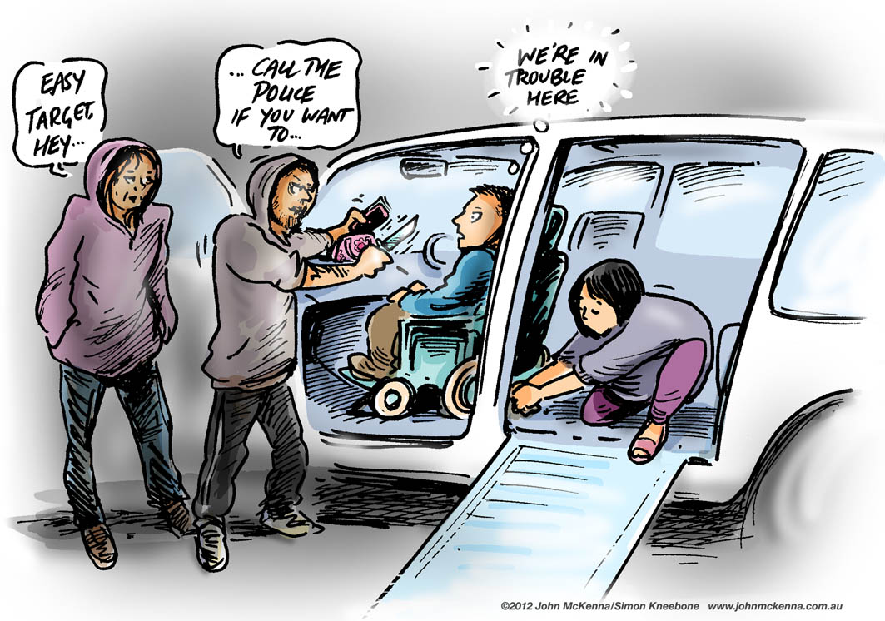Changes in hearing, vision, flexibility and mobility all are a natural and unavoidable part of life as anything might happen during the course of life. Even as we grow old, many kinds of disabilities creep into our lives. But this doesn't mean people with disabilities are incapable of protecting themselves.

To take common sense safety precautions must always be taken to reduce vulnerability. Following safety tips might be helpful in this regard:

* Whenever possible, travel with someone you know. There's strength in numbers.
* Have a plan for what you will do if confronted. Show confidence, yell, use a body alarm or whistle or find some other way to make noise.
* Be realistic about your limitations. Avoid places or situations that put you at risk, such as dark alleys and unlit parking lots.
* Avoid establishing predictable activity patterns. Most of us have daily routines, but never varying them may increase your vulnerability to crime.
* If a wheelchair user or using other adaptive device, one should keep money and personal items hidden from view, but easily accessible. Use a fanny pack or pocket attached to the wheelchair arm rather than bags attached to the rear of the chair.
* Have emergency phone numbers and a means of contacting emergency assistance available and accessible to you at all times.
* Plan an escape route from each room in your residence to use in case of emergency.
* Make sure doors have peepholes or viewing areas at a level that allows you to view visitors.
* Put good locks on all the doors and windows. Use them while you're home as well when you're out.
* Never open the door for a stranger. Ask for proof of who they are and the purpose of their visit. If one is visually impaired and unable to see the person's official identification, verify by checking the person's identity with their agency.
* Never tell a stranger calling by phone that you are alone or disabled.
* When riding a bus, sit as close to the driver as possible.
* Always carry your medical information in case of an emergency.
* If one has speech or hearing impairment, one must carry a card of communication symbols to ensure that it can be understood by others.
* If there is difficulty in speaking, have a friend record a message giving your name, address and type of disability to use in emergencies. Keep the tape in a recorder next to your phone.

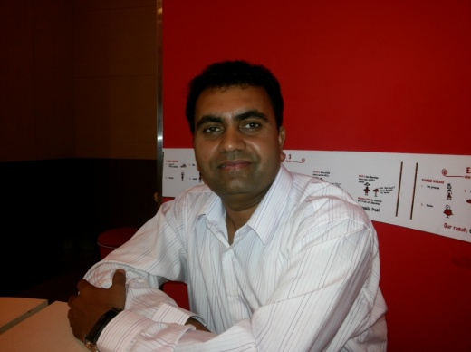

Contributed by Rajendra Maurya (Team member Cross the Hurdles)

# Personality of the Quarter

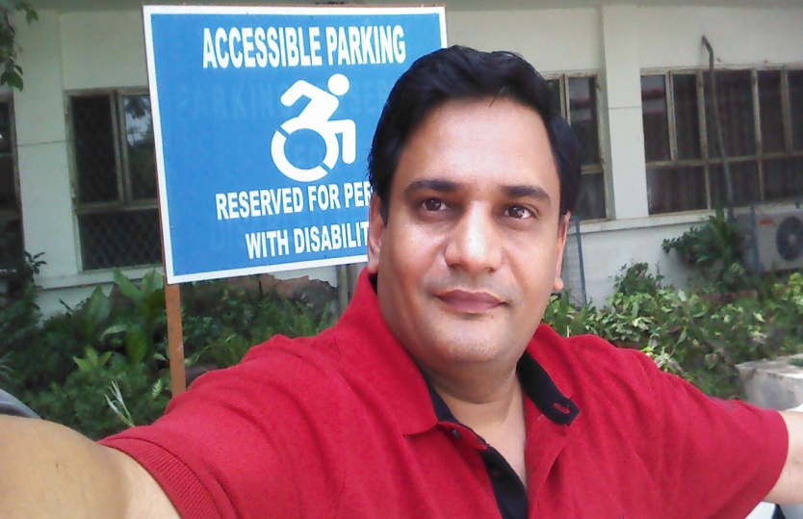

***Dr Satendra Phalswal, apart from being a doctor and a teacher, is involved in many other activities like he is member of Medical Education Unit, Coordinator, Equal Opportunity Cell, Founder of Infinite Ability, involved in "Theatre for Oppressed", writes for medical journals, working as a member of many editorial boards of international journals etc. He loves adventure trips. He is an ardent fan of Zimbabwean Cricket Team, He is makes sure that he is watches the first day first show of Anil Kapoor’s and Sonam Kapoor’s movies and what not! Let us meet Dr Satendra Singh as our Personality of the Quarter in this issue:***

Dr Satendra Singh, you are known as a disability rights activist, please tell us your views about politicization of disability seen at present in this country?

To be honest, I am not an activist. Like any other disabled person in India, I face these problems day in and day out. It bothers me, it affects me. I refuse to take injustice lying down. Being a person with mobility impairment doesn’t mean I cannot stand up for my rights. We often do not raise our voice and that’s the reason why our voices are not heard. Sadly, we have friction among our own disability communities. Few self-centered so called ‘disability activists’ are derailing the momentum. Disability is about diversity and there has to be difference of opinion. That doesn’t mean we should pull each other. There is no reason why we can’t work together.

You are a doctor, a teacher, a husband, a father, a son. What role you like to play the best?

Multitasker…yeah, that explains it. I am passionate towards medical education, medical humanities, disability rights, Anil Kapoor, Zimbabwean cricket team. I wear these multiple hats with equal obsession. Similarly, the roles of a doctor, teacher, husband, father and a son comes naturally to me. The transition into multiple personalities is not difficult for me. Still, if you insist, I would say I am a ‘learner’. I am still learning how to be a humane doctor, an evolving teacher, a romantic husband, a responsible father and a dedicated son.

How do you manage so much of work pressure and taking care of your family all at the same time? From where does that energy come? 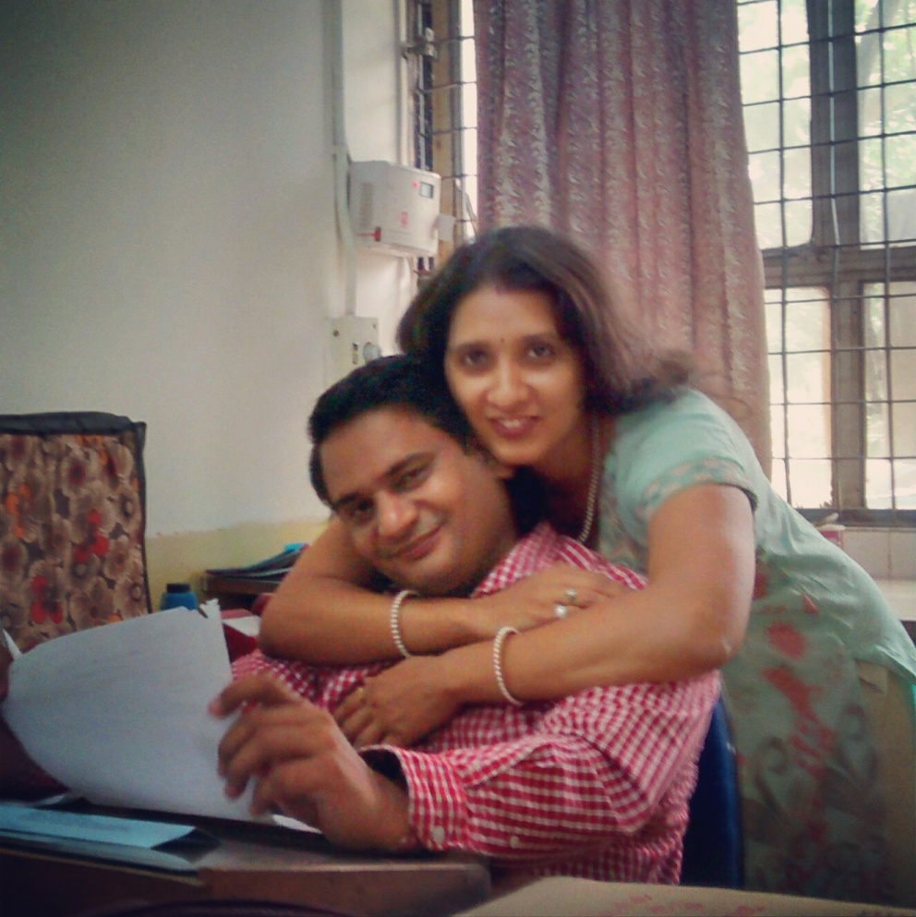

I am a workaholic and I love being busy. My beautiful wife is responsible for giving me the space to balance work and family. She manages everything at home and I don’t have to worry. The mental peace at home is very important. The extra energy for raising disability issues comes from discrimination. How can you tolerate that? Be it UPSC discrimination, inaccessible medical institutions, ATMs , post offices, polling booths, dehumanizing security procedures at airports, disability certification, complexity in availing assistive devices, I have been involved in each one of these personally. I refuse to accept harassment and fight for it. What follows is a lengthy battle of letters, reminders, RTI’s, media reports and negotiations with ministries. One has to move out of his/her comfort zone. Things do not come on silver platter. In India you have to fight for your rights, they are not granted. A person with disability has huge patience and fighting abilities. I am no different. Just channelize your energy effectively.

If you were not a doctor, what would you have been?

I had both Maths and Bio in class XII but I never tried for engineering since I always wanted to become a doctor. I don’t know where I would have been if not in this profession. May be in film line directing Anil Kapoor to an Oscar winning film or may be Coach of Zimbabwe cricket team and making them World Champions or may be a correspondent at National Geographic or Discovery.



If you are one day to change the things in our country, what changes would you like to bring?

Universal design in each and every thing that is possible. Universal design in physical spaces to bring out accessibility. Universal design for learning to bring out curricular reforms and reaching out diverse learners…Universal design in technology to reach out each and every individual under the sun.

What is your opinion about the Karma theory of disability?

Personally I feel it’s a disgusting doctrine. I don’t believe in past life, I believe in present. It’s the work which counts; it’s the intention which matters. Saying "it's my karma" is a pathetic way of disgracing yourself. A person without a hand doesn’t have a lifeline but he still lives. You create your own destiny. It’s not in someone else’s hand. Impairments are part and parcel of life. They are universal. We all are temporarily able bodied. People have impairments, it’s the society which makes us disabled and not the past sins or karma’s. Impairments are secondary, life comes first. Let’s experience it the fullest. Who cares about future or past life!

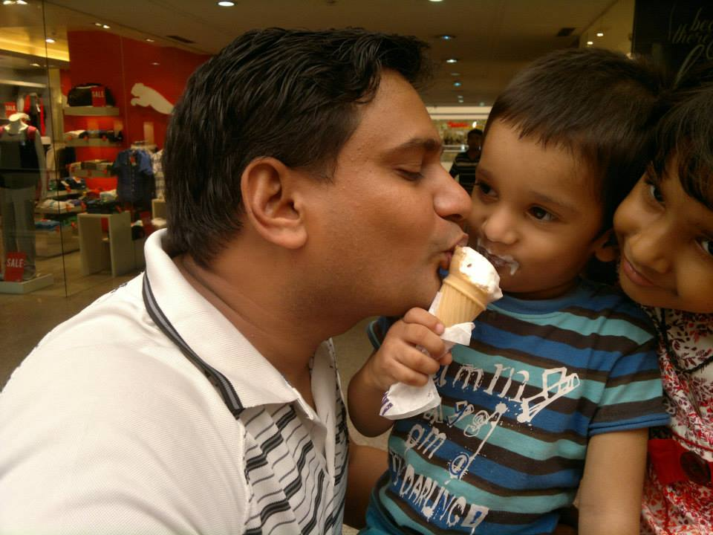Has your disability ever come in your way of bringing up your children or your being a loving and caring husband?

Many times. It’s pretty ‘normal’ for a disabled person to encounter these in raising his/her family. The main reason for this is the attitudinal barriers prevalent in our society. The lack of sensitivity at times is unintentional because of their lack of knowledge about our disability. If, the insensitivity is intentional than we must not accept it must raise our voice.

The root cause of this, I believe, is lack of inclusive education. Right from the beginning we must promote diversity in schools. There is no happy sight than a disabled and non-disabled child learning from each other. Many times non-disabled person don’t know how to help because of their ignorance’s.

What message would you like to give to the people with disabilities?

You only get one life, make the most of it. Having said that, don’t live for your own dreams; do something for others as well. You may leave the world but your actions will be remembered forever.

**Biography**

# Károly Takács

**K**

**ároly Takács** (Hungary), born on 21 January 1910 –died on 5 January 1976)was the first shooter to win two Olympic gold medals in the 25 meter rapid fire pistol event, both with his left hand after his right hand was seriously injured. He is the third known physically disabled athlete to have competed in the Olympic Games after George Eyser in 1904 and [Olivér Halassy](http://en.wikipedia.org/wiki/Oliv%C3%A9r_Halassy) in 1928, followed by Liz Hartel in 1952 and [Neroli Fairhall](http://en.wikipedia.org/wiki/Neroli_Fairhall) in 1984.

Takács was born in Budapest and joined the Hungarian Army. By 1936, he was a world-class pistol shooter, but he was denied a place in the Hungarian shooting team for the 1936 Summer Olympics on the grounds that he was a sergeant, and only commissioned officers were allowed to compete. This prohibition was lifted in Hungary after the Berlin Games, and Takács had expectations of success at the 1940 Summer Olympics, scheduled to be held in Tokyo. 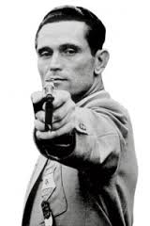

During army training in 1938, his right hand was badly injured when a faulty grenade exploded. Takács was determined to continue his shooting career, and switched to shooting with his left hand. He practised in secret, surprising his countrymen when he won the Hungarian national pistol shooting championship in the spring of 1939. He also was a member of the Hungarian team that won the 1939 ISSF World Shooting Championships in the event. The Olympic Games scheduled for 1940 and 1944 were cancelled due to the Second World War, but Takács surprised the world by winning the gold medal at the 1948 Summer Olympics in London, aged 38, in 25 Meter Rapid Fire Pistol. Beating the favourite, Argentine Carlos Enrique Díaz Sáenz Valiente, who was the reigning world champion, into second place, setting a new world record.

He won a second gold medal in the same event at the 1952 Summer Olympics in Helsinki, and also attended the 1956 Summer Olympics in Melbourne, but finished eighth and failed to win a third medal. His story has given him a place among the "Olympic heroes" of the International Olympic Committee. Although most associated with rapid fire pistol, Takács also won a bronze medal at the 1958 ISSF World Shooting Championships in 25 metre center-fire pistol. He also won 35 Hungarian national shooting championships.

After his shooting career, Takács became a coach. He trained Hungarian [Szilárd Kun](http://en.wikipedia.org/wiki/Szil%C3%A1rd_Kun), who won the silver medal at the 1952 Summer Olympics. He ended his army career as a lieutenant colonel.

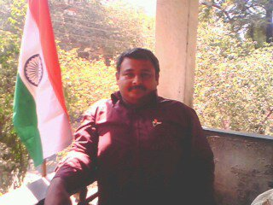Mani  Laxman  Panse

588, Shukrawar Peth

Sathe  Colony

Pune -411002

020-24461977 (Residence)

09370431977 (Mobile)



# Need New Normal Now

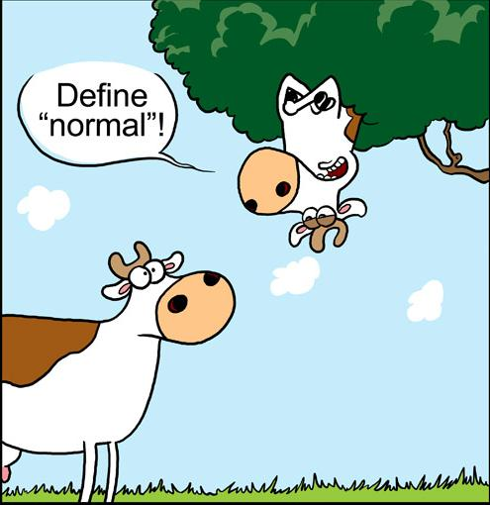Times have changed in the last two decades and how, as all of us have stood in wonder and applauded the changes, welcomed them with open arms. We have the mobile phones and the internet which have shrunk the world. We have conferences between people sitting in four different continents in their different time zones. We are going more digital, more state of the art, with every passing day.  From VCRs to DVDs to Blue Rays to Home Theatres. From latest AC cars to AC offices and homes, life has changed so much.

It is said that - change is the only permanent thing, but guess what has not changed, and sadly so - the definition of NORMAL has not changed. With the passage of time we are having more and more children who are not NORMAL. The reasons are still debatable but the facts remain. Their numbers are growing steadily and surely. All we have done is, instead of calling them ABNORMAL we have started calling them Special Children.

Is this happening because of all these so called technological advances that we are making, which are having an adverse effect on our coming generations? Are they paying the price for our ever increasingly luxurious lives or is it that they are the NEW NORMAL!!

Meet a child like that and you’ll know what I mean. They are so innocent, they have no bad feelings for you or anybody, they respond to love and love alone. They do not abuse, they do not compete, they are not jealous; in fact they are above all these petty feelings that we NORMALS so abundantly have. Their souls are pure and innocent. They only know to give and accept love in large measures.

May be, just maybe it is God’s wish to have these beautiful souls amongst us, as a reminder that when HE created us we were just as innocent as these special children are. We did not have any language back then and yet we communicated; we did not have anything but yet we made it so far…so far ahead that we have almost forgotten where we started from. Maybe God is recreating a new world.

Their increasing numbers prove that more than ever before, we need to define a **new normal now**. We need to mold our lives more and more around these special children. Instead of looking for including them we need to be included in their lives and learn new lessons they are here to teach us because they surely are God’s angels. They are here to show us, that despite our mis-endeavors, the complete disregard of what God has given us, despite our pettiness; God still loves us and has given us a second chance to reclaim the innocence lost.

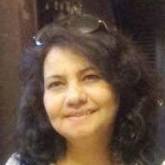Reva Sudeep, A social Activitist

**Expert Speak**

**Dr Preetika Kalra**

**BPT, MPT (NEURO), MDCPT, MIAP**



# MS.jpgTips for Safe Exercise with Multiple Sclerosis

Check with your doctor before beginning any exercise program. He may make recommendations about:

* The types of exercise best suited to you and those you should avoid
* The intensity of the workout (how hard you should work)
* The length of your workout and any physical limitations
* Referrals to other professionals, such as a physical therapist, who can help create a personal exercise program that meets your needs. The type of exercise that works best for you depends on your symptoms, fitness level, and overall health.
* Always warm up before beginning your exercise routine and cool down at the end.
* If you plan to work out for 30 minutes, start with 10-minute workout sessions and work your way up.
* Work out in a safe place; avoid slippery floors, poor lighting, throw rugs, and other potential tripping hazards.
* If you have trouble balancing, exercise within reach of a grab-bar or rail.
* If at any time you feel sick or you begin to hurt, STOP.
* Select an activity that you enjoy and have fun. Water aerobics, swimming, tai chi, and yoga are examples of exercises that often work well for people with MS.

What Should Be Done When Overheated?

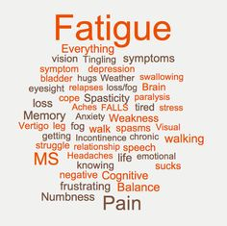Some people with MS are sensitive to heat, which means they notice that their symptoms either reappear or become worse when their body heat rises. This might happen during or after exercise. Here are some tips to avoid overheating.

* Don't exercise during the hot time of the day (10 a.m. to 2 p.m.). Try to exercise in the morning or evening if you are exercising outside.
* Drink plenty of cool fluids.
* Become aware of your body. If you notice any symptoms that you didn't have before you began exercising, slow down or stop exercising until you cool down.
* Swimming and water aerobics are good ways to stay cool while you exercise. Also, make sure that there are non-slip floors in the locker room and around the pool.



# Big News This Quarter

**Exempted from routine transfer**

The Central Government has said that the government employees who have children with disability to take care of will be exempted from routine transfers and they will not be asked to take voluntary retirement on refusing such postings

A government employee who has a child with disability serves as the main caregiver and any relocation of such an employee will effect the systemic rehabilitation of the child since the new environment or set-up could prove to be a hindrance for the rehabilitation process, the order said.

Here the word 'disabled' includes blindness or low vision, hearing impairment, locomotor disability or cerebral palsy, leprosy, mental retardation, mental illness and multiple disabilities.

Upbringing and rehabilitation of child who has some disability require financial support. If the government employees are made to choose voluntary retirement on the pretext of routine transfer or rotation transfer, this can have adverse impact on the rehabilitation process of the disabled child. This directive therefore has been circulated to all central ministries and departments. It has also been mentioned that the support system (for rehabilitation) includes preferred linguistic zone, school or academic level, administration, neighbours, tutors or special educators, friends, medical care including hospitals and therapists. So any displacement of such a government employee would have a “bearing on the systemic rehabilitation” of the child since the new environment could prove to be a hurdle for the rehabilitation process.

The order came following demands from several quarters that a government employees.

# Tips of the Quarter

# Ayurvedic Remedy and Cure for Constipation

* Soak the mix of Amaltas fruit + Tamarind, keep it overnight, before drinking mashed and filter it. This is the good Ayurvedic remedy for constipation.
* 10-20 ml fruit juice twice a day is useful in curing constipation.
* Increased the use of coconut oil, especially in diet as it is the effective Ayurvedic treatment for constipation.
* 5 ml ghee along with warm milk may be taken at bed time with sugar. It is a good natural remedy for constipation.
* Spinach juice relieves from chronic constipation.
* Isabgol(Plantago ovata) and vitis vinifera boiled with milk take the mix at bed time with 5 ml ghee. It is Ayurvedic remedy for sluggish bowel movements.
* Triphala powder is an excellent cleanser and natural colon cleanser for constipation.
* Warm lemon juice helps in clearing motion and constipation problems.
* Aloe vera juice cleanses the intestine and relief from constipation.
* Bael fruit, an Ayurvedic food, is helpful in removing waste from the body.
* Raisins are packed with fibre and act as great natural laxatives. Soak a handful in water overnight and have them first thing in the morning on an empty stomach.
* Castor oil is beneficial for the disease.
* Haritak, an Ayurvedic herb, helpful for treating constipation.
* Spices like cumin seeds, coriander, and turmeric powder easily digested the foods. All these are good Ayurvedic product for constipation.
* Guavas have soluble fibre in the pulp and insoluble fibre content in the seeds.
* They also help with the mucus production in the anus and with peristalsis (a series of contractions within the intestinal lining that helps the passage of food in the stomach)
* Lemon *(Nimbu)* juiceis recommended by most Ayurvedic practitioners as a quick and simple remedy for constipation. A warm glass of water with lemon and salt, first thing in the morning not only acts as a cleansing agent for the intestines, the salt content helps in quick and easy passage of stool.
* For relief from constipation, boil a few figs in a glass of milk, drink this mixture at night before bed.
* You can have about 100 ml of spinach juice mixed with an equal quantity of water twice daily.



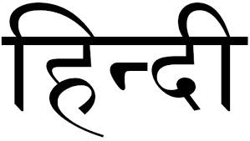

**कहानी**

# 6.jpg मुस्कुरा ऐ ज़िन्दगी...!

अपराजिता नाम था उसका और अपने नाम के अनुरुप ही कभी हार नहीं मानी उसने। वक़्त की हर ठोकर को अपने मनोबल से उसने एक नया मुकाम दिया।  
  
अपने माता-पिता की एकमात्र संतान थी वो। उसके माता-पिता ने उसे लेकर जो सपने देखे थे, वो उस वक़्त चूर-चूर हो गये जब 5 वर्ष की उम्र में पोलियो ने उसे व्‍हील-चेयर पर बैठा दिया।  
  
उसके माता-पिता एक पल को डगमगाये तो थे, पर उन्होंने हार नहीं मानी। उसे हर संभव लाड़-प्यार दिया और वक़्त के झंझावातों से लड़कर दुनिया के सामने मजबूती से खड़े होने का हौसला दिया। प्यार से अपरा बुलाते थे वो उसे।  
  
वक़्त धीरे-धीरे गुज़रता गया, अपरा धीरे-धीरे बड़ी होने लगी। उसे देख कर कोई नहीं कह सकता था कि उसने कभी जिन्‍दगी से हार मानी होगी। हर समय हँसती-खिलखिलाती रहती थी वह। उसके माता-पिता भी उसकी खिलखिलाहट से अभिभूत हो जाते थे।  
  
कल्पना चावला को देखकर पता नहीं क्‍या हो जाता था उसे। कल्पना के अनेकों पंख लग जाते थे और वो आकाश की अनन्‍त उँचाइयों पर उड़ने लगती थी। पर उसके पंख तो वक़्त ने बेरहमी से कुचल दिये थे। फिर भी उसने अपने हौसलों की उड़ान को कभी थमने नहीं दिया। वक़्त के साथ और ज़्यादा मजबूत बनाती गई वो उन्हें।  
  
कल्पना चावला तो वो नहीं बन सकती थी, पर औरों को बनने के लिये प्रेरित तो कर सकती थी; यही सोचकर शिक्षण को उसने प्रोफेशन के रुप में चुना। शायद यही वो प्रोफेशन था, जिसमें उसकी अपंगता आड़े नहीं आती।

वो दिन भी जल्दी ही आ गया, जब उसका चयन दिल्ली विश्वविद्यालय के एक विख्यात कॉलेज में प्रवक्ता के रुप में हो गया। खुशी से फूली नहीं समा रही थी वो। आज वास्तव में उसे महसूस हो रहा था, जैसे वो अनंत आकाश की उँचाइयों में उड़ी जा रही हो।

धीरे-धीरे वक़्त बीतने लगा। कभी-कभी उसका मन अनमना सा होने लगता था, जब वो किसी प्रेमी-युगल या विवाहित जोड़े को देखती। उसका मन विचलित होकर पूछने लगता, ‘‘ क्या उसे कभी कोई प्यार से स्वीकारेगा?''

पर ऐसे विचारों को वो अपने पर हावी नहीं होने देती। आखिर ईश्‍वर ने उससे ऐसे सपने देखने का हक जो छीन लिया था और ये सपने उसके मन के किसी कोने में टीस बन कर दफन हो गये थे।  
  
उसने कभी सोचा नहीं था कि चैतन्य इस तरह उसकी ज़िन्दगी में प्यार की फुहार बन कर आयेगा और उसका जीवन खुशियों से भर देगा। चैतन्य से उसकी मुलाकात एक Social site पर हुई थी। धीरे-धीरे ये मुलाकात इस तरह प्यार में बदल जायेगी, उसने कभी सोचा भी नहीं था।  
  
‘‘ मेरी जीवनसंगिनी बनोगी? '' हैरान रह गई थी वो, चैतन्य के मुख से यह प्रश्न सुनकर। उसके गाल पर हौले से चपत लगा कर चैतन्य ने उसकी तंद्रा तोड़ी।

खिलखिलाकर हँस दिया था वो। वह भी काफी देर तक उसे इस तरह हँसते हुये देखती रही। फिर हौले से उसने चैतन्य के कंधे पर अपना सिर रख दिया। उसकी आँखों से खुशी के आँसू बह-बह कर उसके अन्‍तर्मन को भिगोते रहे।

चैतन्य से विवाह के पश्‍चात तो जैसे उसकी जिन्‍दगी में खुशियों की बाढ़ आ गई थी, वो उसे सिर-आँखों पर बैठा कर रखता था। पर उसकी खुशियाँ उस समय थम गईं, जब डॉक्‍टर ने उसे बताया कि बच्चे को जन्म देना उसके लिये खतरे से खाली नहीं हैं। लेकिन चैतन्य ने तो जैसे उसकी खुशियों की ज़िम्मेदारी अपने सिर ले ली थी। हँसता हुआ बोला वह, ‘‘ इसमें उदास होने की क्या ‍या बात है? दुनिया में इतने अनाथ बच्चे हैं, उनका हाथ थामने वाला भी तो कोई होना चाहिए। ''  
  
चैतन्य की बात सुनते ही अपराजिता के चेहरे की हँसी लौट आई और वो भी उसके साथ खिलखिलाकर हँस पड़ी।

अगले ही दिन वो ‘सरोजनी देवी अनाथालय' पहुँच गये; सारी रात नींद नहीं आई थी अपराजिता को। अन्दर पहुँच कर दोंनो एक स्वर में बोल पड़े, ‘‘ हमें एक बेटी को गोद लेना है।'' फिर दोनों ही एक दूसरे की तरफ देख कर मुस्कुरा दिए।

सारी औपचारिकताएँ पूरी करने के बाद वे अन्दर एक बड़े से हॉल में पहुँचे। जब वो एक बच्ची के पास से गुजर रहे थे, तभी उनके साथ आई अनाथालय की संचालिका ने कहा, ‘‘ इसे रहने दीजिए, यह ‘डाउन सिंड्रोम' से पीड़ित है और शायद कुछ ही दिनों की मेहमान है।'’

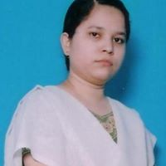पर अपराजिता की नजर तो उस बच्ची से हट ही नहीं रही थी। उसने हौले से उसके गालों को छुआ। अचानक उस बच्ची ने उसकी उँगली को पकड़ लिया; जैसे कह रही हो, ‘‘ माँ ! मुझे अपने साथ ले चलो।''  
अपराजिता ने चैतन्य से आँखों ही आँखों में कुछ कहा; चैतन्यने भी प्यार से सहमति में सिर हिलाया। कुछ पलों बाद दोनों ‘अनन्या' के साथ अनाथालय के बाहर थे; यही प्यारा सा नाम तो दिया था उन्होंने अपनी परी को।  
जिन्दगी दूर खड़ी उन तीनों को देखकर मुस्कुरा रही थी...................!!  
  
  
 गायत्री गुंजन

(भूतपूर्व प्रवक्ता, कुमार आर सी कालेज मैनपुरी यू पी)

# दिखाएं हाथ का हुनर पाएं रोजगार

ईश्वर ने जिन व्यक्तियों को हाथ नहीं दिये उन को पैर दिये हैं, जिनके पैंर नहीं उनके हाथ हैं, जिनकी आंखे नहीं उनके पास आवाज हैं, जिनके पास आवाज नहीं उनके पास सुनने और देखने की शक्ति हैं कहने का साफ अर्थ हैं ईश्वर ने कोई न कोई कमी दी हैं किन्तु उसका विकल्प भी हमारे सामने रखा हैं।

मुद्दे का विषय यह नहीं हैं कि हमारे पास क्या नहीं हैं ? मुद्दे का विषय यह हैं कि हमारे क्या उपलब्ध हैं। हम अक्सर अपनी कमियों को लेकर बैठ जाते हैं किन्तु यह हमें आभास रहता हैं कि हमारे पास कुछ न कुछ उपलब्ध हमारी अनुपलब्धता हमारी उपलब्धता पर कतई हावी न हो इसका सदैव ध्यान रखें, क्योंकि जो बीत चुका हैं उसे हम वापस प्राप्त नहीं कर सकते किन्तु जो हैं उसे तो प्राप्त करने में कोई कसर न छोड़े।

जहां तक रोजगार के क्षेत्र की बात हैं तो यह कोई विशेष विषय नहीं हैं। अगर आप के पास वे कौशल (स्किल्स) उपलब्ध हैं जिनकी उपलब्धता के आधार पर रोजगार या सरकारी नौकरी प्राप्त की जा सकती हैं तो उसे अवश्य मजबूत बनाये। उदाहराणार्थ-आशुलिपि, हिन्दी-अंग्रेजी टाईपिंग, फोटोशाप, कोरल-ड्रा, पेजमेकर, वेब-डिजाईनिंग ऐसे विषय हैं जिनके आधार पर हम कम्प्युटर में दक्षता व सरकारी व अर्द्धसरकारी क्षेत्रों में अपने कदम जमा सकते हैं, हो सकता हैं आपको एक बार में सफलता न मिले किंतु यह तय हैं देर-सवेर आपका प्रयास निपुणता में परिवर्तित हो जायेगा। फलस्वरूप आपको वो अंतिम मुकाम अवश्य मिल जायेगा जिसकी आप कोशिश कर रहे हैं।

अगर आपकी पारिवारिक पृष्ठभूमि सशक्त हैं और आपको परिवार का तन-मन-धन से सहयोग हैं और पारिवारिक उद्योग, कुटीर-उद्योग, लघु-उद्योग, व्यापार इत्यादि में कोई बुराई नहीं हैं। सिक्के के एक ही पहलू पर ध्यान न दे। दूसरा पहलू भी अवश्य देखें। सरकारी नौकरी अवश्य बेहतर विकल्प किंतु सर्वोत्तम विकल्प भी नहीं कह सकते, क्योंकि पारिवारिक जरूरतें भी मार्ग में आती हैं जिनका बखूबी हमें संचालन करना होता हैं।

अगर इस बारे में शिक्षण-प्रशिक्षण की बात आए तो हम देखते हैं। आज कई कार्यक्रम जिला उद्योग केन्द्र, ट्राइसेम योजना, जवाहर रोजगार योजना, एन.सी.वी.टी., पॉलिटेक्निक कालेज, सरकारी व गैर सरकारी कम्प्युटर संस्थान, हिन्दी-अंग्रेजी टाईपिंग प्रशिक्षण संस्थान, आशुलिपि (शार्टहैण्ड/स्टेनोग्राफी) संस्थान इत्यादि उपलब्ध हैं जिनके अन्तर्गत निरन्तर प्रशिक्षण प्राप्त करने पर हम अपना एक रोजगार या सरकारी नौकरी का बेजोड़ मुकाम तय कर सकते हैं। आवश्यकता सिर्फ इस बात की हैं कि किस क्षेत्र में हमें रूचि हैं और कौनसा क्षेत्र हमें रास आता हैं।

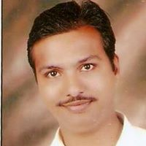

महेन्द्र आशर्वा

5, सुन्दर नगर, पाली-(राज.) 306401



**कविता**

# pic.jpg

# अपंगता.....किसकी है ये पहचान ! अपाहिज अयोग्य असमर्थ लाचार किसकी है ये पहचान ? वो जो देख नहीं पाते या जो सब कुछ देख-सुन कर भी किंकर्तव्यविमूढ़ रह जाते हैं... चलने से लाचार कौन ? वो जो खुद को बैसाखियों के सहारे बमुश्किल आगे बढ़ा पाते हैं, या जो खुद आगे निकलने की गरज़ में दूसरों को गिरा कर अपनी मंज़िल को दौड़ जाते हैं... बोल-सुन ना पाना मज़बूरी है उनकी पर जो देख-सुन कर भी बोल ना पायें क्या संज्ञा है उनकी ? कभी-२ विचार आता है मन में झकझोर जाता है भीतर तक विधाता से मानव का, सम्पूर्ण तन पाकर भी क्या मानव होने का फ़र्ज़ सम्पूर्णता से निभा पाए हम ? या दूसरों की कमजोरियों पर हंसना ही सीखा है हमने अपनी कमजोरियों को छुपाने के लिए... मानवीय अपंगता की साक्षात् प्रतिमूर्ति बन कर रह गए हैं हम अपाहिज, अयोग्य, असमर्थ, लाचार शायद यही है पहचान हमारी.....!!



गायत्री गुंजन

(भूतपूर्व प्रवक्ता, कुमार आर सी कालेज मैनपुरी यू पी)

# कर्म की महानता

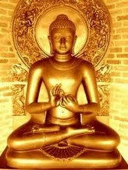एक बार बुद्ध एक गांव में अपने किसान भक्त के यहां गए। शाम को किसान ने उनके प्रवचन का आयोजन किया। बुद्ध का प्रवचन सुनने के लिए गांव के सभी लोग उपस्थित थे, लेकिन वह भक्त ही कहीं दिखाई नहीं दे रहा था। गांव के लोगों में कानाफूसी होने लगी कि कैसा भक्त है कि प्रवचन का आयोजन करके स्वयं गायब हो गया। प्रवचन खत्म होने के बाद सब लोग घर चले गए। रात में किसान घर लौटा। बुद्ध ने पूछा, कहां चले गए थे? गांव के सभी लोग तुम्हें पूछ रहे थे।  
  
किसान ने कहा, दरअसल प्रवचन की सारी व्यवस्था हो गई थी, पर तभी अचानक मेरा बैल बीमार हो गया। पहले तो मैंने घरेलू उपचार करके उसे ठीक करने की कोशिश की, लेकिन जब उसकी तबीयत ज्यादा खराब होने लगी तो मुझे उसे लेकर पशु चिकित्सक के पास जाना पड़ा। अगर नहीं ले जाता तो वह नहीं बचता। आपका प्रवचन तो मैं बाद में भी सुन लूंगा। अगले दिन सुबह जब गांव वाले पुन: बुद्ध के पास आए तो उन्होंने किसान की शिकायत करते हुए कहा, यह तो आपका भक्त होने का दिखावा करता है। प्रवचन का आयोजन कर स्वयं ही गायब हो जाता है।

बुद्ध ने उन्हें पूरी घटना सुनाई और फिर समझाया, उसने प्रवचन सुनने की जगह कर्म को महत्व देकर यह सिद्ध कर दिया कि मेरी शिक्षा को उसने बिल्कुल ठीक ढंग से समझा है। उसे अब मेरे प्रवचन की आवश्यकता नहीं है। मैं यही तो समझाता हूं कि अपने विवेक और बुद्धि से सोचो कि कौन सा काम पहले किया जाना जरूरी है। यदि किसान बीमार बैल को छोड़ कर मेरा प्रवचन सुनने को प्राथमिकता देता तो दवा के बगैर बैल के प्राण निकल जाते। उसके बाद तो मेरा प्रवचन देना ही व्यर्थ हो जाता। मेरे प्रवचन का सार यही है कि सब कुछ त्यागकर प्राणी मात्र की रक्षा करो। इस घटना के माध्यम से गांव वालों ने भी उनके प्रवचन का भाव समझ लिया।

