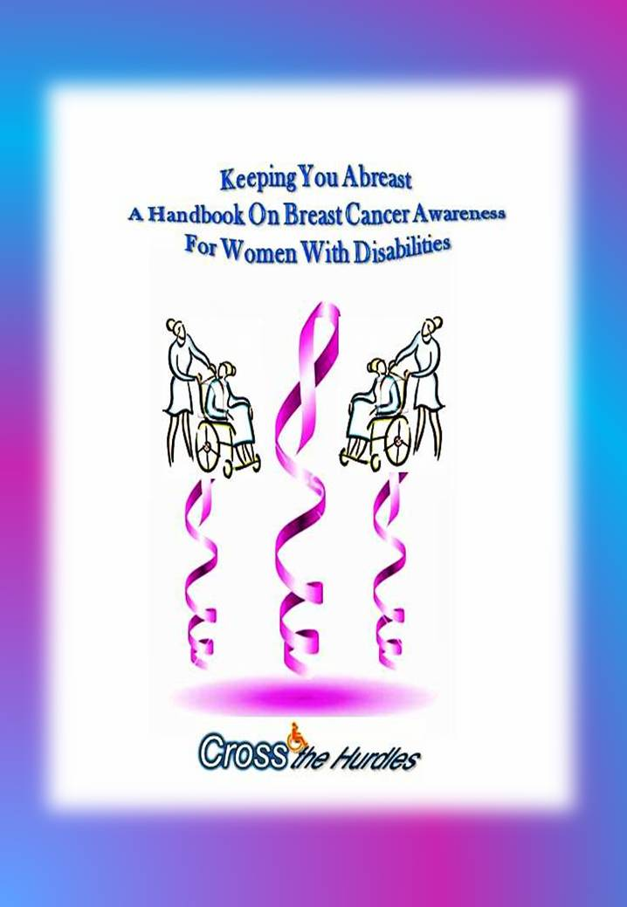
Preface
Cross the Hurdles is glad to release this handbook, especially written for the females with disabilities, for breast cancer awareness. Breast cancer is a nonexistent entity for a majority of population till it affects our near and dear ones.
This Handbook is meant to help females with disabilities and their care givers for making them aware of the risk factors of breast cancer and how they can examine themselves.
There is massive increase in the number of cases and more of younger women are getting affected. Because of neglect and ignorance most of the females present symptoms beyond the earlier stage. And at this time it becomes to prevent this cancer. Timely detection can either prevent it or can get it treated.
India is facing breast cancer epidemic and likely that it would become the most common cancer in women in India till 2020.
Breast health is important to all women irrespective of their age, race, breast size, and ability. There is an equal risk of breast cancer for women with disabilities as it is for non-disabled women. But the challenges we face for detecting, controlling, and treating it are often greater than those of non-disabled women. Even the health professionals assume that all our medical problems relate only to our disability. Health care strategies are not clearly known to the women with disabilities. Unfortunately there are no information pamphlets or even the family members of females with disabilities say, suggest or worry anything about women who have difficulty doing their own breast self examinations. They are a kind of invisible creatures. So the basic objective behind releasing this handbook is providing accessible information to these women so that they may know about the subject in detail and how to proceed if any such problem crops up.
So if nobody does it for you, it is you who have to take care of yourself. Take control of your body and your health. We certainly need to educate ourselves.
Abha Khetarpal
President
Cross the Hurdles
Published by Cross the Hurdles
© 2013 All copyrights reserved
Disclaimer: It also should be noted that not all methods and techniques for conducting a breast self exam are presented in this guide. Therefore, to ensure that the breast self exam is being conducted correctly; a qualified health care provider should be consulted.
Price:
Rs 200
10 USD

