# 

Contents

Letter To The Editor 3

Quote of the Quarter 4

Personality of the Quarter 5

The Power of Creative Imagination 15

A classroom solution for the low vision 18

मानसिक स्वास्थ्य 20

Inclusive society can only be achieved through Inclusive Education 22

WE ARE PARENTS WITH SPECIAL NEEDS 24

A smile that has eased all the pain 25

Destiny’s Child 27

ACCEPT, AWARE AND EMPOWER 29

Artwork of the Quarter 31

कल से ही… 32

Life is precious; Story of Shikha Jain 33

जीवन भर का साथी….मेरा जीवन साथी 34

Sports Personality 36

कुष्‍ठ रोग 38

Necessity is the mother of all innovations 40

# Letter To The Editor

**Guest Editorial**

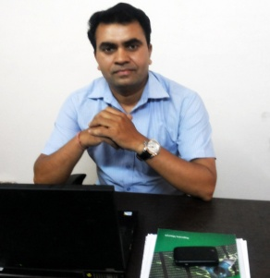Today it brings me an immense pleasure to write a guest editorial for this e-magazine Cross the Hurdles. Since a year or so I have been attached to Cross the Hurdles and am delighted to find it growing not only in length and breath but also in depth. The articles and various write ups and the creative works published in it reflect the real life portrayal of conditions of people with disabilities and their families and how confidently and firmly they are facing the adversities coming their way.

Dear Editor

The initiative taken by NHFDC for providing concessional loans to students with disabilities is quite a laudable one and there is no doubt about that. They have signed a MoU with PNB and circulated list of 6 branches (RABs) with contact details of the students with disabilities to avail the benefit. But what I want to bring to your notice is whether these RAB’s are accessible or not. I myself contacted all the 6 branches and found out that two of them were on second floor without lift, one on first floor without lift, one at ground floor but with steps at the entrance. One contact number given was that of a residential person and the other number was only fax. The Karol Bagh, New Delhi's RAB official was completely unaware about this signed MoU.

So I am quite disappointed to see that nobody seems to be accountable for this whole scenario. I have written to Secretary, DDA, MoSJE as well as CMD, NHFDC and included in the request to make RBI also accountable by having a detailed list of inaccessible ATMs/Banks.

Accessibility for persons with disabilities has always remained the greatest issue of all.

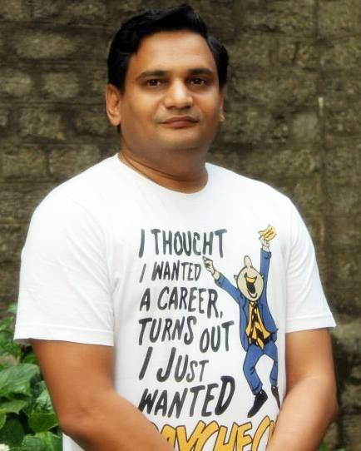

***Dr Satendra Singh Phalswal,***

***Assistant Professor, Physiology***

***UCMS&GTB Hospital, New Delhi***

Recently I had a chance to attend the symposium organized by Cross the Hurdles in collaboration with Indian Spinal Injuries Center, ISIC, New Delhi. It dealt with the topic of "Integrating the Medical and Social Models of Disability: Time for a New Paradigm". All the nine speakers who were experts in their fields stressed on an integrative approach towards disability. Being a non disabled myself I could understand the importance of Disability Studies in higher education in order to build up an inclusive society.

I really appreciate and feel attached to all the other projects undertaken by Cross the Hurdles. I myself am a part of one such project which called Cross the Hurdles Web Network where the organization provides web pages, domain names and web hosting to the people with disabilities in order to showcase their talents to the world.

This e-magazine is also dedicated to the cause of bringing the various issues related to disability through the persons with disability themselves and their families to the surface level by giving them a space of their own where they can come out openly and vent out their feelings and their share opinions with each other.

I wish great success to Cross the Hurdles.

Rajendra Maurya

Team Member

Cross the Hurdles



***Editor in Chief***

***Abha Khetarpal***

***Cover Page***

***Gaurav Kumar***

***Acknowledgements***

***Rita Arora***

***(We are highly thankful to Rita Arora for allowing us to have her painting******for the cover page).***

# Quote of the Quarter

*I am only one, but still I am one. I cannot do everything, but still I can do something; and because I cannot do everything, I will not refuse to do something that I can do.*  
Helen Keller

**Ms Wheelchair Contest (An upcoming event)**

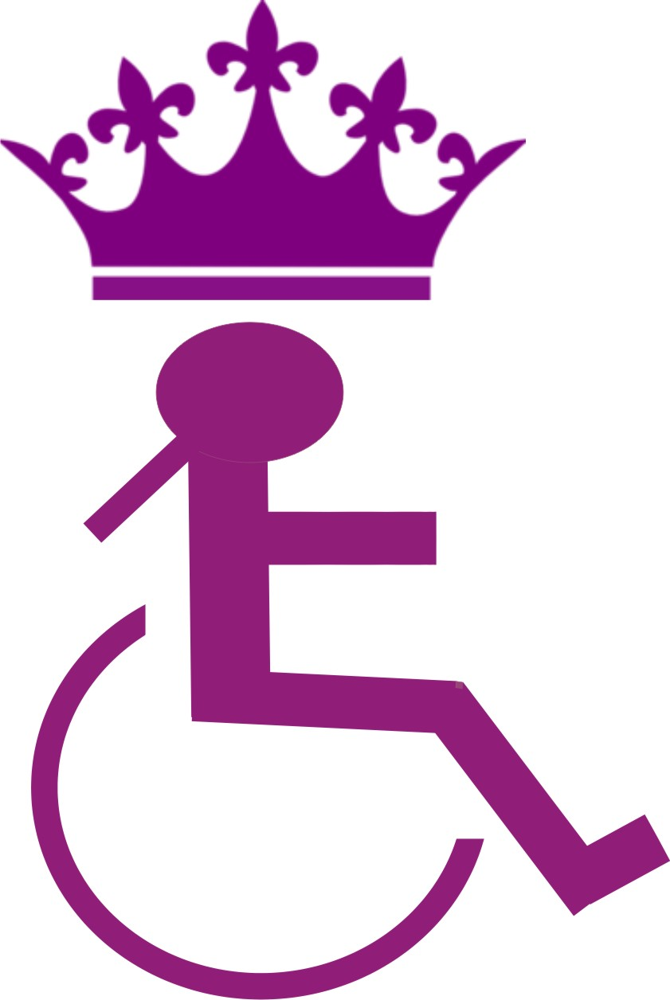

If you see beauty from the mindset of an ableist, you would try to look out for the images that are beautiful from the commercial standards. What I would suggest you, is to try and look for beauty from an angle of aesthetics, as aesthetics opens us to more expansive and diverse conceptions of the human. The idea of aesthetic beauty does not mirror ideals of physical perfection or symmetry or orderliness or smoothness. Beauty in aesthetics means diversity, it pertains to uniqueness. Beauty can be there in roughness, in scars, in deformities, in bends, in cracks and everywhere!

Why disability is never included in discussions when we talk of natural beauty when disability itself is natural? Disability can become a powerful tool for rethinking about our appearances, intelligence and creativity. Let us reframe the concept of beauty. Let us redefine it. So shed all your complexes and unchain yourself from the stigma of disability. Come out in open and feel like a free bird. You will find yourself to be the most beautiful one!

Sandystar Welfare and Charitable Trust (SsWCT) in association with Cross the Hurdles ([www.crossthehurdles.org](http://www.crossthehurdles.org)) and with some other NGOs, is going to organize the first Ms Wheelchair Contest in the month of November 2013 in Mumbai.

The last date for submission of entries is 30th September, 2013. For further detail visit <http://www.mswheelchairindia.org/home.html>

# Personality of the Quarter

*Born in Tamil Nadu, India and raised in Columbia, MD, Kavita Krishnaswamy got her B.S. in Computer Science and Mathematics. In 2001, Kavita joined UMBC, Maryland, as an undergraduate and in 2009 for graduation program and then went on to pursue her Ph.D. When she's not studying, Kavita likes to watch movies and listen to audio books. Kavita, a student with spinal muscular atrophy (SMA), was not able to physically attend classes and could only type with one finger. She attended her classes via Skype from home.  But even from home,  Kavita continued to maintain the highest grades, a 4.0 GPA while working on her research.  At present Kavita a PhD student working on research to increase independence for people with disabilities using robotics. So let us meet today this charming as well as a strong personality and see what she has to say:*

**Who has been your greatest support?**

My greatest support has been my parents who share my life daily and have supported my dreams. I am grateful that I am blessed with wonderful parents. My Mom is my strength and her continual support of taking care of me 24/7 is filled with unconditional love and utmost patience for 31 years. My Dad protects me and keeps me secure at home with unwavering support and affection.

My brothers Raj and Vick have also been a tremendous source of support and always make me believe that I can achieve every goal I set. My friends also give me constant encouragement and motivation to become my best in all facets of life. Specifically, I feel fortunate to have Manoj Kumar.K as one of my greatest friends who has been by my side through thick and thin and always provides me with the inspiration to be successful.

I also attribute receiving my greatest support at the University of Maryland, Baltimore County (UMBC). UMBC is a wonderful place that not only has high-quality technology research development but professors there want all students to be leaders in their field, regardless of disability. Despite my disability with spinal muscular atrophy, I completed my undergraduate at UMBC dual majoring in computer science and math in 2007. Figure 1 is the celebration of my graduation. Now, I am a PhD student working on research to increase independence for people with disabilities using robotics.

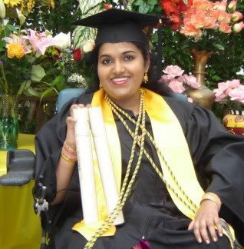

Figure 1: My Graduation Celebration

**Can you please explain to us in brief about the subject of your research?**

My research goals are to provide assistance and increase independence for people with disabilities using machine learning, artificial intelligence, and robotic technologies to improve their quality of life. In particular, my research is focused on path planning and the development of an accessible robotic interface to assist users with activities of daily living. For example, a user could retrieve an object by controlling a robot via voice and/or mouse interface. Currently, I am investigating the use of brain computer interfaces, speech recognition, and facial gestures to control a robotic interface for repositioning the arms of users with disabilities to strengthen their muscles and relieve pressure on the joints.

**Why did you choose Robotics as the subject of your research?**

Robotics provides the most hope for me to maximize my physical strength by using it as a tool to perform tasks. One day, a robot will be in every home as the computer is in every household right now.

**How do you think Robotics can help with disabilities?**

Robotics can assist people with disabilities by increasing their independence. It will relieve them of the physical work required to perform daily life activities. Although the level of technological development is gradually improving, it is still going up to the mark because it cannot still provide direct physical contact due to the precision and safety hazards that may occur during path planning.

**Do you think if you were in India, do you think you could have managed to do this much as you have done now?**

Based on my knowledge of the described environmental conditions in India and experiences of Indians with disabilities, I do not believe that I could have come so far in life if I was in India. Culturally, disability is perceived as a tragic fate of unfortunate individuals that cannot be overcome in any way in India. Often, family members and friends of those with a disability experience shame and/or embarrassment of having to associate with people with disabilities. As a result, many individuals with disabilities are often confined in a room and disassociated from the family and society. The feelings, needs, ambitions, and dreams of the person with the disability is seldom regarded in the Indian family. Unfortunately, it is as if the person with the disability was just born to be locked up in a room for a lifetime. Apart from the social stigma that people with disabilities experience in India, they are not given the support and encouragement to make independent decisions or pursue education, employment, marriage, and home ownership. Additionally, there is a lack of basic necessities and accessibility issues, such as, having a wheelchair and constructing ramps in public buildings.

Having a disability in any country is a challenge; however, I believe that for me there is more access to education, employment, and the ability to contribute to society in the United States of America (USA). Although the cost of healthcare is expensive globally, medical expenses may be covered through medical insurance which helps many people with disabilities in USA. For example, the cost of a wheelchair, hospital bed, and hours provided by hired caregivers/nurses could be covered by medical insurance, depending on eligibility requirements.

Additionally, the Americans with Disabilities Act of 1990 (ADA) is a civil rights law that prohibits, under certain circumstances, discrimination based on disability. The ADA can help people with disabilities gain equal opportunity in employment, access to public places with accommodations, such as ramps and curb-cuts, transportation, telecommunications, and state and local government services. Employers are also obligated to provide a reasonable accommodation that makes it possible for individuals with a disability to enjoy an equal employment opportunity. For example, with the support of the UMBC Computer Science Department, Graduate School, and Student Support Services, I received accommodations to remotely attend classes via Skype. The Internet has also allowed me to work from home in many of my positions.

**Being an Indian, you must have studied the cultures of the both the countries i.e India and US What do you think about the difference in attitudes of people towards females with disabilities?**

Women are seen as more inferior to men in Indian culture than in American culture. Most Indian families take more pride in having a son than a daughter. Even though most societies are traditionally patriarchal, most of the developed nations like USA provide more opportunities for women than developing countries, such as, India.

When a woman has an additional barrier of having a disability, she experiences even more obstacles in society. Even though both men and women with disabilities may equally experience personal, social, and emotional difficulties, I feel women with disabilities encounter many more obstacles in their struggle for equality in all the cultures across the world. As a result, more opportunities, privileges, and resources are available to men with disabilities than women with disabilities worldwide

Nevertheless, I feel the culture in USA strives to provide equality. Personally, I know more women with disabilities educated, employed, in a relationship, married, and have happy and healthy children in USA. In relationships, I have seen couples where one or both partners have a disability living happily and successfully in USA. Figure 2 was taken on the wedding day of my friends Samantha Moreno McGrath and Mike McGrath that both have disabilities and are successfully enjoying a happy married life in Knoxville, Tennessee.

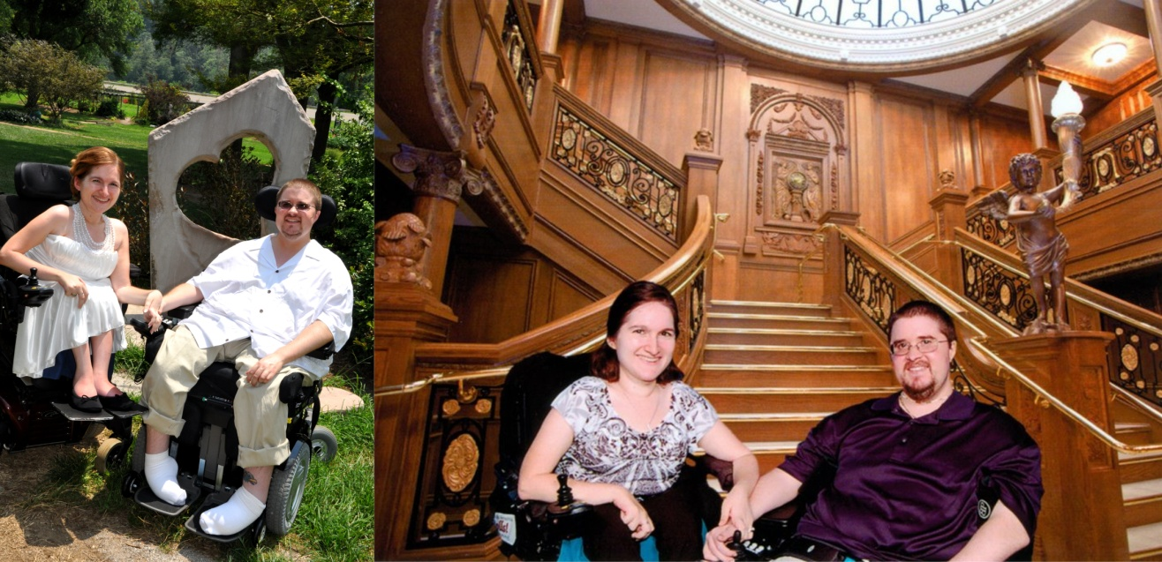

Figure 2: Samantha and Mike that both have disabilities and are successfully enjoying a happy married life (Used with Permission)

Additionally, I have seen disability in either parent or even both parents with disabilities raising children with no disabilities; no matter what the circumstance each scenario has provided a positive outcome. Figure 3 was taken on the wedding day of my friend Cory Jacobson and her husband and the day they found out about their baby girl on the way in Colorado. My friend Melissa M. in Ohio is shown spending time with her daughter in Figure

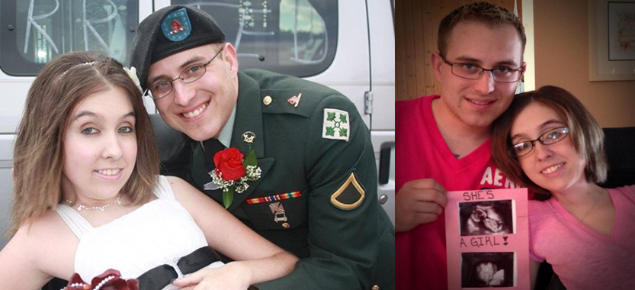

Figure 3: Cory and her husband on their wedding day and the day they found out about their baby girl on the way. Used with Permission.

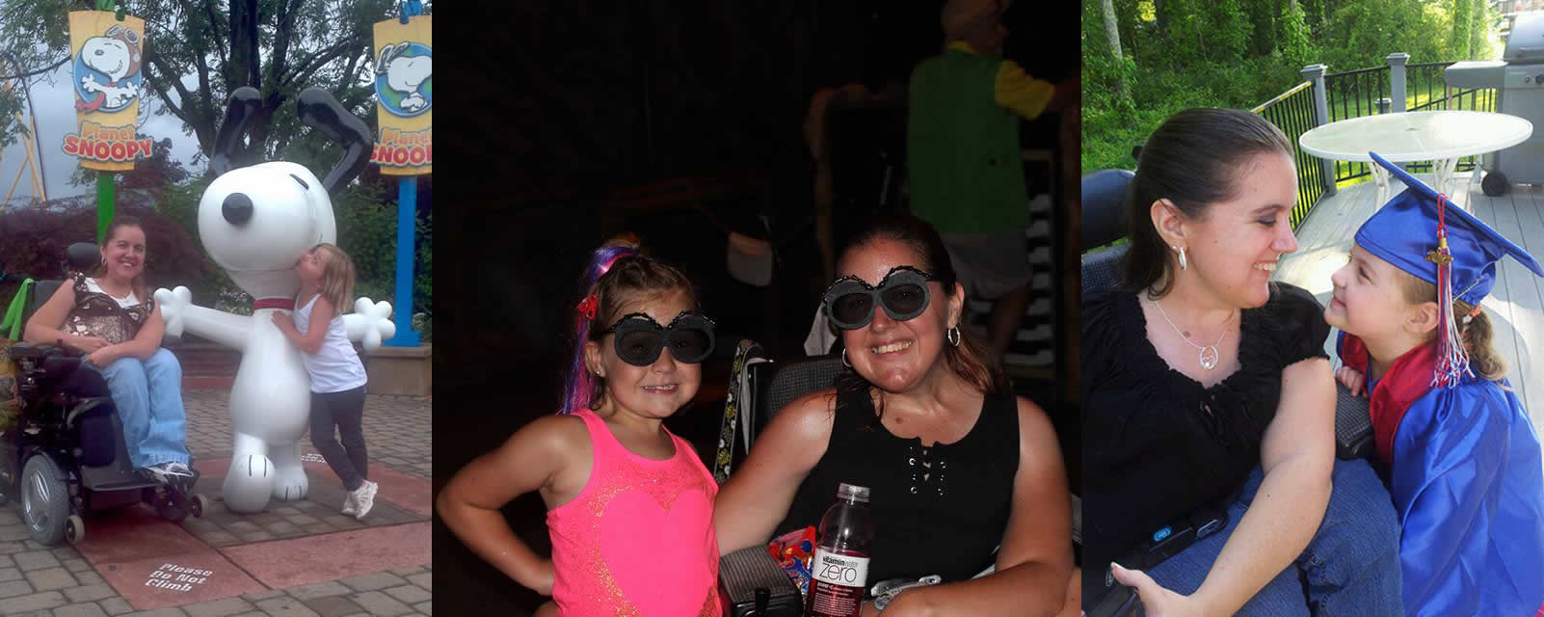

Figure 4: Melissa happily spending time with her daughter.

In India, many opportunities are closed to women with disabilities than men with disabilities. Indian woman suffer more from marginalization, discrimination, and stigmatization that prevent them from advancing in life. I feel Indian women with disabilities often face increased stigmas and are not expected to be in a relationship, married, and have children. Even if a family follows the tradition of arranged marriages, people with disabilities, including both men and women, are excluded from marriage prospects. Likewise, if a family follows the tradition of arranged marriages and they follow the chronological order in which each child was born, then the child with a disability is often skipped and the next child is married off. There is also a misconception in India that all people with disabilities cannot have children and even if they do have children that they will also have a disability that is not true. Just consider people with disabilities and look at their parents. Do their parents have a disability? That's your answer!

**It would be hypocritical on my part if I say that your disability has never come in your way of your achieving so much success. I understand moving ahead in life with disability needs lots of mental conditioning. So how did you manage all that?**

I am very positive that I deserve a fulfilling life just as any other person. I just have to work a little bit harder to make my dreams come true. Everybody deserves to be happy, regardless of disability. Nobody ever succeeded on their first try. With my burning desire for the attainment of a fulfilling life, my concentration is on trying and keep trying until all my goals are achieved. It is not enough to just set goals but you also have to follow through and make sure that you take the steps necessary to achieve goals for a positive change in life. Obstacles will get in the way but it is more important to focus on the tasks to be completed in order to accomplish your goals and bring them into reality.

As a person with a disability, you may feel self-conscious about your limitations and be concerned about what people think about you. Likewise, we may feel that our peers and others in society treat us differently and it may make us feel uncomfortable. Primarily, it is these attitudinal obstacles that prevent us from rising to the top because we spend so much time thinking about what people are thinking about us instead of thinking about ourselves and taking pride in our identity. The best way that you can reshape the misconceptions that exist in society is to help people realize that individuals with a disability equally deserve and can enjoy a fulfilling life by taking pride in their identity and educating the world positively.

Our thoughts determine our destiny. You are not a victim of your circumstances but you become a victim if you react negatively to your circumstances. Happiness is a birthright that is not selfish and is not a burden on others for you to have and experience a desire for happiness. In fact, when one individual is happy, that happiness can be shared with many others and in that capacity happiness can only be increased. I have learned to be content and thrive in life, regardless of my circumstances. When you smile, those around you will also smile back. Try… :-)

**What does life mean to you?**

Life is a gift that nurtures from the cooperative effort of individuals to help and support each other succeed. We have to learn the skill of innovation and creativity so that we can change our environmental conditions to suit our needs and triumph over our barriers in life. Life provides me with enthusiasm to continually find ways for solving the problems we face and those in similar circumstances also experience so that we can all work together and achieve mutual happiness as a team. I am always looking for opportunities to be a good friend, provide support to the best of my abilities, learn about the greater purpose of my life, and create solutions for the challenges in life for myself and everyone.

**What are plans for future regarding your career?**

Within the next 10 years, I will have my PhD degree, be married to that man I love, have a happy and healthy child, be successfully employed as a professor and researcher, have my own home, invent a number of assistive devices and robotic technologies that help increase independence for people with disabilities, make my parents proud, and be thanking God for bringing all of my dreams into reality. In all aspects, I want to be successful and do the best that I possibly can to overcome adversities that may stand against my way.

With my strengths and abilities, I also want to help make sure others with or without disabilities reach their highest potential in life and make their dreams come true. Everything is possible with faith in God and confidence in yourself. If I can do it, you can also do it. Just believe!

**What message would you like to give to Indians with disabilities? Specifically, what message would you like to give to girls here in India with Disability?**

Let's begin to change the world.

*Education*: I realize that success is often rooted in a good education. Individuals with disabilities, particularly children and youth, should attain the highest education possible. Students with disabilities may face a number of challenges in going to school and completing course work. Your parents are your best advocates and they should talk with the school system to find a way for you to at least finish high school. For example, the school may provide a teacher that is willing to teach at your home or you could attend class via Skype. Everything is possible.

To meet the growing social and economic challenges of society today, it is necessary for individuals to have a college education. If you pursue a degree in your field of interest, the bountiful rewards will lead to an eminent job and comfortable lifestyle. People with disabilities are underrepresented in especially pursuing degrees and accessing careers in the Science, Technology, Engineering and Mathematics (STEM) fields. Increasing access to STEM education and careers is critical to the future competitiveness in the global economy. Although students with disabilities can acquire equal opportunities for education, it is important to work with your college officials to receive the proper accommodations to have equal chance of obtaining the experience of maximum academic performance. For example, you could attend class via Skype or take online courses. It is also possible to directly work with your professors to request accommodations for extended time to complete coursework, textbooks in electronic format, and other reasonable accommodations.

Beyond a college degree, you can become your own teacher and learn on your own with the support of the Internet, books, and learning from others. You may also be a teacher for others by helping people to learn about your experiences of living with a disability so that they can have more awareness. There is no end to learning.

*Employment*: With a college degree, an individual has more employment opportunities. Finding and retaining a job in your chosen profession can ensure financial security and independence. Acquiring the necessary skills to get the job that you want is the first priority. Also, it is important that you have the accommodations to perform the tasks of the job. There is also a number of ways that you can be self-employed by tutoring students online or at your own home, writing and publishing your own book, creating your own blog website, and creating instructional Youtube videos or podcasts.

*Friendship*: It is important to have a good friend to share your joys and sorrows. A good friend may come in the form of a classmate, colleague, and a stranger that you meet in the grocery shop. Sometimes, it may be difficult for people with mobility limitations to go places and meet new people. In such cases, there are many trusted online social groups and forums where people can make many friends. It is just important to be cautious online because people can create fake identifications.

*Relationship*: A friend can also be a significant other. Companionship is very important to appreciate the beauty of life. Finding somebody that accepts your disability and values you with respect, love, and care is the key to long-lasting and enduring success in this domain. Try and keep trying until you find your treasure. Attend social events; go to conferences, or even the mall to find a love interest. If the person approaches you, smile and say hi. The harsh reality is that people are afraid to approach and communicate with individuals with disabilities in fear of inadvertently talking about something that may offend the individual with a disability. You may approach the person and say hi and smile. If you experience social anxiety or have difficulties going places, finding somebody online and having a long-distance relationship is also an option with the support of the Internet. It is important to be careful and determine fraudulent profiles on social networking and dating sites. In the process of finding love in-person or online, you may experience a number of heartbreaks before you find Mr. Right or Ms. Right. Stay strong, learn from that experience, share your thoughts with a trusted individual that can provide moral support, and apply your new knowledge with constant faith in your next venture. It is just a matter of time so just keep trying and you will succeed and you will reap the rewards of your efforts!

*Marriage*: Cultivating a lasting, friendship is possible with a loving husband or wife. A significant other from the successful in-person or long-distance relationship may be a great spouse and friend in marriage. Even if your families do not search for marriage prospects on your behalf, it is your own responsibility to let your family and friends know of your interest to get married so that they be on the lookout for a good man or woman. In the context of arranged marriages in India, the parents with a person of the disability may prefer to get their child married off to a person without a disability or not get the individual married at all. Often, an Indian family may accept a groom with a disability rather than a bride with a disability. This may be due to the fact that Indian culture expects the woman of the household to take care of the family and the misconception that a woman cannot contribute to the family with a disability.

In the Indian culture, it is important for individuals to get the consent of their parents to get married. As a person with a disability, you may have to help your parents understand why you want to marry the person of your choice. Don't be intimidated to talk with your parents. Your parents may not initially agree depending on your circumstances with a disability or because they don't feel that the person of your choice may not adequately take care of you. This may mean you may have to try and keep trying again to give them as much information as possible for their consent. In the case that you and your person of choice both have disabilities, it is important for you to help your family realize that both of you are more successful, stronger, and helpful to each other when both of you are together. With every little challenge, there is always a way to overcome victoriously.

*Children*: The sweetest of human experiences is the joy of parenthood. The birth of a first child brings happiness and love to the entire family that is beyond measure. Most women that become mothers for the first time often will encounter and experience new challenges that are common to pregnancy and caring for a newborn. Every woman has some risk during pregnancy, with or without disability.  Since it is uncharted territory for the new mother and father, family members and friends often help cope and tackle the challenges be providing assistance to take care of them can be and the new mother. When a parent or both parents have a disability, additional planning may just be necessary for persons with disabilities to care for a child with a little more assistance, accessible technologies, adaptable parenting and baby care equipment, and an open mind. Thanks to advances in modern medical technologies, proper planning may also include genetic counseling, genetic testing, in vitro fertilization (IVF), IVF with preimplantation genetic diagnosis (PGD), and even surrogacy [1]. In fact, there are a number of genetic conditions that may be screened in the PGD procedure and is listed on the following website [2] for those interested. Individuals with disabilities can also have a child through a natural birth, cesarean section (C-section), genetic engineering and adoption, depending on the nature of the disability of one parent or both parents.

*Societal Contribution*: Every man and woman deserves the right to celebrate the occasion of falling in love, getting married, and being a parent, regardless of disability. People with disabilities have always been creative and are accustomed to finding unique ways to handle different situations. Likewise, having a spouse and/or becoming a parent are simply a new set of challenges that can be easily tackled with proper planning. It is not only important for women with disabilities, but also important for men with disabilities to start their own families. Youth with disabilities need to seek and be given information regarding love and relationship, marriage, children, education, and employment in the context of the disability nature. Let nobody make decisions for you. You deserve the right to make your own sound decision with given information.

Most of all enjoy life as much as possible and be happy. Let everything be possible with creativity. There are no permanent obstacles that can stand between your dreams and the realities of your life. If you have the power to overcome your adversities in your mind, then it implies that you can bring it into your reality.

My friend Patti Panzarino is happily married and is Ms. Wheelchair Massachusetts 2012 and won the Lifetime Achievement Award at the Ms. Wheelchair America 2013 pageant, shown in Figure 4. My buddy Blake Watson from Jackson, MS recently completed the manuscript of his first novel in Figure 5.

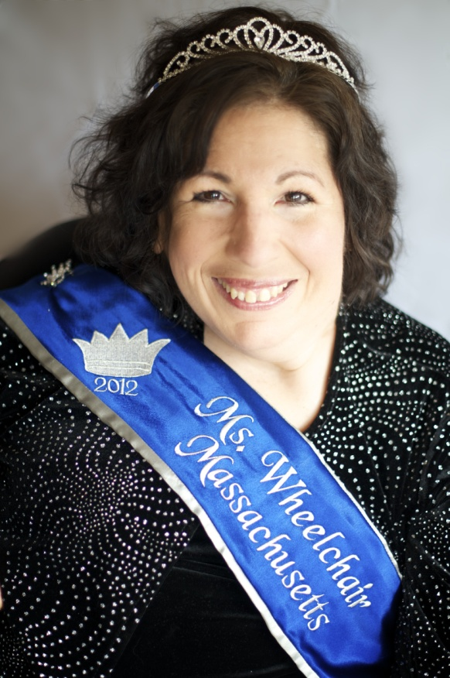

Figure 4: Patti Panzarino winning the Ms. Wheelchair Massachusetts pageant. Used with permission.

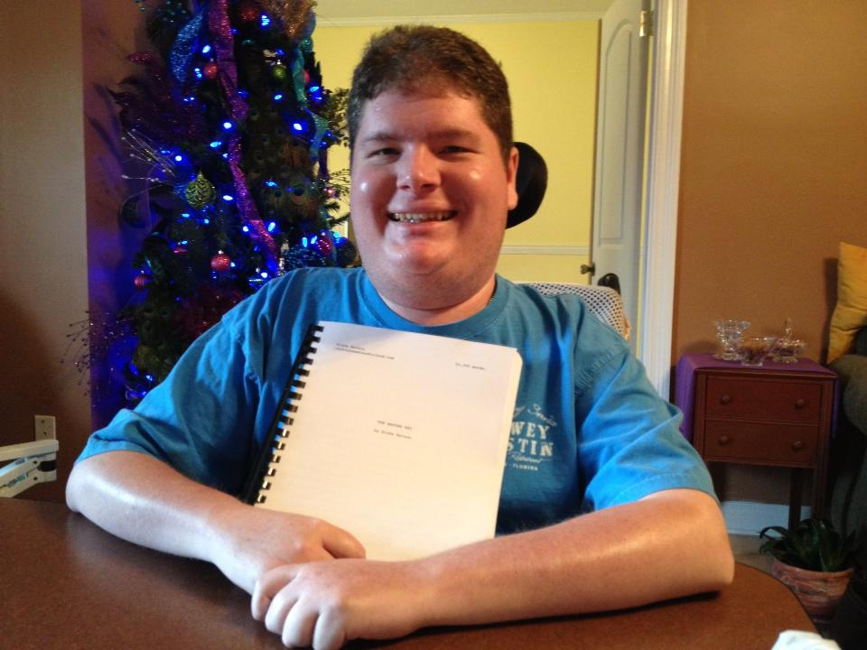

Figure 5: Blake Watson recently completed the manuscript of his first novel. Used with permission.

Slowly, change is happening in India for improving the lives of people disabilities. The environmental and architectural barriers are gradually being removed from the metropolitan cities in India. For example, my friend Deepa in Bangalore is successfully employed for the last five yrs in a reputable IT firm, shown in Figure 6. Similarly, Figure 7 shows my friend Mohini traveling in her wheelchair accessible van in India. More change is necessary, but we are on the right track.

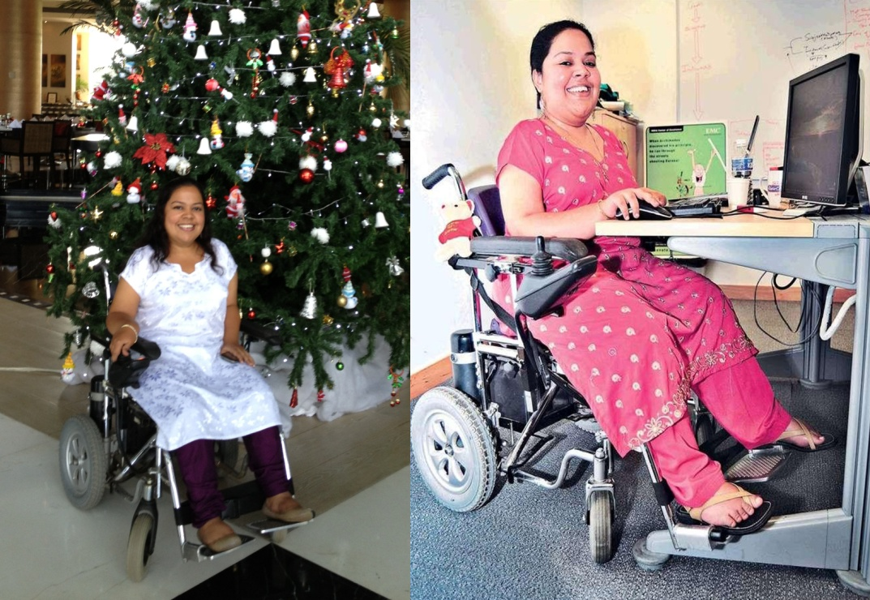

Figure 6: Deepa successfully employed in India. Used with permission.

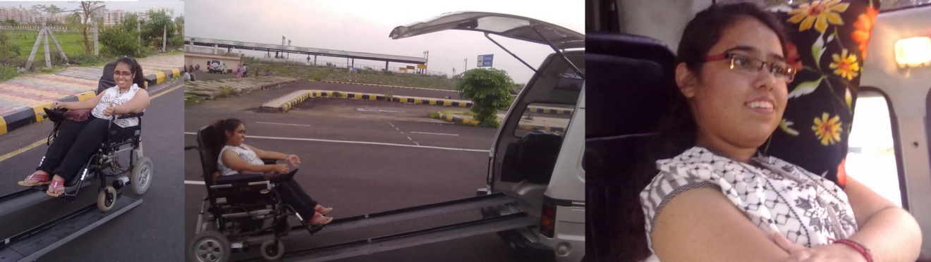

Figure 7: Mohini traveling in her accessible van in India. Used with permission.

According to the laws of nature, humans are not innately born with wings to fly. Yet, this limitation did not undermine our ability to take flight with the principles of aviation and the Wright brothers successfully found a way building the first-to-fly powered and controlled aircraft that led the transition into the modern era of commercial airplanes now transporting people worldwide [3]. Beyond Earth, man has even landed on the moon and has sent several successful robotic missions to Mars [4]. Therefore, there is always a way to overcome our perceived barriers by coming up with innovative solutions with the power of technology, support and cooperation of friends and family, creativity, medical advances, and persistently trying until achieving success and bringing desired dreams into reality.

[1] http://mda.org/sites/default/files/Quest17-3_Pregnancy_Series_revised.pdf

[2] http://www.hfea.gov.uk/cps/hfea/gen/pgd-screening.htm

[3] http://www2.hesston.edu/Physics/WingDesign/research.htm

[4] http://www.space.com/11417-mars-missions-space-travel-challenges.html

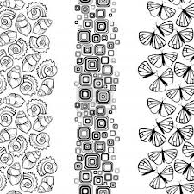

# The Power of Creative Imagination

It has been said that man can create anything, which he can imagine. The imagination is literally the workshop where all our plans are fashioned in and given shape to. We all possess the Power of Imagination. Now, let us take a minute to clearly focus on and try to understand what we mean by that. In its most basic and simplistic form, it means that we have the unbridled ability to create absolutely anything that we can think of and dream about.

Albert Einstein has said that Imagination is the greatest creative force in the Universe. That holds a powerful punch. When we tap into that creativity it is no wonder that limits and boundaries become obsolete.

The faculty of imagination, unfortunately has not been given due emphasis and put on the back burner by many who see it as not having foundation in reality while exactly the opposite is true. It is our imagination that always preceded the creation of our reality. The bible says, “As a man thinketh, so shall he become”.

And, according to Gautama Buddha “We are what we think. All that we are arises from our thoughts. With our thoughts, we make our world.”

It is necessary to note that many a time people use this amazing tool to unknowingly create things and situations in their lives that they do not desire. Many people spend a great deal of time thinking about things that they do not want. This is unfortunate but fixable. How many times have you run through a scenario in your mind of not having enough money to pay a bill or mentally rehearsed an argument with a friend or loved one?

This is a creative force and when using it, we must be aware that we are creating what we are imaging and visualizing; so consciousness is a necessary component of this equation. It is simple to master and with practice we become habitually aware of our thoughts and hence, do not need to scrutinize them continually. When we practice awareness of creative thoughts it becomes ingrained into our subconscious mind and we begin to filter out negative thoughts and scenarios almost automatically. It may take conscious effort at first but the best part is that once it becomes automatic, you will effortlessly start to create positive events and abundance in your life.

The visualization process is great fun, so you should be very open not only to this but also to all the positive emotions that come along with it. Start by determining what it is that you want in your life. Allow yourself to see what your spirit and mind’s eye wish you to see. Do not be over concerned with too many details because we need to remember that God, or the Source knows better than we do what is the ultimate best for us. For example, if you desire a soul mate or romantic partner, it may not be easy or possible for you to know exactly who the perfect person for you is, but the Universe knows. It is not necessary to see the face of the desired soul mate but you can imagine yourself doing special things with that person and experience the joy and happy feelings associated with your desire being fulfilled even though you may not have met that mortal yet.

The fastest and most certain way to manifest your desire is to create an image of it in your mind, then attach the feeling and emotion to it. Feel the happiness and joy as though your desire has been fulfilled right now. That is the vibration you’re required to send out. Create the clearest image or vision possible. Create and experience everything in the present, right now.

It is not fruitful to create something by saying that you want it, because in a literal sense you are creating the “want” for it. Believe and feel that you already have it. Believe and feel with the clearest vision possible. This is what will bring about the circumstances and people that you need to make it all happen.

There has been a lot of confusion and controversy about just stopping at this point. Remember that this is only part of the process, a piece of the equation. There is still action required on your part. When the right circumstances or people or idea comes along and you feel that intuitive nudge, it is your responsibility to jump joyously into action. Be persistent and make it happen with follow up action. This reminds me of an old joke that was once told. “A man goes out in a canoe. The water is choppy and the winds pick up and soon he realizes that he’s got stuck in the middle of the ocean, all alone and his boat has a hole in it. The man considered himself faithful to God and knew that the Source would rescue him. A short time passes and a man on a raft comes by and asks the man if he needs help. The man answers, no thank you God will save me. A little more time passes by and a large fish swims up and asks the man if he wants to ride on his back to the shore. The man piously answers no thank you God will save me. Some more time passes and a huge log goes floating by but the man insists that God will save him. The man ultimately drowns, dies and goes up to heaven. When he confronts God, he asks why he did not come and save him. He said he had so much faith, how could God just let him die? God then answers and says, “My dear son, I sent you a man in a boat, a fish, and a log, all of which you denied, what more would you have had me do?”

We do have a personal responsibility to take action. The Universe may align everything that we need in a row so that we may have our desire but there are times when it is up to us to use our free will and take action. The Universe aligning everything for us is not always the final step. We have an internal communication system that lets us know when it is right for us to act. We need to consciously acknowledge and use this to our advantage. This is what we commonly call as “Intuition” or “listening to our inner spirit”. Label it whatever you like, but make sure to tap into this creative and connected force. It is often action that is the final step to bring about your desires. Please remember there is no one single step, this is a process. A process that is amazing if used consciously to our advantage.

Much Love

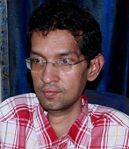

Jitendra Kumar Biswal

Astro-spiritual Analyst & Counselor

http://www.facebook.com/Jitendra.Ku.Biswal

**Technology**

# A classroom solution for the low vision

As a part of our study on assistive technology for people with low vision, Barrierbreak realized that often the complexities of students with low vision are not as evident as they are for students who are blind. Low vision students generally have no or very poor distance vision making it difficult for them to read from the black board in the classrooms or get information from diagrams, charts, graphs or overhead screens. Equipping the classroom with the right technology can enable a student with low vision get access to education and information as any other student.

About Shubhi Shadiza

Shubhi Shadiza is a student with low vision of the Second Year Bachelor of Arts at the St. Xavier’s College, Mumbai and her subjects are English, Economics and Psychology. She decided to continue her education with St. Xavier’s as they provide her with in house resources that aids her in her studies.

Due to low vision, Shubhi was not able to see the blackboard as clearly and had to rely on a one to one teaching approach or help from her friends. She had gone through an inclusive education and had faced this problem for most years of her life. This does affect her learning in a class especially when it comes to subjects like Economics where she needs to understand, say the diagram that the professor might be showing on the blackboard. Even though she loved Economics as a subject, she was unable to cope with the graphs in class when the professor would explain them on the black board and found this to be depressing. It was also difficult for her to do certain things like sketching & painting and thus distancing her from the others and the reality at hand.

Solution & Impact

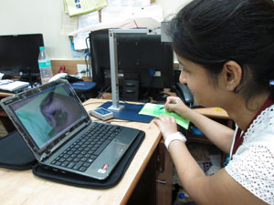As a part of our initiative and experiment with XRCVC (Xaviers Resource Centre for the Visually Challenged) we introduced Optelec ClearNote for Shubhi in her classroom. ClearNote is a portable optical device that has been specially designed for people with low vision. This lightweight unit makes transportation to school or the office easy and is ideal for near, distance or self viewing. BarrierBreak provided a one to one training to Shubhi on how the device needs to be used and then asked her to use it on her own for a month for free.

Using this device Shubhi could not only access the blackboard in the classroom or other distance objects easily but even a cap of the pen that lied down a few feet away from her. She was also able to enjoy painting and sketching and could see and correct any little mistake in her work. She was no longer depended on her teachers, friends or volunteers to comprehend and study graphs in Economics. Moreover, she could now read each and every book that she would like to without it having to be scanned / edited / typed or read by someone else using the ClearNote

She adds “I was lucky enough to be a part of this experiment where I got a chance to use the Clear Note for more than a month which I utilized completely. I used this tool for two and a half hours every day for the time period I was allotted. I have even used it to read banners and recognize faces from far and have succeeded in every task. Overall, it has made my life easier and I now feel like any other student in my college. It is one of the greatest boons in my life as now I am much more independent than before.”

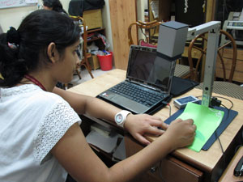From a BarrierBreak perspective, it has the potential of providing a solution beyond the classroom by allowing Shubhi to sketch and paint. Shubhi says “Clear note even made sketching and painting possible for me as I could see the little mistakes in my work and could correct them on my own. It helped me change my life and has made it simpler and easier than before.”

There is more to life beyond studies. Solutions can sometimes go beyond and provide opportunities to people!

Dr. Sam Taraporevala, Director, XRCVC adds “At the XRCVC we believe very strongly that technology can help create a level playing field. The experiment with the clear note proves this point. Such technologies if made widely available would be able to bridge many a divide. We feel very satisfied with the results and look forward to the next positive steps”.

About Optelec ClearNote

The Optelec ClearNote is an USB-compatible video magnifier that creates the ultimate workstation for low vision students and mobile professionals.

About XRCVC

XRCVC is a state of the art support centre, aiming to work towards the holistic development of visually challenged persons, located at St. Xavier’s College, Mumbai.

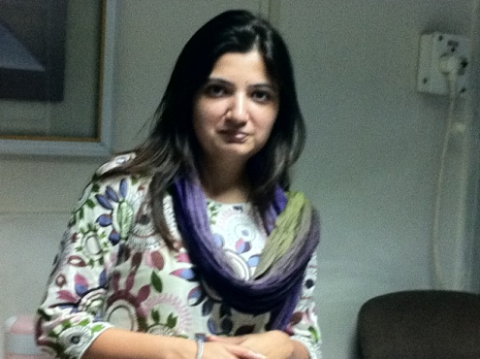About BarrierBreak

[BarrierBreak](http://www.barrierbreak.com/) is an Accessibility and Assistive Technology firm in India. BarrierBreak, a brand of Net Systems Informatics (I) Private Limited is the pioneer of Accessibility and Assistive Technology in India and the first company to set up an Accessibility lab as well. Our teams are aligned with our vision and mission to help our clients to provide accessible solutions.

**Shilpi Kapoor . Managing Director**

**BarrierBreak**

India: +91 (22) 2686 0487/89

Email: info@barrierbreak.com

Web: http://www.barrierbreak.com/मानसिक स्वास्थ्य

हम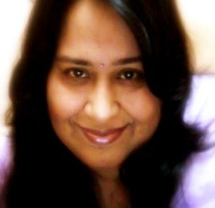 में से अधिकांश लोग अपने मानसिक स्वास्थ्य के मुद्दों की ओ़र ना तो अधिक ध्यान देते हैं ना ही ज़्यादा जागरूक रहते हैं, मगर देखा जाये तो एक चौथाई लोग जीवन में कभी ना कभी मानसिक परेशानी, दिक्कतों  और समस्याओं का सामना करते हैं.

तनाव या बाहरी दबाव का होना, कोई दर्दनाक घटना, नींद का ना आना, कोई शारीरिक पीड़ा, शराब का ना  छोड़ पाना इतियादी कारण कई तरह की अस्थायी प्रतिक्रियाओं को जन्म देते हैं और दीर्घकालीक मनोरोग  की स्थिति उत्पन्न कर देते हैं.

शारीरिक स्वास्थ्य का मुल्यानकन शरीर की स्तिथि से आसानी से किया जा सकता है, जिसके लिए हम रक्तचाप, तापमान आदि के मापदंडों का इस्तेमाल कर सकते हैं. अगर हमारे भौतिक घटक स्वस्थ हैं तो हम शारीरिक रूप से स्वस्थ माने जाते हैं. मगर मानसिक और सामाजिक स्वास्थ्य मापना एक चुनौती बन जाता है…बिना मानसिक रूप से स्वस्थ हुए एक व्यक्ति खुद को सही अर्थों में स्वस्थ नहीं कह सकता. मानसिक  स्वास्थ्य हमारे भौतिक और सामाजिक जीवन के साथ-साथ हमारी भावनात्मक और जैविक स्तिथियों को भी कई तरह से प्रभावित करता है.

और जब तब तक कोई मानसिक, सामाजिक और शारीरिक. इन तीनो रूपों से स्वस्थ ना हों, उस व्यक्ति तो पुर्णतः स्वस्थ नहीं माना जा सकता.

मानसिक स्वास्थ्य की समस्या स्त्री और पुरुष में सामान्य रूप से होती है परन्तु उन समस्याओं के  प्रकार अलग-अलग हैं. स्त्रियों में अवसाद और मानसिक परेशानी की समस्या पुरुषों से लगभग दो गुना ज़्यादा होती है. और दूसरी ओ़र पुरुषों में नशे की लत, आत्मा हत्या के लिए प्रवण, असामाजिक व्यक्तिवा विकार आदि अधिक देखा गया है.

मानसिक स्वास्थ्य का अर्थ केवल मानसिक रोगों के आभाव का होना मात्र ही नहीं है. हम अपने खुद के बारे में क्या सोचते हैं, कैसे खुद को अपने माहौल, अपने परिवेश में अच्छी तरह से ढाल पाते हैं और जीवन की घटनाओं के साथ कैसे खुद का समायोजन करते हैं…ये सब इसमें शामिल होता है.

अमरीकी राष्ट्रीय मानसिक स्वाथ्य संगठन के अनुसार, मानसिक रूप से स्वस्थ लोगों की दस प्रमुख विशेषताएं होती हैं जिन्हे आप सबके समक्ष रख रही हूँ:

1. वे खुद के बारे में अच्छा महसूस करते हैं
2. इनके रिश्ते स्थायी और संतोषजनक होते हैं
3. वे अन्य  लोगों के साथ आराम से रह सकते हैं और उनके साथ अच्छा महसूस  करते हैं
4. भय, क्रोध, इर्ष्य, आत्मा ग्लानी जैसे भावनाएं इन पर हावी नहीं होती
5. वे  खुद  पर  हंसने  की  क्षमता  रखते  हैं  और  दूसरों  से  साथ  मिल  कर  हंसा  भी  इन्हें  पसंद  है
6. आत्मसम्मान होने के साथ-साथ, इनके मन में दूजों के लिए, मतभेद की स्तिथि में भी, उतना ही सम्मान होता
7. वे जीवन की निराशा को स्वीकार करने में सक्षम होते हैं
8. ज़िन्दगी की मांगों को पूरा करने में समर्थ होने के साथ-साथ ये समस्यायों का सामना करने से घबराते नहीं
9. वे अपने निर्णय खुद ले सकते हैं
10. अपने माहौल को अपने अनुसार आकार देने का सामर्थ्य रखते हैं और साथ ही विपरीत स्तिथियों  में खुद को ढाल पाते हैं

इन मापदंडों में खुद को बहुत आसानी से हम सब आंक सकते हैं. और खुद को एक स्वस्थ शरीर के साथ एक स्वस्थ मन देने में कामयाब हो सकते हैं, तांकि हम एक सफल जीवन बिता पायें और साथ ही एक स्वस्थ समाज की नीव, आने वाली पीड़ियों के लिए, रख पायें…अगर जीवन के सभी पहलुओं, जैसे कि सामाजिक, भौतिक, अध्यात्मिक एवं भावनात्मकता पहलुओं के बीच संतुलन बनाया जा सके तो हम मानसिक तौर पर स्वस्थ रह सकते हैं. ये स्पष्ट रूप से हमारे समग्र स्वास्थ्य का अभिन्न हिस्सा है.

मानसिक रूप से स्वस्थ व्यक्ति में ही साहस, आशा, इमानदारी, पारस्परिक कौशल और नैतिकता के गुण दिखाई देते हैं और ये लोग दृढ़ता से काम कर पाते हैं.

आभा खेतरपाल   
अध्यक्ष

क्रोस दी हर्दाल्ज़

# Inclusive society can only be achieved through Inclusive Education

Education is an important need and Article 24 of the CRPD stresses governments to ensure equal access to an “**inclusive education system at all levels**”. Though India has ratified the convention in 2007 but still it is estimated that the share of disabled children not enrolled in school is more than five times the national rate, even in the more prosperous states [World Bank 2009 report]. The alarming situation is no better in the best performing state like Karnataka where 25% of children with disabilities are out of the school. In poorer states like Madhya Pradesh and Assam, this number is more than 50%. Educational training programs rarely address the health needs of students with disabilities [World Bank 2009 report].

Unlike the western culture where equality for the disabled is taught at schools and home, the cultural perception of India is still so narrow and orthodox that the needs of children with disabilities are viewed as welfare rather than equality of opportunity. This is clearly depicted with the division in our country that **the special schools fall under the responsibility of the Ministry of Social Justice and Empowerment, while children in mainstream schools come under the Department of Education** in the Ministry of Human Resource Development [Naidhu, 2008]. 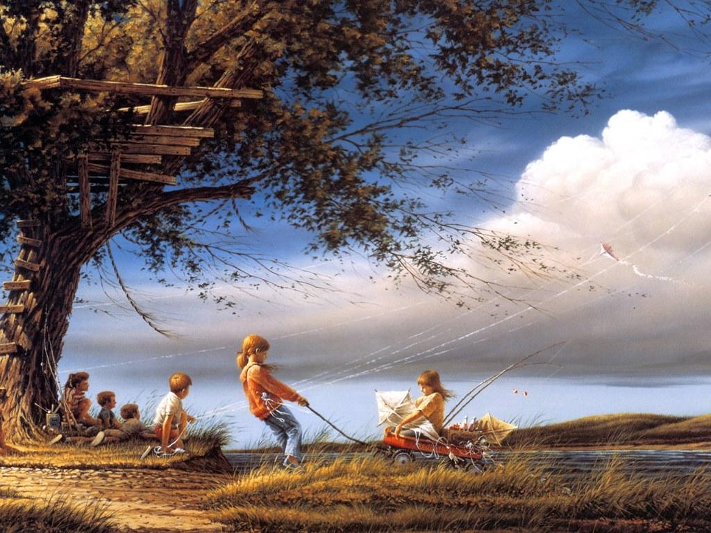

The above fact is even highlighted in the **2011 WHO World Bank, World Report on Disability**. This is a death blow to inclusion and integration as this particular model tends to further segregate children with disabilities, and shifts the focus from education and achieving social and economic inclusion to treatment and social isolation. This is in stark contrast to western culture where Children with such special needs are usually entitled to receive additional services or accommodations through the public schools.

This is something which has been troubling me for a while. However, mere sad faces on current situation will do no good unless we take some initiative from our side. This year, the theme of International Day of Persons with Disabilities, is: “**Break barriers, open doors: for an inclusive society for all.**” Fittingly, I wrote to the Chief Commissioner for Persons with Disabilities (CCPD) my above thoughts thereby requesting to kindly intervene to make education inclusive to children’s with disabilities and stop exclusion into special schools.

The Office of CCPD forwarded my representation to the Secretary, MHRD, Department of School Education & Literacy as well as to Shri KVS Rao, Director (DD-III), Ministry of Social Justice & Empowerment, Department of Disability Affairs vide No.13-1(Education Policy) /CCD/ 2010/R4061 dated 4 June 2013. The letter also stated, “...while all out efforts be made to promote inclusive education, the system of imparting education in specific set up should coexist with the system of inclusive education n main stream schools to ensure choices to students with disabilities.”

When Amar Jyoti Institute at Delhi can successfully showcase a model of inclusive education for students with disabilities than why can’t other institutes follow the same. It’s all about the social accountability and will power. Inclusion will only help our society and contribute to breaking attitudinal barriers in the process. Let’s see how far this plea goes?

Dr Satendra Singh

Coordinator, Enabling Unit

UCMS & GTB Hospital, Delhi

Founder, Infinite Ability

**Parents Speak**

# WE ARE PARENTS WITH SPECIAL NEEDS

As a mother to a boy with moderate autism, I want to admit to all who read this that we special needs parents have some extra needs that we want you to attend to.

We are often left with feeling of being left alone, as we are often preoccupied with our kids and their diverse minute to minute needs. But that does not mean that we do not need attention and company. What exactly you do when you meet your special needs friend cum parent? Just look at what we may need as you may be someone we may be counting on for emotional and moral support.

We need

* We need you-to talk to us about our life, but without intruding our privacy. We will tell and share whatever we would like to. We do need to talk our heart out so often.
* We need friends for our kids. Actually we need this much more than our need for a friend. Let’s try to work this out. Let us meet more often. It will help our kids to pick up on social skills. Why not have a play date occasionally! We are ready to guide you in making your kids understand our kids. Do prepare them. That would really be helpful.
* We need you to share your thoughts.-we would love to hear if you have any doubts or questions regarding our kids. We may not always have an answer of course but it will make us feel glad that yes, someone thinks about us.
* We need you to make an effort in understanding our kids. They are not “weird”. Try to spare a thought in understanding them, their needs, and why they behave the way they do. Even a social smile or a “hello” to begin with is good enough.
* Understand our silence-especially soon after our child is diagnosed, we have prefer to be silent, that’s our way to grieve. Do not feel offended if I am not my usual chirpy self. I may need time to accept the verdict.
* We need you to be there at least sometimes in our hour of need. We may need a break from our 24*7 schedules, may be just for an hour. We would be helpful, if we know that we have someone to count upon.
* We need you to gossip with us too-yes, we like talking about our kids and autism. But we need nonsense talk too. We need break from our special world. Talk to us about latest gossip, Latest news from Bollywood, latest fashion and trends. We would appreciate that.
* We need to party too. We need to be invited, of course along with our kids too. We too need to socialize. We need to be part of usual picnics, get togethers, movies etc. We may not always accept, but then keep inviting us. We would love some good attention.

*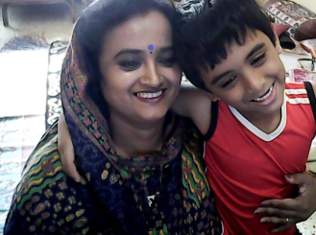(Nalini Srivastava, mother of a son diagnosed with Asprger’s Syndrome, who has dedicated her whole towards her son and towards rehabilitating her son).*

# C:\Users\abha\Desktop\CTH Magazine\August issue\smile.jpgA smile that has eased all the pain

When I gave birth to my daughter I thought she had the most beautiful eyes I had ever seen. I was completely over whelmed with the motherly love that I didn't notice her slanting eyes, flat nose bridge and moon shaped face, typical features of someone with Down Syndrome.   
  
When the doctor first told me that Shreya has Down Syndrome there was the obvious shock and disbelief but somewhere deep inside there was absolute acceptance as well. My husband and I had talked about the possibility of the child having any abnormality and we wanted to have our child in whatever form he/she wants to come to us. And we have no regrets.  
  
Dealing with Shreya's diagnoses was in no way easy. Although we lived in the UK but Shreya was born in India as I had come to stay with family for the delivery. At the time of Shreya's diagnosis my husband and I were in two different parts of the world and I was to join him in a month’s time. Shreya's diagnosis was kept a secret from me by my family for 21 days as I was recovering from a C-Section and was very weak. I didn't know much about Down Syndrome at least not enough to bring up a child who was diagnosed with it. I read up everything I could on the Internet but it scared me even more. Those were the initial days and every single moment was spent thinking about her. Every time I laughed I felt guilty. I had everyone around me but not having my husband next to me made it all worse. We dealt with our grief alone and we still regret not being together when the news was broken to us. Shreya also had additional health problems like hypothyroid and congenital heart defects. She suffers with chronic constipation and infections are easy to get and difficult to get rid of.   
  
We returned to UK as soon as we could and Shreya started the early intervention program, which is crucial for children with special needs. She came under the care of nearly half a dozen professionals. We were relieved that she was in safe hands of people who cared about her. There were people to guide us, help and support us through this difficult time. But we realized that what was lacking in her life was social interaction which was important for her age. We made the decision to come back to India to be with our family. We wanted her to be around her grandparents, uncles, aunts and cousins.   
  
But, all the anxieties and fears returned on our arrival in India. I felt lost with no information, trying to find the right doctors was also difficult and living in a small city like Chandigarh doesn't make it easier.   
  
Shreya has now started her therapies but I realized in the last 2 years we have been in India how difficult it must be for new parents when they learn about their child's disability. There is complete lack of information and support in India. Parents are thrown into the deep end and just left alone.   
  
Your journey starts from the very moment you hear those words," your child has down syndrome." You feel lost and betrayed. You ask yourself a hundred times, what was it that I did wrong in the past that my child is suffering. Having feelings of guilt and betrayal are natural. No matter what you think you should remember that it isn't your fault that your child has a disability. No matter what wrong you may have done, it isn't your fault. Do not spend your life mourning for the child you thought you would have, rather enjoy the special and lovely things that come with raising a child with special needs. Try to channelize your energy into thinking what next. See beyond your child's disability; rather focus on his or her potential. Try to take as much information as you can get from your child's doctor. Talk to other pediatricians for information about therapies and specialist doctors. Remember the earlier you start the therapies the more beneficial and quicker will be the result. Talk to your child while you do your daily chores, tell the child what you are doing, and treat the child like you would treat any other child.  
  
Having a child with special needs changes not just your life but also your other child's life. I remember during the initial days of learning about Shreya's diagnosis I couldn't help but think of her future especially when we grow old. I never realized how many times I had said to my son that he should always take care of his little sister even when he grows up. My son was only 3 years old then. He turned to me and said, “mummy I know I know, you don't have to say it so many times." We have to remember that the sibling of a special needs child will also have his or her set of dreams and aspirations. You have to make sure that you spend valuable and quality time with your other child and not forget that he or she also has needs which can sometimes take a back seat because of the sibling's disability.   
  
Raising a child with special needs is a lifelong commitment that is as unique as each person who embarks on it. If you are a parent raising a child with special needs then you and I are like strangers on the same journey and yet we are not strangers at all. We share the same fears and we connect on a deep and personal level. I have found my friendship with other parents with children with special needs invaluable. There is always so much to learn and share. It has been Shreya's disability that has allowed some beautiful people to cross our path in life some of whom have now become close friends. I have felt that in India people try to keep the issues of disability in a closet. When I moved back to India, one of my priorities was to try and find other parents of children with Down Syndrome. I made sure I asked every doctor I met that I was interested in interacting with other parents. In the last 2 years I have managed to find almost 25 parents who have children with Down Syndrome just in Chandigarh alone. I now run a small support group for these families where I try to provide whatever assistance I can. It is a small but growing family.

I hope my story has evoked a smile, a tear, a sense that life despite its challenges is ultimately good, and that you are not alone with your array of emotions. Having Shreya in my life keeps me humble and grateful. She has become my finest teacher, teaching me to find happiness in the little things that usually eludes us in our busy lives. Many things which were of great importance to us, now seem so trivial. She is an always smiling child, laughs and chuckles at the drop of a hat. With all her disabilities I think she is still the lucky one amongst most people in this world because my daughter will not have the ability to malice, be mean and selfish. There will be few people who would understand that it is only the triumphs over this disability that have far outweighed my tears and a smile on her face that has eased the pain

*(****Shivani dhillon*** *has a daughter with Down Syndrome. Shreya is 3 years old and lives in Chandigarh. She also run a small support group for families caring for children or adults with Down Syndrome. She actually started with a facebook page called Down Syndrome Support Group India where she tried to provide information to parents of children with Down’s Syndrome).*

**

# Destiny’s Child

“Destiny’s Child” was the self proclaimed term I used for myself - what else could it be - an uncluttered happy childhood surrounded by the ones I loved and the ones who loved me so much more … a bunch of adorable friends to die for n vice versa ... pampering Grandparents … holidaying with cousins, summer break after summer breaks… Bonding big time; bonds that have withstood the test of times.

Growing up was fun! The transition from childhood to adolescence went off smoothly…friends, admirers, crushes and the works. Education, Computer courses and a job…more friendships, more fun and then Love came by and was here to stay...Marriage happened...children came in and brought unprecedented feelings… more to rejoice, more to love…but like they say good times do not last forever!

Blessed with two sons, life was a roller coaster but then not to forget, the ride goes down too. My younger son had suddenly stopped speaking, had withdrawn into a shell which I promptly attributed to the frequent trips his Dad had to take abroad, taking him away from us months on end, only because I did not know any better. What could possibly be the reason for an absolutely normal kid with timely milestones, to regress? I was clueless. To me a child born normal stayed normal … period. A friend advised us to go to Apollo Hospital and consult a doctor there. After the checkups the term AUTISM was thrown at us. I did not know anything about the condition. And since the brain scans were normal I heaved a sigh of relief.

That very evening, we happened to go to Sector 18, NOIDA, where at Tekson’s Bookstore, I looked up books on AUTISM. I found one and started flicking through the pages and then the lines and then the words. Soon enough I could see the words swimming before me and flowing down. Without realizing I sat there numb and crying … there was no sound…as if the world had stood still. I was hoping that any moment someone will nudge me awake and I’ll forget it as a nightmare. But that hope proved to be futile. Suddenly, I was face to face with a life I had never known existed...a complete stranger and a daunting one at that! That night I cried for myself, my life, my family and my friends…it was time to say adieu to all that was known, all that was cocooned and comfortable and predictable. It was time to step into the unknown terrain. The only solace was that all of us were in it together.

This was a decade back…we have come a long way since…bit by bit…testing waters…making a little progress each time. My twelve year old makes me proud when he communicates his needs with his gestures or when he follows my instructions - to get me my phone or get me a remote or when he happily plants a kiss on my cheek and in turn offers his shyly. These are BIG achievements in our world and ones that bring tears of happiness in my eyes.

When parents worry about the A+ and careers of their kids our worry is just to make sure that our child gets a healthy and happy life...takes major stress away…what say? That’s part of the reason that I am so chilled out about the future of my elder son. Everyone has a destiny of his own, we have some and we carve out some…I want him to have his own niche and I want him to have the space to carve out his. I live by the day, one day passes and I am grateful…and look forward to the next in anticipation and hope for what it’ll bring me.

In the mean time I want to spread awareness about AUTISM. The more people know about it the better for our children and for us. I want people to be aware that when a child is having a meltdown, the least they can do is not judge the parents and the kid…if they can’t help at least they can ignore and walk away. I remember this one time when we were in a flight and someone asked us to take the child away since they were disturbed. Well, we did not have a parachute unfortunately (for them of course)!

I may not be a Destiny’s Child, the way I have perceived it back then but today I can proudly use this term in the context of having been given the courage and determination to carry on unabated, this new journey of my life!

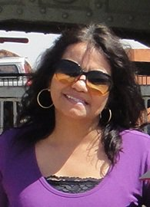Reva Sudeep was born and brought up in Jaipur.

In her own words, “I am Reva- a daughter, a wife, and a mother to two wonderful young boys. I love to blog (http://revasudeep.wordpress.com/) whenever I want to express whatever I am feeling at the moment. A die hard romantic and optimistic to the core- love my family and friends-sums me up I guess :)”.

# ACCEPT, AWARE AND EMPOWER

Our future planning for our children and family starts when the doctor confirms the pregnancy. From that day we start counting days and start dreaming of our child. After baby's birth, we observe the milestones achieved by the baby. When we came to know that our baby is not normal, we were shocked!! And first of all we reject this situation and say 'No this can’t be true’. Definitely the doctor must have had some confusion or our elders would say that some kids achieve their milestones late. But gradually when we understand that there is something wrong with our baby, our dreams get crushed and we don't understand what to do?

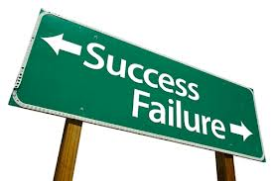So first step is to ACCEPT the truth, but in this aspect the 'ACCEPTENCE' doesn't mean *'OK AB KYA KARU, MERI KISMAT ME HI YE LIKHA THA, or YE SAB PICHHLE JANMO KA PAAP HAI’* etc ...no here acceptance means feel deeply in your heart that if God has chosen you for such difficult job, definitely God would have seen your hidden potential, God must have seen that you are stronger than other parents. So this first step of our struggle is the toughest one and no doubt it is very difficult, but we have to qualify this step with full courage. I tell you that when we deeply get involved in such a tough situation, we need to observe the child's behavior and problem areas, and then we should try to understand in which area we have to work hard with our child. In this way a 'RAY OF HOPE' arises in our self and we motivate ourselves to work hard with our child and we can fulfill the special needs of our kids.

Now I am telling you my own story my son Antariksha (age-25 yrs) has 'CONGENITAL ABNORMALITIES’ (multiple problems). He has severe heart disease, tetralogy of fallots, cleft palate, and dislocation of hip joint and at birth he was a ' blue baby '. His brain was damaged. It was a great challenge for us because at that time I was only 20 years old and in 1988 the society was also not much aware about such a 'rare disease'. Anyway we started the treatment of our son. Plaster was tied on the half of his body for seven months (for dislocation of hip joint), we always take care of his cleft palate at feeding time. He used to suffer frequently from congestion and pneumonia because of heart disease. I still remember that tough time when we never got a little amount of sleep. His first operation was done in 1989 at Chennai and his age was one year. He was unable to gain weight because of defective heart. After the first surgery, we felt a little bit relaxed and became hopeful for his development. On his second heart surgery, final correction was done in 1991 again at Chennai. After that plastic surgery of cleft palate has done .Till that time, we didn't know that he is 'mentally challenged ' and having 'autism ' also .Gradually we understood that his IQ level is below normal. Then we started his training and I devoted my time on him for more than ten years. We all parents have been running an Institute 'Asha Jyoti’ since 2006 and I am the principal of this institution. The purpose of telling my story is to make other parents aware of the fact that confidence and patience pays rather than dejection and depression.

AWARENESS--Now second step after acceptance is to become aware of child's special needs. Gather maximum information about your child's problem. If your child has autism, collect more and more information about autism, like what is autism, how can we manage it, what therapies are in needed for our child, etc. So when you are aware, you can do the best efforts for your child's development because you have become the best therapist, best trainer and the best buddy of your child. Then make the society aware. Conduct awareness campaigns and create the awareness in society about these disabilities because percentage of disability is increasing day by day.

EMPOWER--After acceptance and awareness, you would understand that the situation is under control and you can handle this situation of your child. It’s not a big deal and you can do it. Stay firm on your determination. Never feel embarrassed of your child in social circle. If he shows any odd behavior in public place, don't feel nervous or disturbed or lose your temper. First of all, observe the whole situation with patience that why child is showing such behavior, what he/she wants and how and when he/she stops such behavior. After sometime you will be able to understand how to tackle these situations. Be a 'selective listener'. Don't follow every body's advice unless and until they have not suffered from such situations. When you meet other special parents and associate with them, at that time you can discuss your problems with them and you can get some solution from them because they are also travelling the same boat in which you are travelling. So in my opinion, parents of special children should unite with each other, share problems with each other, understand each other and create a self support group. It will really help you and you will feel that ‘’WE SHALL OVERCOME, WE SHALL OVERCOME ...SOME DAY...O DEEP IN MY HEART ....and you will win.

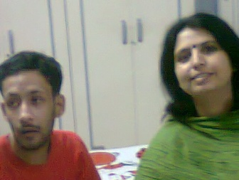

*(Swati Sharma is the Principal of Asha Jyoti Institute, which is an institute for children who have intellectual disabilities. She stays in Lucknow. She has done her B.ed in Special Education. She has a 25 year old son, Antariksha with congenital abnormalities. She has devoted her life for the special children and wants to serve them till her last breath*).

# Artwork of the Quarter

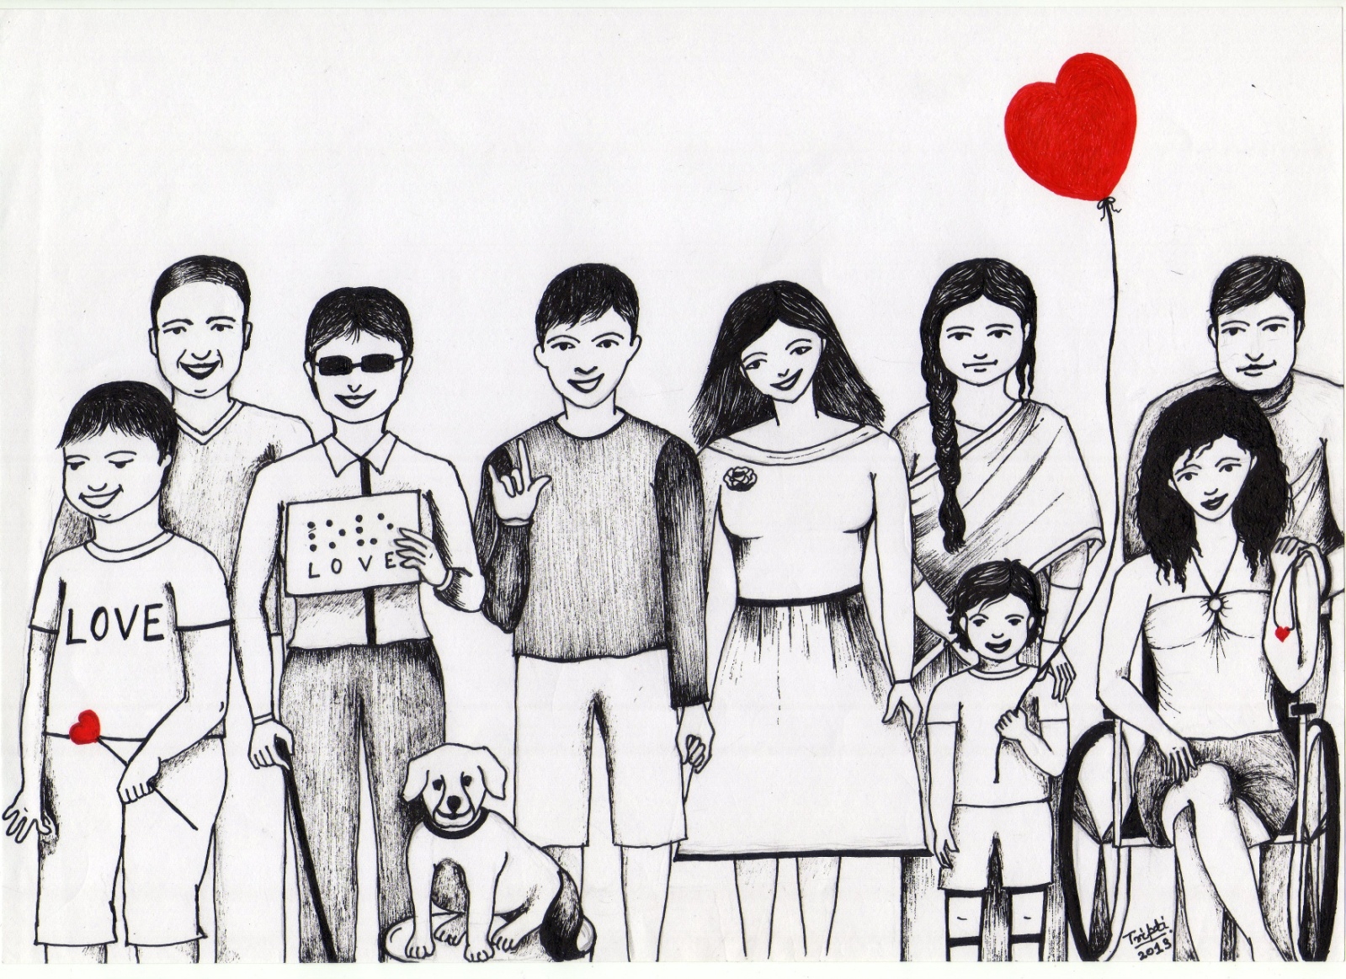

A beautiful as well as a meaningful sketch by Tripty Soni who is a person with Muscular Dstrophy.

In Tripti’s own words, “I have made a sketch on disability. In the picture people with disability are standing with non disabled people. The topic is revolves around- love is the universal language, understood by all or everybody needs love. From right- a wheelchair user with her husband, polio survivor child with his mother, deaf and dumb boy using sign language to show love with his girlfriend, a blind lady holding a Braille script with her pet and a child with intellectual disability with his father are standing.”

# कल से ही…

तुम्हारे बनाये

एक भद्दे से

चित्र को देख

जब लोग

कुछ अधिक ही

प्रशंसा करते हैं

मुझे ठीक नहीं लगता

तुम्हारे द्वारा

गाये गए

एक बेसुरे से गीत पे

कुछ ज़्यादा ही तालियाँ बजती हैं

मैं आहत ही होता हूँ

खुद अपने अलावा

किसी और से

मैं ये उम्मीद

नहीं कर सकता

मैं जानता हूँ

ये कोई प्रशंसा नहीं

होंसला-अफजाई भी नहीं

कोरी दया है

एक सुन्दर अंदाज़ है

वितृष्णा का ही

तुम्हारे और मेरे प्रति

कोई शक्स

ये क्यूँ नहीं कहता

प्रयास तो अच्छा है

तुम कर सकते हो

हमारे बच्चों के साथ

तुम क्यूँ नहीं सीखते

कल से ही....

*(अनजानी कुमार गनेरीवाला, प्रयास ऐसोसिअशन ऑफ पेरेंट्स फॉर स्पेशल चिल्रन के सचिव है। ये एक संवदेनशील व्यक्ति तो हैं ही मगर एक ऐसे पिता हैं जो अपने बेटे आशू से बेहद प्रेम करते हैं। बेटे के डाउन सिंड्रोम ने इन्हें कभी कमज़ोर नहीं बनाया है और इनका हमेशा प्रयास रहा है की कैसे अपने बेटे को आत्मनिर्भर बना सकते हैं।)*

# life.jpgLife is precious; Story of Shikha Jain

Born and brought up in Manipur, Shikha Jain is a role model for many today that shows what hard work and human endurance can do.

What makes Shikha special and a role model to people in her area and to all who know her is her determination and the will to succeed. She became a paraplegic at the age of 7, in a bomb blast. Even as a child she did not let pity and sympathy take over her instead not only she continued her life as any child but also topped her 12th Board Exams and excelled in every way possible for her.

At her age, she has accomplished much more than most people her age only dream of. Her story was included as part of the curriculum in the Moral Science book of Class VI titled, “Be a hero/ heroine”. Shikha has completed her graduation and post graduation in Commerce, completed her B.Ed and PGDCA and now posted as Government teacher at Imphal Manipur; she is unstoppable, as she wants to do so much more.

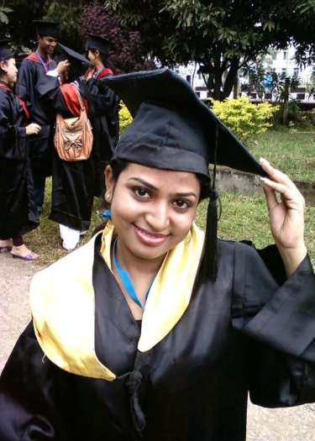Her positive attitude toward life has been her secret ingredient for success. Her charming personality and ever-smiling face attracts everyone who meets her. She always has had the biggest friends’ circles and is one of the most accepted persons in her community.

The secret behind her success and her biggest support is her family, her mother who is a teacher and her sisters have been the real heroes in the entire scenario. They were the ones who had to carry her to school and colleges. They stood by her through thick and thin. Their faith in Shikha has made her what she is today.

Her life had its own challenges, for instance her mobility was with aids (Callipers and crutches) and had to be carried at times. Spinal injury had its own complications, she had a hip dislocation when she was in 10th Std, and had to be confined to her house. She only went to school to write her board exams. She describes this phase as a terrible time as she was confined to her house and was unable to attend school. She also had to come back to the Rehab Institute, CMC, Vellore for follow up and reviews. This meant her family also had to come along with her leaving their work and studies.

As she continues her life, still full of challenges, but filled with determination, she continues to inspire people who meet her, not only the patients but also the families and staff. She still dreams of touching the stars and will not settle just reaching the roof. Her faith in herself and with the support of her family, she knows, she can go anywhere, do anything her heart desires.

She says, “We are the dreamers of a better world. A world without barriers. A world where being disabled does not automatically equate with being disadvantaged… where words like “empathy” and “empowerment” forever replace “pity” and “neglect”… where access in every sense and equitable opportunities are the norm. A world where every person is judged only on individual merit, strength and character. A world where every disability–be it physical, intellectual or psychological, is accepted as a diversity to be respected and accommodated.”

जीवन भर का साथी….मेरा जीवन साथी   
  
आज से करीब डेढ़ साल पहले मेरी जिन्दगी में एक बहुत अहम मोड़ आया।  एक मोड़ जिसने मेरी जिन्दगी में बहुत कुछ बदल दिया, जिन्दगी जीने का मेरा तरीका, अपने वर्तमान और भविष्य को देखने का मेरा नज़रिया। एक मोड़ जिसने मुझमें आत्मविश्वाश भर दिया, बेशक मैं कह सकती हूँ अबतक की मेरी ज़िन्दगी का सबसे हसीन मोड़, वह मोड़ जहाँ मिला मुझे मेरे जीवन भर का साथी…मेरा जीवन साथी।  
  
हालाँकि अपनी जिन्दगी में उसे जगह देने से पहले एक अजीब सी झिझक थी मन में (शायद समाज के नज़रिये की वजह से) लेकिन आज मैं पूरे विश्वास के साथ और सच्चे दिल से कह सकती हूँ की पापा की रज़ामंदी के बगैर लिया हुआ मेरा वो फैसला गलत नहीं था क्यूंकि एक अच्छे जीवन साथी के सारे गुण मौजूद हैं उसमें और मैं उसके मेरे जीवन में होने से काफी खुश हूँ। गलत नहीं थी मैं, जब अपनी लगभग पूरी जमा पूँजी लगा दी व्हीलचेयर खरीदने में।   
  
आज मैं साफ़ तौर पर बहुत बड़ा अंतर देख सकती हूँ उसके आने से पहले और उसके आने के बाद के अपने जीवन में।  मुझे याद है उसके मेरे जीवन में आने से पहले चार दीवारों से घिरा एक कमरा बस इतना ही तो था मेरा संसार लेकिन उसने ना सिर्फ उन दीवारों के बाहर की दुनिया खोल दी मेरे लिए बल्कि भविष्य के सुनहरे सपने देखने का भी अधिकार दिला दिया। पैरों की अक्षमता की वजह से जिन्दगी जो ठहर सी गयी थी, उसके आने से बेफिक्र सी नदी की तरह बहने लगी, रास्ते में आने वाले हर चट्टान को लाँघ जाने के जज्बे के साथ। मुझे याद है वो वक़्त खड़े हो सकने की असमर्थता की वजह से जब ज़मीन पर घिसटती हुयी जिन्दगी काट रही थी हर वक़्त किसी के जूतों तले हाथ या पैर पड़ जाने का डर होता था जहन में, कोई परीक्षा या न टाले जा सकने वाले मौकों पर सार्वजनिक जगहों पर घिसटते हुए हाथों का छिल जाना, पान की पिक या और भी गंदगियों पर हाथ रखने की मज़बूरी या कई बार ना चाहते हुए भी किसी अजनबी(या पापा भी) के द्वारा गोद में उठाये जाने की ज़िल्लत(मदद के लिए) कितना बुरा लगता था ये सब, लेकिन उसके आने के बाद अब सब बदल गया। उसकी बाहों में इतनी सुरक्षित महसूस करती हूँ जितना और कहीं नहीं। भीड़ भरी जगहों पर भी अब बिना किसी के जूतों के डर या गोद में उठा लेने के प्रस्तावों की चिंता के बगैर आत्म विश्वाश और स्वाभिमान के साथ आज मैं जा सकती हूँ तो सिर्फ इसलिए की वो मेरे साथ है हमेशा। मेरा जीवन साथी, मेरा आत्म विश्वाश, मेरे स्वाभिमान का रक्षक, जिसके बगैर मैं अधूरी हूँ और जिसका होना मुझे पूर्णता का एहसास कराता है। वही तो है जिससे मैं प्यार भरी मुस्कान के साथ कह सकती हूँ "तेरा साथ है तो मुझे क्या कमी है, अंधेरो से भी मिल रही रौशनी है।"  
एक बार यु ट्यूब पर एक कविता सुनी थी(शायद प्रसून जोशी की) जिसमें एक लड़की की इच्छा दर्शायी गयी थी उसके जीवन साथी के बारे में, लड़की अपने पिता से मिन्नत करती हुयी कहती है मुझे न राजा के घर ब्याहना न सुनार के घर, मेरा हाथ लोहार के हाथों में दे देना जो मेरी बेड़ियों को काट सके, सुन कर लगा बिल्कुल ऐसा ही तो है न वो भी, उसने भी तो मेरी बेड़ियाँ काट कर सतरंगी सपनो की दुनिया में उड़ने के लिए आज़ाद कर दिया। जिन्दगी की राहों पर हर कदम मेरे साथ रहने वाला मेरे हिस्से के कंकड़, काँटे सब खुद झेल कर मुझे सुरक्षित रखने वाला। सुबह आँखे खोलते हीं पलँग के पास खड़ा नज़र आता है बाहें फैलाए सिर्फ मेरे लिए, मेरे साथ पूरा दिन गुज़ार देने लिए, वो बना भी तो है सिर्फ और सिर्फ मेरे लिए। अब उसके बगैर जीने के बारे में सोचना भी मुझे गँवारा नहीं क्यूंकि मैं जानती हूँ भले ही पूरी दुनिया मेरा साथ छोड़ दे या मैं हीं खुद लोगों को छोड़ दूँ पर वो एक चीज़ जो जीवन भर मेरा साथ निभाएगी जिसके साथ पूरी जिन्दगी मेरी गुज़र जाएगी वो है मेरा 'व्हीलचेयर।' जानती हूँ मेरे और उसके रिश्ते का अंत अगर कहीं होगा तो वो इस जिन्दगी के बाद मौत के आगोश में। तभी तो कहती हूँ उसे जीवन भर का साथी…मेरा जीवन साथी।

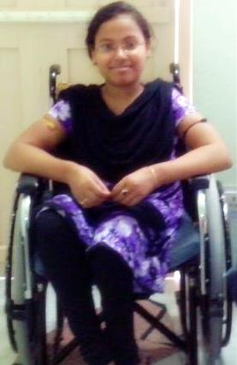आलोकिता गुप्ता

(एक विद्यार्थी जो अपने लिए दुनिया में अपनी राह खुद बनाना चाहती है)

# Sports Personality

**Bob Wieland**

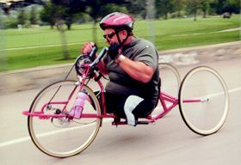Bob Wielandis a Vietnam War veteran of US Army, who lost his legs to a mortar mine in 1969. After recovering from his injuries he was inspired to become a [Marathon](http://en.wikipedia.org/wiki/Marathon) participant. Over his lifetime he has finished many marathons, often taking multiple days to finish. He is the only “Double Amputee” to finish the difficult Kona, Hawaii Ironman race without a Wheelchair. He "ran" across America on his hands, taking three years, eight months, and six days to travel from coast to coast.

**Early life**

Growing up in Wisconsin, Bob went to the [University of Wisconsin](http://en.wikipedia.org/wiki/University_of_Wisconsin). A talented [baseball](http://en.wikipedia.org/wiki/Baseball) player, he was negotiating a deal with the Philadelphia Phillies when he decided to join the Army as a combat medic.

In Vietnam in June 1969, his squad walked into a mine field. When a member of his unit stepped on a booby-trapped mortar, Wieland rushed to give first aid but he, too, stepped on a 82mm buried mortar, a round designed to destroy tanks, which severely damaged his legs; they had to be amputated above the knee. In a letter to his parents after his accident, he wrote: on June 14, 1969,

*Dear Mom and Dad,*

*I'm in the hospital. Everything is going to be O.K. The people here are taking good care of me.*

*Love, Bob.*

*P.S. I think I lost my legs.*

Bob likes to say of that day, "My legs went one direction, my life another."

After recovering from his injuries, he enrolled at California State University, Los Angeles majoring in education. After university, he joined the Green Bay Packers as a physical trainer.

**Marathon**

In November 1986 he completed the New York City Marathon, taking four days to complete the 26 miles (42 km) race. He "ran" across America on his hands, taking three years, eight months, and six days to travel from coast to coast and raise money for Vietnam War veterans. In 1988 at 41, he finished the Los Angeles Marathon, taking 74.5 hours to finish the 26.2 miles (42.2 km) race. He started the race a day earlier than everyone else and finished two days after the last runner had crossed the finish line.

Wieland was a guest on 100 Huntley Street. 100 Huntley Street is a Christian daily talk show and the flagship program of Crossroads Christian Communications based in Burlington, [Ontario](http://en.wikipedia.org/wiki/Ontario), Canada. Created in 1976 by Rev. [David Mainse](http://en.wikipedia.org/wiki/David_Mainse), it first aired on June 15, 1977 from its first studios located at 100 Huntley Street in the St. James Town area of Downtown Toronto.

On August 23rd, 2012 - Bob Wieland announced to the world on live TV his plans for the Celebrate America Tour starting in January 2013. Over the next 5 years, his plans are to visit all 50 States in the USA, extending a challenge to do a measure more and inspire others! He will be speaking at conventions, corporate meetings, military bases, universities, high schools and churches. Long Live Bob Wieland and his Mission to Motivate Others through his Noble Cause.

"Sometimes you don't realize your own strength, until you come face to face with your greatest weakness".

https://mail.google.com/mail/images/cleardot.gif

(**Mani Laxman Panse** from Pune is a Polio survivor. He does data entry job. He takes active part in sports meets).



# कुष्‍ठ रोग

कुष्‍ठ रोग या कुष्‍ठ एक रोगाणु के कारण होता है। यह संक्रामक-दूसरों को लगनेवाला रोग है परंतु बहुत ही कम फैलनेवाला है। केवल ऐसे संक्रामित कुष्‍ठ रोगी जिनका बहुत दिनों से उपचार न हुआ हो उसके संपर्क में आने से कुष्‍ठ फैल सकता है।

**लक्षण** 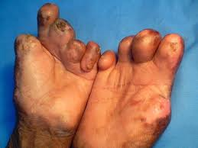

* त्‍वचा पर एक रंगहीन दाग जो थोड़ा या पूरी तरह स्‍पर्शहीन हो या उस दाग पर किसी चीज की चुभन का भी अनुभव नहीं होता।
* हाथ और पैरों का सुन्‍न हो जाना।
* चेहरे पर, नितंबों पर, शरीर के अन्‍य हिस्‍सों की दूसरी ओर बहुत सारे, नरम एवं जिनकी परिभाषा न बताई जाए ऐसे लाल व स्‍पर्शक्षम या स्‍पर्शहीन धब्‍बे।

**कुष्‍ठ रोग के संबंध में गलत तथ्‍य**

* कुछ लोगों का विश्‍वास है कि वंशानुगत कारणों, अनैतिक आचरण, अशुद्ध रक्‍त, खान-पान की गलत आदतें जैसे सूखी मछली, पूर्वपापकर्म आदि कारणों से कुष्‍ठ रोग होता है।
* लोग मानते हैं कि कुष्‍ठरोग केवल कुछ ही परिवारों में फैलता है। यह केवल स्‍पर्शमात्र से हो जाता है।
* कुष्‍ठ रोग प्राय: कुरूपता के साथ जुड़ा हुआ होता है। कुरूपता आने के बाद ही कुष्‍ठ रोग का निदान किया जा सकता है।
* कुष्‍ठ रोग अत्‍यंत संक्रमणशील है एवं यह संक्रमणशीलता कुरूपता से जुड़ी हुई है।
* कुष्‍ठ रोग लाइलाज है।
* जिन परिवारों में कुष्‍ठ रोगी हैं, उस परिवार के बच्‍चों को कुष्‍ठ रोग होगा ही

**क्या खाएं?**

* कुष्ठ रोगी को प्रतिदिन बथुए की सब्जी खाने से बहुत लाभ होता है।  
* सत्यानाशी के 10 ग्राम रस का प्रतिदिन सेवन करें।  
* सूखे आंवलों को कूट-पीसकर चूर्ण बनाकर रखें। प्रतिदिन 3 ग्राम चूर्ण जल के साथ सेवन करें।  
* निर्गुण्डी के ताजे पत्तों का 10 ग्राम रस जल में मिलाकर पिएं।  
* काली हरड़ 40 ग्राम, काली मिर्च 20 ग्राम और शुद्ध बछनाग 10 ग्राम मात्रा में कूट-पीसकर गाय के घी में भूनकर, प्रतिदिन 5 ग्राम चूर्ण 10 ग्राम मधु मिलाकर सेवन करें।  
* नीम के पत्तों को जल में उबालकर स्थान करें।  
* चालमोंगरा के तेल को वेसलीन में मिलाकर कुष्ठ के व्रण पर लगाएं।  
* कुष्ठ रोगी को फूलगोभी की सब्जी प्रतिदिन खिलाएं।  
* नीम के वृक्ष की पकी निबौली खाने से कुष्ठ रोग नष्ट होता है।  
* आंवला और नीम के कोमल गुलाबी पत्ते 3-3 ग्राम मात्रा में पीसकर मधु मिलाकर सेवन करें।  
* करंज, नीम व खदिर के पत्तों को जल में उबालकर स्नान करें।  
* नमी और चालमोंगरा का तेल मिलाकर कुष्ठ के व्रण पर लगाएं।

* कुष्ठ रोगी को प्रतिदिन अंकुरित चने खाने चाहिए।  
* जिमीकंद की सब्जी प्रतिदिन खाने से कुष्ठ रोग नष्ट होता है।

**क्या न खाएं?**

* फास्ट फूड व चाइनीज व्यंजनों का सेवन न करें।  
* चाय, कॉफी व शराब बहुत हानि पहुंचाते है।  
* तेल, घी, मक्खन आदि से बनी चीजें न खाएं।  
* घी, तेल, मक्खन से बने पकवान न खाएं।  
* कुष्ठ रोगी को पूरी तरह स्वच्छता भरा वातावरण प्रदान करें।  
* दुषित जल व दूषित बासी भोजन का सेवन नहीं करना चाहिए।  
* मांस, मछली व अंडे के साथ-साथ उष्ण मिर्च-मसालों से बनी तली हुई चीजों का सेवन ना करें।

कुष्ठ रोग पूर्व जन्म के पापों का फल नहीं है और ना ही यह लाइलाज है। कुष्ठ रोग किसी भी अवस्था में पूरी तरह ठीक हो जाता है। यह बात अलग है कि आरंभिक अवस्था में इसका उपचार आसानी से हो जाता है। चरमावस्था में इस रोग के कारण शरीर में कई प्रकार की विकृतियां उत्पन्न हो जाती हैं। यह रोग वंशानुगत नहीं होता है। यदि कुष्ठ रोग अति संक्रामक स्थिति में है, तो परिचारक, प्रतिरक्षण के बतौर कुष्ठ रोग की दवाओं का सेवन करके रोग मुक्त रह सकता है।



# Necessity is the mother of all innovations

Ameya Mogre, a spinal cord injury patient, living in Mumbai, with the help of a mechanic converted his Kinectic Honda into a wheelchair friendly vehicle and found back his long lost independence after his accident. The customization has cost him around Rs 60,000 ( excluding the cost of the vehicle) but he is so happy that sometimes money does not matter. Sometimes it is more valuable and precious to have a feeling that ‘Yes, I can do’ and this very feeling has given him wings to fly. The person who remain so depressed few months back is now always found smiling, cheerful and sometimes in naughty mood too!! Have a look at his mobility bike.

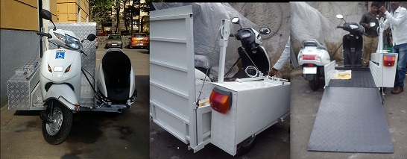

*(For further details you may contact: Ameya Mogre at 91-9022098998)*

